Tech Rider - Baba Dochia

Marius Pop - Electronics, synths, guitar

Marc Stoica - Guitar, voice

Andrei Voicu - Drums, FX

Cristian Cânpean - Visuals

Contact:
Marius Pop (technical issues) baba.dochia.band@gmail.com; + 40742.204.489
Andra Rotariu (manager) andra@swanboymusic.ro +40723608612

Setup and Sound Check

The band will require 30 minutes (minimum) for stage setup and 1 hour (minimum) for sound check.

Backline

- 1 Drum kit with the following specifications:

- Kick drum
- 1 Tom 1
- 1 Tom 2
- 1 Floor tom
- 4 Cymbals stands + 1 Hi-hat stand
- 1 Snare stand
- 1 Drum seat

The mics for the drum set will be set up according to the input list.
- Mic - Kick
- Mic - Snare Top
- Mic - Snare Bottom
- Mic - Rack tom
- Mic - Floor tom
- Mic - Overhead mic left
- Mic - Overhead mic right
- Jack ¼” – Sound-card (deck 1)
- Jack ¼”– Sound-card (deck 1)
- Jack ¼”- from electronic drum-pad to FoH mixer

Overall Drumsound will consist of 70% acoustic drums and 30% electronic drum-pad

- 1 guitar combo amplifiers
- 1 DI box for the second guitar
- 1 video beamer covering the back of the stage with a VGA or HDMI cable long enough to reach visuals desk.
- 1 EUROLITE CP 240 controller
- 4 LED bar-uri Eurolite led pix-16 qcl bar sau compatibile

Additional mics required:
2x Shure SM57 or equivalent for the guitar cabinet (combo)
3x Shure SM58 plus 3 mic stands

Stands required :
- Deck 1 - 3 keyboard stands
- Deck 2 - 2 keyboard stands

Monitors required :
Total of 3 monitors placed as :
- 1 monitor in front of deck 1
- 1 monitor in front of deck 2
- 1 monitor in front of deck 3

Additional requirements :
- 2 Outlets placed near Drums
- 4 Outlets placed near Deck 1
- 2 Outlets placed near Deck 2
- 5 Outlets placed near Deck 3
- white screening surface for visuals (on the back of the stage)

Our outputs:

- 1 output jack from Electronic Drumpad to FoH Mixer
- 2 output jacks (left and right) from our audio card to FoH mixer
- 1st guitar through combo amplifier
- 2nd guitar through DI box
- 1 VGA/ HDMI from Visuals deck to projector
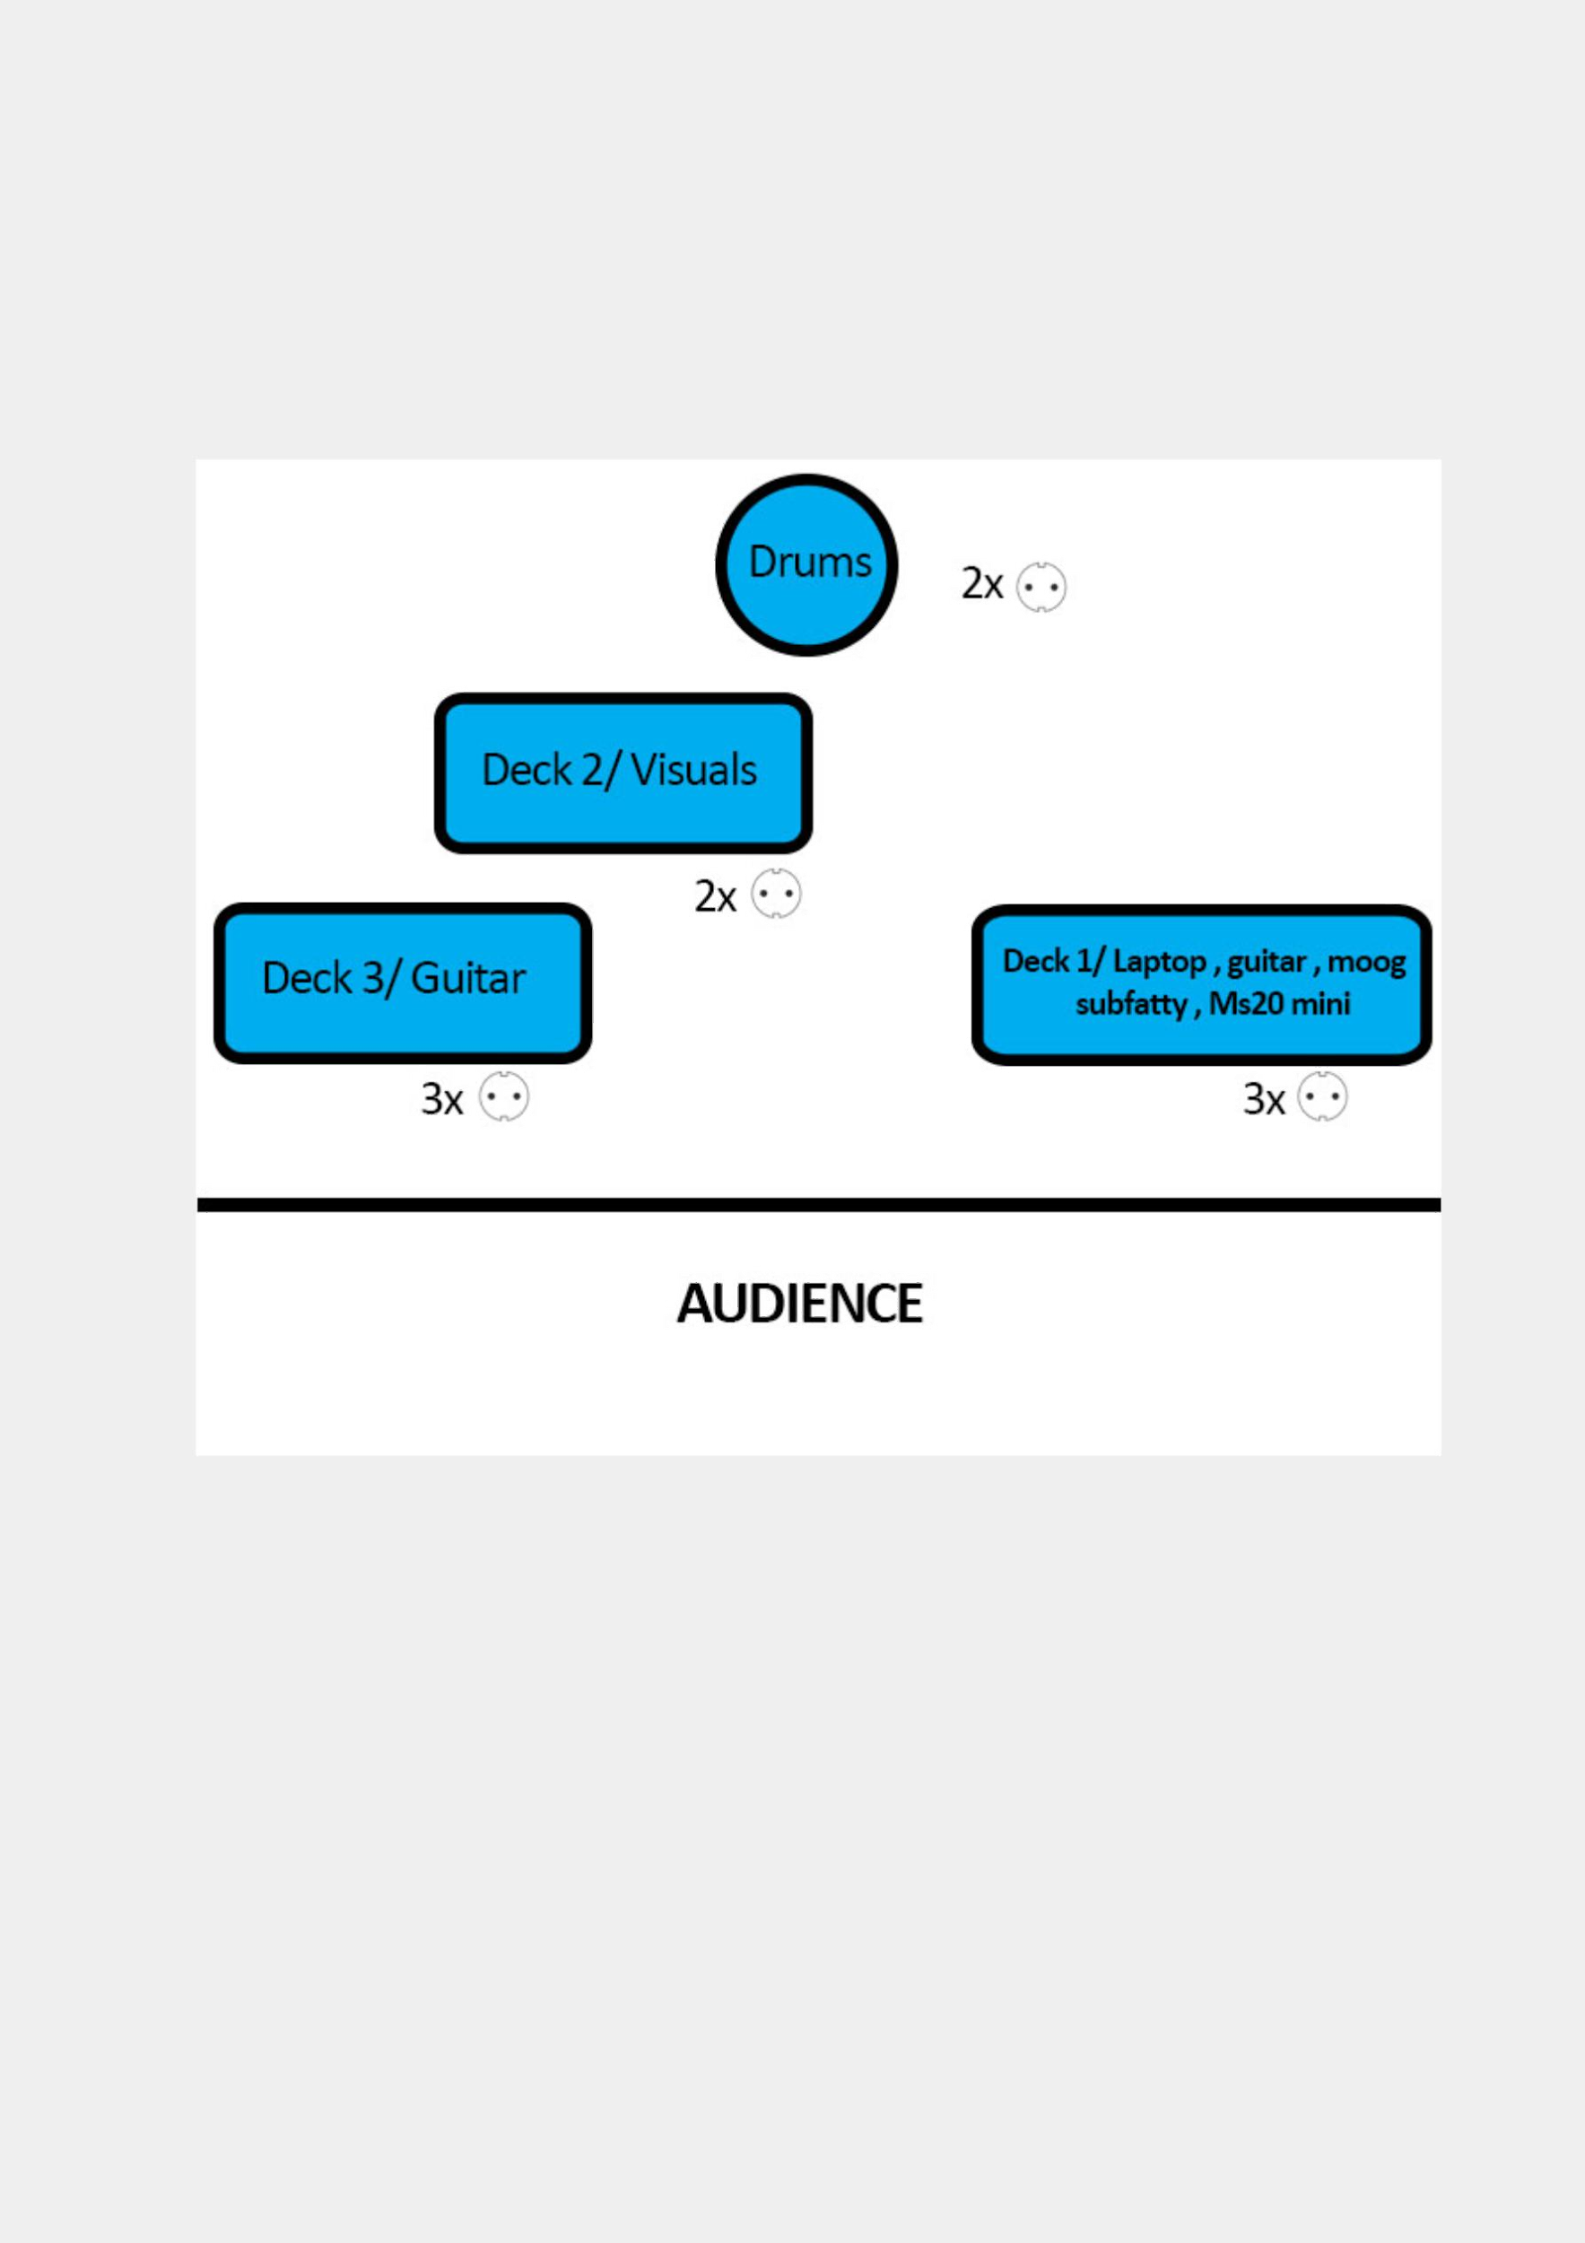
tage plot

