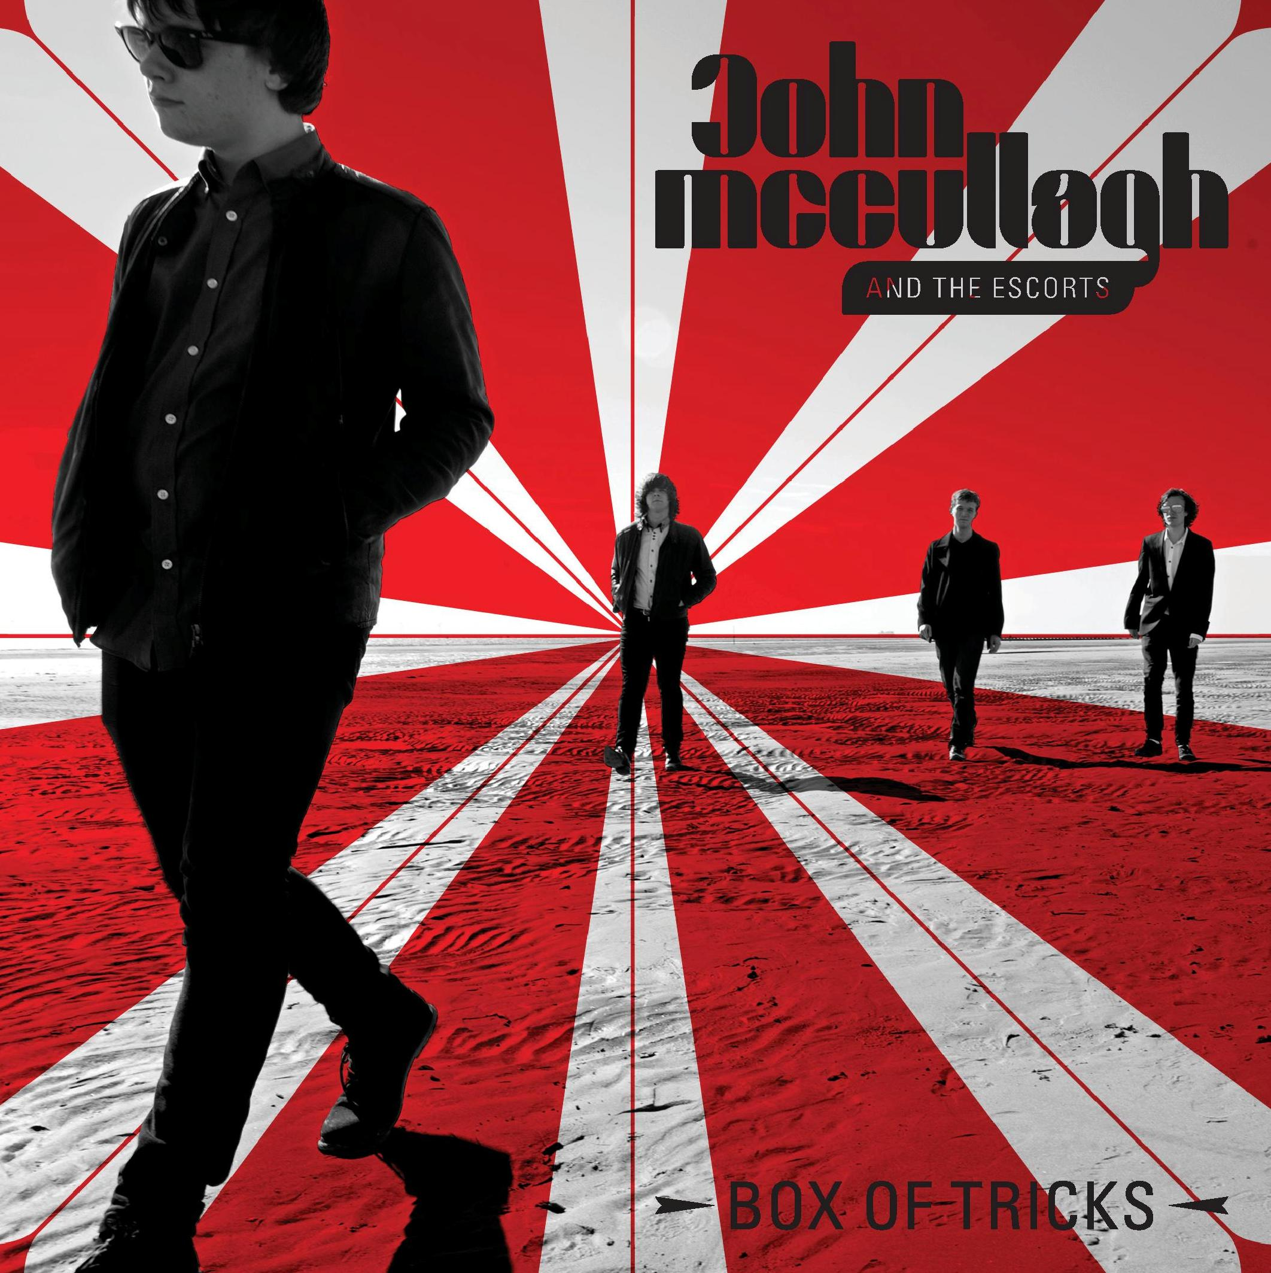
JOHN McCULLAGH
& THE ESCORTS
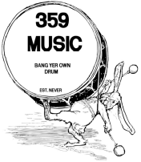
‘Box Of Tricks’
RELEASE DATE: 13th OCTOBER 2014
LABEL: 359 MUSIC
FORMAT: DIGITAL DOWNLOAD and 7” VINYL

NEW SINGLE, NEW TOUR DATES, NEW BAND!

John McCullagh, Doncaster’s highly acclaimed teenage troubadour, is back with a brand new single, having established himself as one of UK’s brightest songwriting talents.

Since his last single in February, ‘Towerland Lullaby’, which saw him work with Alabama 3, John has played across the UK and abroad, as well as working on material for his forthcoming second album Newborn Cry. The sessions have seen him working with Liverpool legend John Power (The La’s, Cast), who has collaborated on some of John’s new songs as well as producing the recordings.

Like his inspiration Bob Dylan, John has also recruited musicians for new backing band The Escorts – so named because of the insalubrious nature of the business above their recording studio in Liverpool! Alongside John are Matt Breen (lead guitar), Chris Jones (bass) and Nick Miniski (drums).

Boasting a much fuller sound than before, with some catchy Byrds-ish guitars, John’s new single ‘Box Of Tricks’ is released as a download on 13th October 2014 and as a 7” edition on 20th October. The vinyl version boasts an exclusive B-side, a version of Richie Havens’ classic ‘We Belong Together’, recorded late last year in Belgium.

Influenced by the likes of Donovan, Marc Bolan, Paul Weller and Johnny Cash, McCullagh has been playing guitar and writing songs since he was twelve, and his latent talent for his beloved six-string was soon followed by mastery of the harmonica. When McCullagh was just fifteen years old, he became one of the first signings to music industry legend Alan McGee’s label, 359 Music.

His debut album, North South Divide, was produced in a day and released in October 2013 to widespread critical acclaim. McGee said of his new protégé, “John is an amazing talent for such a young kid. To be honest, he’s just a natural.”

In addition, McCullagh has spent the past year or so making his mark on the UK’s live circuit, opening for artists such as The Strypes, Richard Hawley, The Enemy, Babyshambles, John Power, Alabama 3, Paul Heaton and Reverend & The Makers. His raw ability belies his age, leaving audiences captivated by the profound maturity in his performances. Richard Hawley said, “John is a real talent, I'd happily take him on tour with me in the future. The real deal.", while The Strypes’ lead guitarist Josh McClorey said of McCullagh, “Really fantastic to see somebody playing primal music with such energy and enthusiasm - watch this space!"

John heads out on tour in late October before embarking on a prestigious support slot with Cast in December. His second album, Newborn Cry, is due for release in early 2015.

https://www.facebook.com/JohnMcCullaghOfficial
http://soundcloud.com/john-mccullagh https://twitter.com/JohnMccullagh_

For further information, please contact Matt Ingham:
Tel: + 44 (0)20 7996 3120 or E-Mail: matti@cherryred.co.uk

