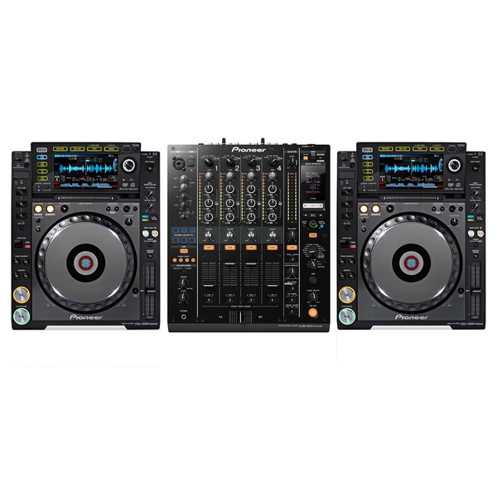

Line1 Line2 Line3 Line4

1x High Quality Mixer Pioneer DJM 900 NXS

(DJM850,DJM900)

4x Pinoneer CDJ 2000 NXS with LANcabel

(min. 2 CDJ2000 NXS)

2 x monitors placed to the left and right of the DJ booth

**Technical rider**