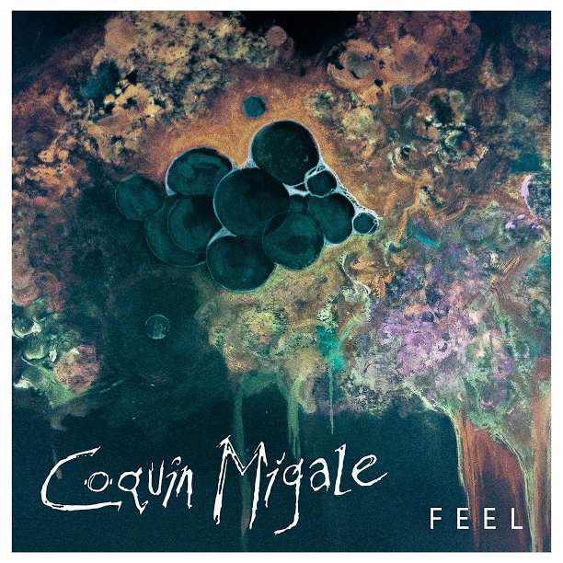**FOR IMMEDIATE RELEASE**

11th December 2014

*Contact:*

Matthew Wooton (07800647914)

Alex Soper (07854729894)

11 Mildmay Road,

West Jesmond,

Newcastle,

NE2 3DU

[CoquinMigale@gmail.com](mailto:CoquinMigale@gmail.com)

**COQUIN MIGALE TO RELEASE SECOND EP, “F E E L”.**

After releasing the lead track from their upcoming EP on their soundcloud, Coquin Migale have announced that “F E E L” will be released on 11th December 2014, available for pre order now on iTunes.

A headline launch party has also been announced for the 10th December 2014, at The Head of Steam, with Charlie Dancer, Spitfire Hostels and Back Into The Wild. Entry is £4 a ticket but valid proof of pre order will get you in for free.

The EP was recorded at Blank Studios, Newcastle-Upon-Tyne across summer 2014.

**MEMBERS:** Alex Soper (Vocals & Guitar), Matthew Wooton (Guitar), Stevie Kane (Bass), Dan Rawlinson (Drums)

Please contact us if you would like to be added to our free entry media guestlist for our launch night or for any additional information you may require.

**Social Media Links:**

Facebook.com/CoquinMigale Twitter.com/CoquinMigale soundcloud.com/CoquinMigale

**END**