TECHNICAL & HOSPITALITY RIDER 2021

MANAGEMENT
ELİF KOCASERT
+90 (543) 142 83 32
elif@kalben.net

PRODUCTION:
EMRE ERGÜN
+90 (546) 855 37 71
emre.ergun1@gmail.com

SOUND ENGİNEER
Suat Hurşutağaoğlu
+90 (532) 283 46 44
suat@svaaudio.com

ADDITION – 1 TECHNICAL CONTRACT:
IMPORTANT: This Rider that follows is an integral part of the contract. The items below are not a “wish list”. They are not optional. The items below are essential in guaranteeing the success of what you will find out to be a mind-blowing show.
Please sign and return to KALBEN’s MANAGEMENT. Any modifications must be pre-approved at least two weeks before first Show/ Rehearsal by the Production Manager. Thank you.

PLANS AND MAPS:
A full set of seating plans and scale floor & roof/rigging plans must be sent to MANAGEMENT as soon as possible. A map of the area surrounding the venue, showing access routes into the venue, must also be made available to the Production Manager.

GENERAL DESCRIPTION:
The KALBEN show is designed to be performed as an “End of Arena” show. The Production needs following components.
- Stage
- PA and Monitor System
- Lighting System
- Backline Equipments
- Trussing
- Local Tonmaister

FRONT OF HOUSE:
- A high quality 4-Way actively crossed-over stereo speaker system with a frequency response 20Hz-20kHz capableof delivering a clean, undistorted 120db SPL at the FOH mixing position, with plenty of headroom to spare.
SPEAKERS:
House Installed P.A.
8x PA Line Array
4x PA Subb
CONSOLE: House used Sound Console such as; Yamaha CL5, Midas M32, Behringer X32 etc.

MONITOR:
- 6x 12 inch Wedge monitor
- All the wedge monitors must be same model and same inch.
- 2x Sennheiser ew500 IEM G3 Wireless In Ear System
(Transmitter, Receiver and inear)
- 2x 1 A5000-circular polarized Antenna + AC3200-II active combiner
Preferences:
- L’acoustic: 112P, 115XT HiQ, Meyer: MJF-212, d&b: M4, M6 etc.

STAGE PLAN:
---

INPUT & OUTPUT LIST:
No: | INPUT LIST | TYPE | STAND
1 | Tuğrul Acoustic Guitar | DI Box (Klark Teknik DN-100 or BSS Audio AR-133) | No
2 | Kalben Acoustic Guitar | DI Box (Klark Teknik DN-100 or BSS Audio AR-133) | No
3 | Kalben Electro Guitar | Shure SM57 – Sennheiser e906 | No
4 | Kalben Main Mic | Telefunken M80 (WE BRING IT.) | Long
5 | Kalben Spare | Shure Beta 58A | No
6 | Tuğrul Vox | Shure Beta 58A | Long
No: | OUTPUT LIST | TYPE | MODE
1 | Guitar Left | Sennheiser G3 ew500 | Stereo
2 | Guitar Right | Sennheiser G3 ew500 | Stereo
3 | Kalben Left | Sennheiser G3 ew500 | Stereo
4 | Kalben Right | Sennheiser G3 ew500 | Stereo
5 | AC Guitar | 2x12" inch Wedge Monitor | Mono
6 | Kalben Front | 4x12" inch Wedge Monitor | Mono
7 | Side Left | 2x12+Subb | Stereo
8 | Side Right | 2x12+Subb | Stereo
14 | PA Subb | House Installed | Mono
15 | PA Left | House Installed | Stereo
16 | Pa Right | House Installed | Stereo

BACKLINES:

Guitar:
1x Fender Hot Rod Deville or Deluxe or Twin Reverb
3x Guitar Stand

LİGHT:

Safety rope for all light fixtures.

The light fixtures must be original, and not defective / bulb hour old.

Truss had to be fixed to the ground with steel ropes and all safety and security practices had to be done.

LİGHT BOARD GrandMA2 Light / Full Size / onPC Command & Fader Wing

FİXTURE LİST

MAC Aura Design Mode 14 TRUSS

MAC Viper Performance 9 TRUSS

MAC Viper Performance 5 FLOOR

ETC S4 25-50 ZOOM (LED or Lee 201 Filter) 4 TRUSS

HAZER 2 FLOOR

Find the light plot attached

TECHNİCİAN : Need 1 technician for focus the fixtures at truss after all setup.

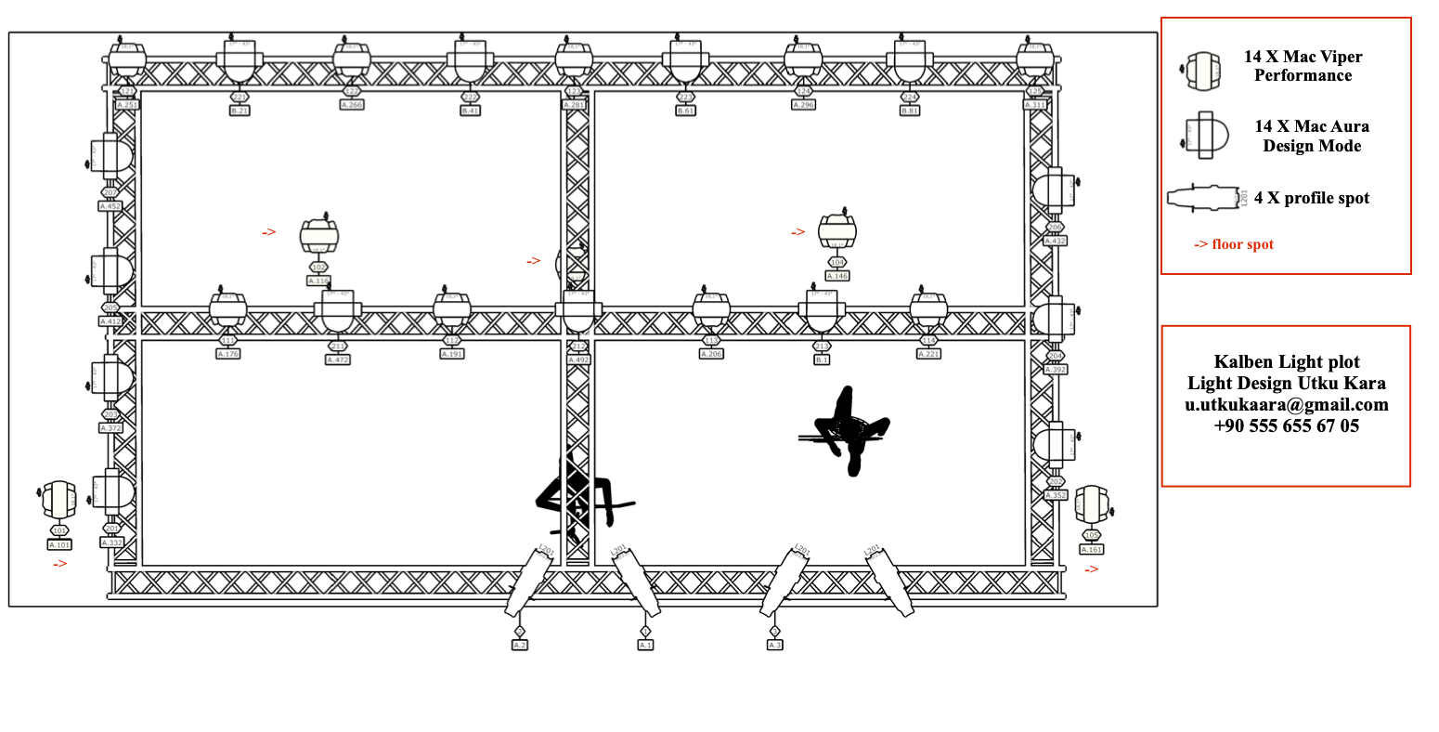
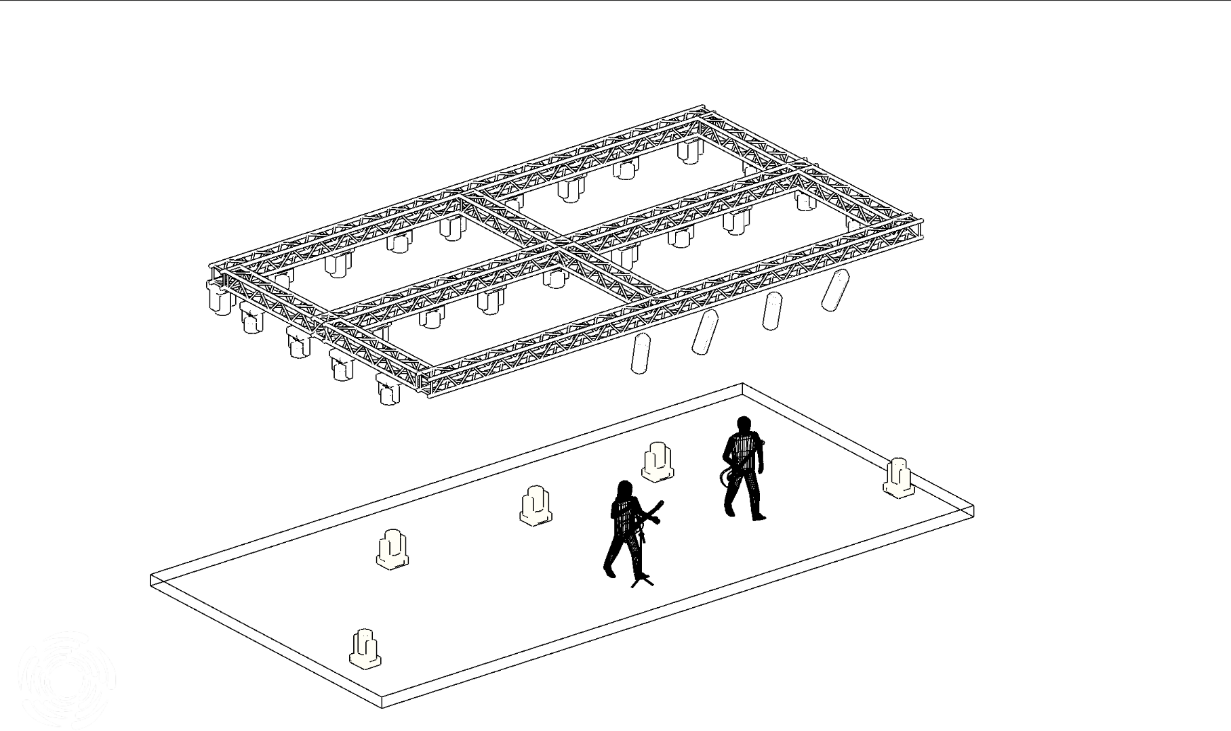

ADDITION – 2 HOSPITALITY CONTRACT:
IMPORTANT: This Rider that follows is an integral part of the contract. The items below are not a “wish list”. They are not optional. The items below are essential in guaranteeing the success of what you will find out to be a mind-blowing show.
Please sign and return to KALBEN’s MANAGEMENT. Any modifications must be pre-approved at least two weeks before first Show/ Rehearsal by the Tour Manager. Thank you.

FOOD AND BEVERAGES REQUIREMNTS:

- 3x Meat&Chicken Sandwiches
- 3x Vegaterian Sandwiches
- 10x Water
- 5x Cold Beverages (Cola, Spirit)
- Fresh Fruit Juice
- Various Herbal Teas
- Appetizers
- Raw Appetizers

