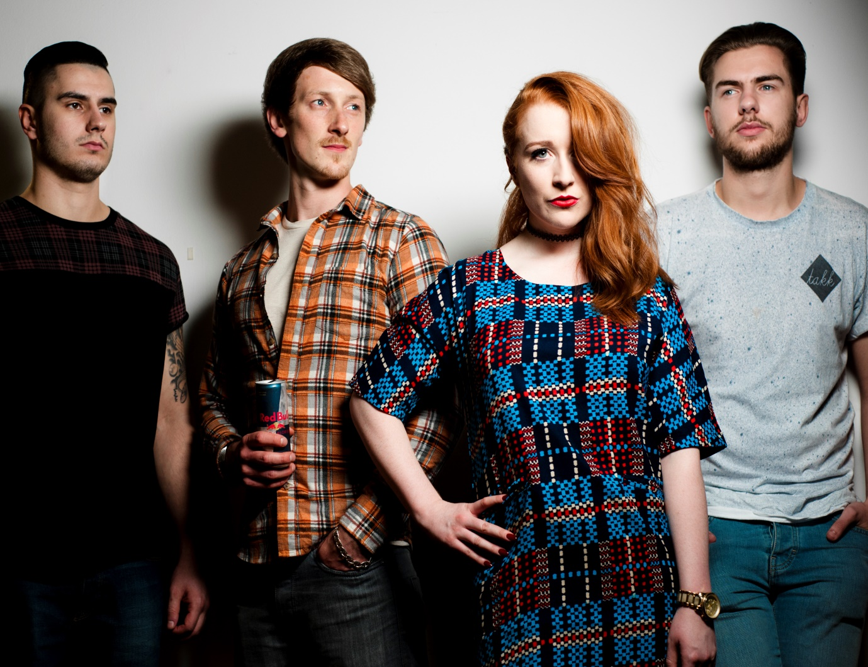

Life on Standby
Alternative Electronic Rock
PRESS PACK

Life on Standby
Press Pack

About Life on Standby ………………2
Biography of Life on Standby……….2
Live Shows & Tours ……………………3
Reviews………………………………….4
Links………………………………………5
Contact…………………………………5

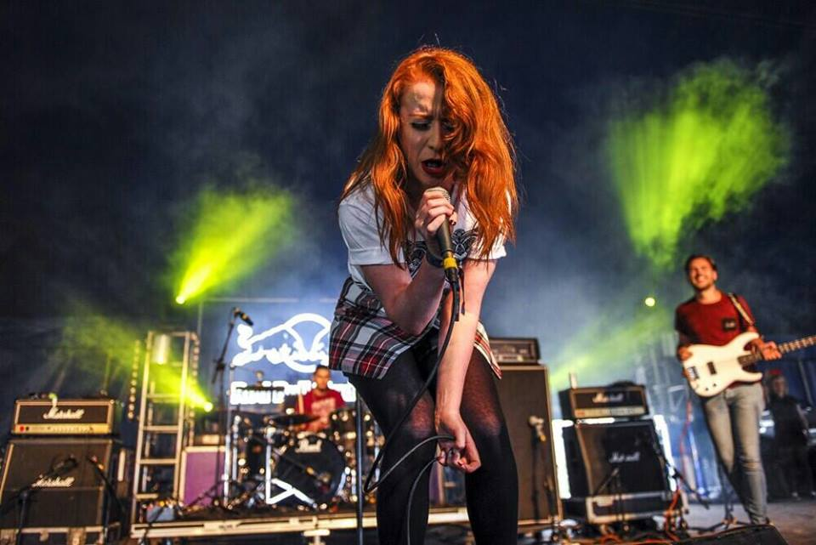

About Life on Standby?
Erin Donnachie: Erin’s interest in Music started at a young age learning piano and later singing in choirs and jazz bands. It was when she was approached by Gianluca and Gavin to join their band that she adapted to becoming a strong rock vocalist.

Gavin Williams: Gavin picked up a guitar at 17 years old after idolizing legends such as Slash and Black Sabbath since he was quite young and formed a band with his best friend Gianluca before forming Life on Standby.
Gianluca Demelas: Gianluca asked for a drum kit for his Christmas after seeing a friend learn drums and dreamt of being like John Bonham. Through school Gianluca jammed with Gavin and the two soon formed a band which became Life on Standby.

Liam Walker: Liam (originally a guitarist) has an interest in blues and John Mayer. Liam joined Life on Standby as the band’s bassist while he was still in school.

Biography of Life on Standby:
Life on Standby formed in 2011 within the heart of Greenock (outside Glasgow), Scotland. Since their formation the Electro Alternative Rock outfit have released two EPs ‘Set the Sail’ and ‘Masquerade’, as well as releasing their first album on Wednesday 10th March 2015. Since the release of ‘Masquerade’ in particular, the band have found they playing some of the most prestigious venues/festivals in Scotland and England. Life on Standby were also invited down to Red Bull Studios London to record a live track and video for their track ‘Eagles’ in May 2014 which this journey led to them embarking on their first UK in October 2014.
Live Shows and Tours:

Past Venues: (2011-2012)
Garage Attic (Glasgow, Scotland)
Garage G2 (Glasgow, Scotland)
Word Up (Greenock, Scotland)
Tonara Fest (Tonara, Italy)
Bar Bloc (Glasgow, Scotland)
O2 ABC (Glasgow, Scotland)
Recent Venues: (2013-2014)
O2 Academy (Main Stage – Glasgow, Scotland)
King Tuts Wah Wah Hut x 2 (Glasgow, Scotland)
Gig on the Green (Greenock, Scotland)
Oran Mor – Sold out Headline show (Glasgow, Scotland)
PJ Malloy’s (Dunfermline, Scotland)
Download Festival 2014 (Donnington, England)
Recent UK Tour: (Oct 2014)
Green Room (Perth, Scotland)
Eagle (Inverness, Scotland)
Nice N Sleazy (Glasgow, Scotland)
Lomax (Liverpool, England)
Lounge 41 (Workington, England)
the Victoria Inn (Derby, England)
Future Live Events: (2015)
Audio – Glasgow, Scotland: Fri 30th January
Lounge 41 – Workington, England: Sat 7th March
The Swan – Stranraer, Scotland: Fri 13th March
The Green Room – Perth: Sat 14th March
Fanny by Gaslight – Kilmarnock: Sun 15th March
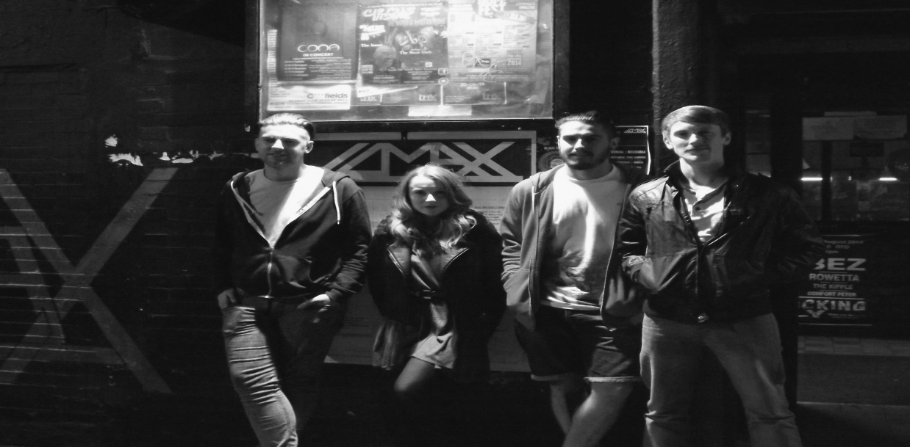

Reviews:
“Incorporating snatches of electronica affords them an eclectic variation on their hard-chugging, contemporary sound, with front woman Erin Donnachie’s spirited performance lending them a streak of punk edge” – Jay Richardson, The Scotsman.

"One of the best unsigned Alternative Electronic bands in Scotland" - Daily Mail.

"Definitely a band to look out for" - Duncan Gray, Triple G Music.

“Life on Standby were the standout act of the night, such a mass of raw energy and emotion” – Underground Uncovered.

“One could perhaps argue that Greenock’s Life on Standby don’t fit the usual mould of a Download Festival band, but don’t be fooled by their electronic leanings. Behind the synths and front woman Erin’s soothing vocals lays a body of eclectic, crunching riffs that will shake off any Sunday hangover.” – Daily Dischord

“SINCE forming in 2011, Life on Standby has emerged as one of Scotland's best unsigned alternative electronic bands.” – Evening Times.

Social Media:

Facebook: www.facebook.com/lifeonstandbyuk
Twitter: https://twitter.com/life_onstandby
Soundcloud: www.soundcloud.com/lifeonstandbyuk
Instagram: http://www.enjoygram.com/lifeonstandbyuk
YouTube: https://www.youtube.com/user/LifeonStandbymusic1/videos

Contact:
Artist Manager: Emma Rose Mackenzie
Email: emmamackenziemusic@hotmail.co.uk
Contact Number (anytime): 07969836188
Postal Address: 5 Caravelle Way
Renfrew
Renfrewshire
Scotland
PA4 0NR

