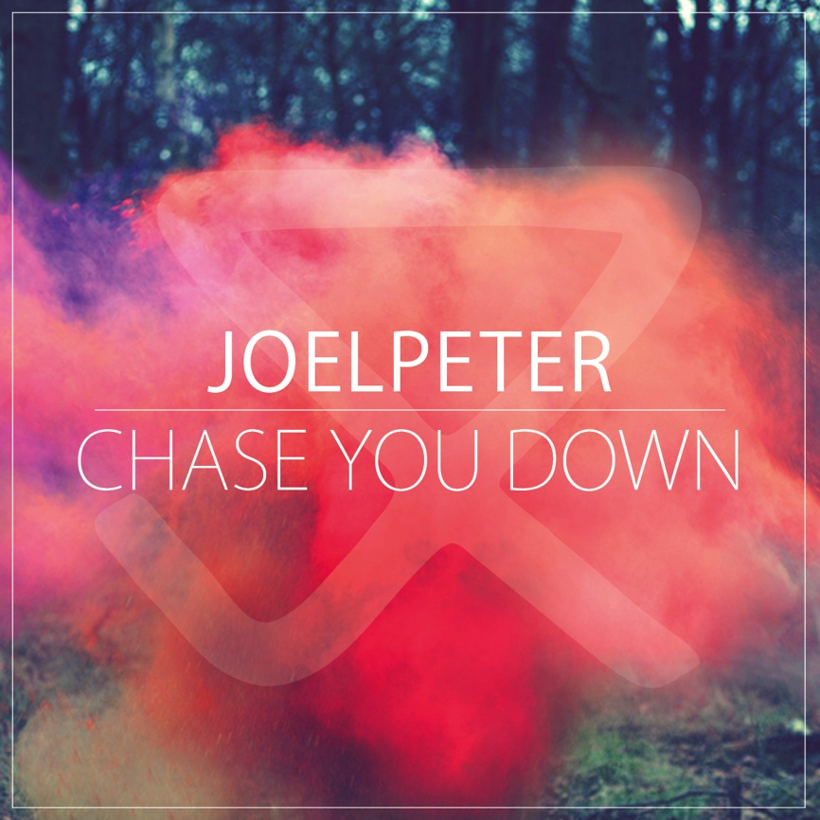
Artist: JOEL PETER
Title: ‘Chase You Down’ Single Release
Release Date: 8th December 2014
SoundCloud:
Video:

"Taking cues from the indie pop of Bombay Bicycle Club and Everything Everything, infectious hooks are given extra push with layered vocals and harmonies of a summery hue.” - Q Magazine

JOEL PETER are a five-piece indie guitar-pop band from the surrounding areas of Worthing. The band consists of Joel (Vocals/Guitars), Warren (Guitars), Luc (Bass), John (Drums) and Jack (Keys), who have been gigging together, but not always in the same bands, since their early teens. They release their upbeat new single ‘Chase You Down’ on 8th December 2014. The track will also be available as a free download through SoundCloud until 24th November 2014.

Teased as a teen about his voice, Joel boasts a vocal range reminiscent of James Vincent McMorrow, James Blake and Justin Vernon. A naturally melodic writer at heart, he pens commercially appealing songs and has done from a very early age. Joel was in a previous band with Ben Thatcher (drummer of Royal Blood) before setting up Joel Peter.

The band blend sun bleached guitars, big vocals and pulse-like rhythms, under the narrative of folk songwriting, to create songs that make you feel good and put a smile on your face. With older artists, such as Paul Simon and The Cure, then newer ones, such as Interpol, Foals and Bombay Bicycle Club, all listed as influences, it's no surprise that Joel Peter sound as they do.
Last year Joel Peter received recognition from BBC6 presenter Tom Robinson as a “true pop songwriter” when debut single ‘Wrap My Ankles’ was featured as one of his singles of the week. New single ‘Chase You Down’ has also recently had the backing of the renowned radio DJ.

With a string of packed out festival performances behind them, their current EP ‘Play The Colour’ under their belt and supportive tweets from two of music's newest children, Josh Record and Lucy Rose, the five-piece look set for big things in 2015.

For a chance to see their energetic and uplifting live show join Joel Peter at the Sebright Arms in London on 13th December 2014.

FOR MORE INFORMATION ON ALL THINGS JOEL PETER PLEASE VISIT:
www.joelpeter.tumblr.com
https://soundcloud.com/joelpetermusic/
https://www.facebook.com/joelpetermusic
Twitter: @joelpetermusic
www.youtube.com/joelpetermusic

