ARTIST: This Burning Age TITLE: EP2: Devotion
RELEASED: 28 July 2014 LABEL: 5th Day Records
WEBSITE: www.facebook.com/thisburningage FORMAT: CD / Digital
FOR FANS OF: NIN, Interpol, Rammstein, Sonic Youth, Smashing Pumpkins GENRE: Alt-Electro-Rock

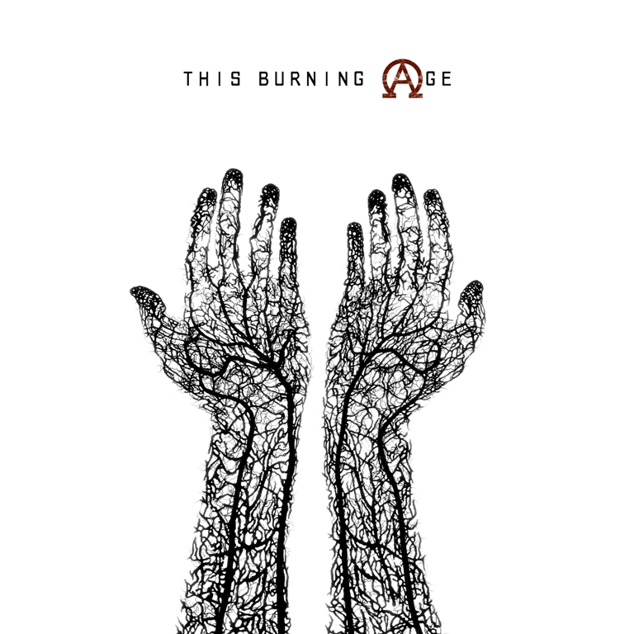
Track listing:
1) There Is No Hope Except For That Which You Give Me
2) Hollow
3) Nothing

THIS BURNING AGE ARE:
Friday – Vocals // Guitar // Synths // Arrangements
Jon Farrington-Smith – Guitar
Dave Bennett – Bass Guitar
Christian Jerromes – Drums

“Definitely are a band to look out for” – Mutiny Press
“Nine Inch Nails meets The Smashing Pumpkins and Sonic Youth” – Mind Equals Blown

“We have something remarkable on our hands” – This Is Not A Scene
“Hits you like a tonne of bricks” – Soundscape Magazine

Alt-electro rockers This Burning Age are proud to present Devotion, the second release in their four-EP concept cycle charting the course of the next twelve months, due for release July 28th.
Following on from the concept of EP1: Supplication, Devotion is a three-track meditation and homage to broken and twisted love, from eulogies to hope and redemption from despair and disconnection, to mutually destructive passion. Inspired equally by art-rock throughout the ages and the poetry of lyric writing, Devotion is a worthy successor to the widely-acclaimed initial EP.
From the relentless aggression of album opener ‘There Is No Hope Except For That Which You Give Me’ to the infectious spaciousness of lead track ‘Hollow’ and finishing on a high with the grittily industrial ‘Nothing’, Devotion is a rollercoaster of a ride.
With the exception of production, the entirety of the four-EP project is set to be completed in-house, from artwork to distribution to managing the record label, the band's own. Keep those eyes peeled for the band’s upcoming music video for ‘Hollow’ also.
Any further questions? Hit me up at matt@holdtightpr.com.

