BIANCA CIOCCA

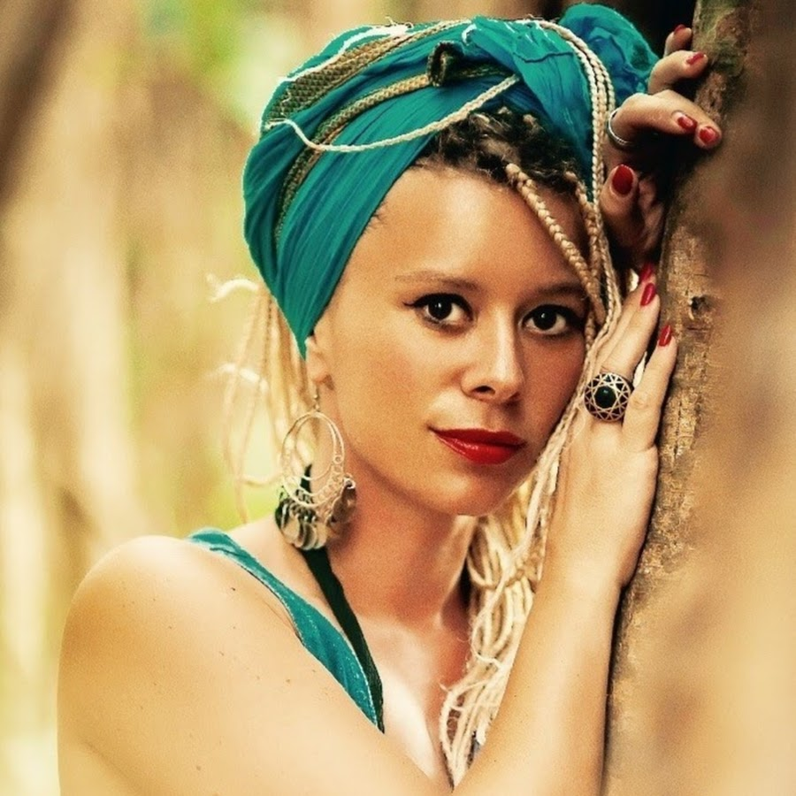

SOUND

P.A. Recommended equipment

• ADAMSON Y 18 + T- 21 SUB, SPEKTRIX + SPEKTRIX SUB
• NEXO GEO T + SUB CD18
• L’ ACOUSTIC: V-DOSC + SUBS SB 218, KUDO + SUB SB-18
• MEYER SOUND: M3D + M3D SUB, MICA + SUB 700 HP, MILO + SUB 700 HP
• ELECTRO VOICE: XLC 127 + SUB XLC 118

The amount of speakers will be related to the size of the show, it is recommended that it is hanged or well distributed according to the venue or festival, keeping in mind the coverage both vertically and horizontally F.O.H. mixing console: The foh mixing console must be in front of the stage forming a triangle according to the P:A sound system position, no more than 25 meters and with good visibility of the stage. Only digital consoles.

Accepted mixing consoles
• YAMAHA M7-CL
• YAMAHA PM-5 D
• DIGICO 01, 05 , SD-8
• SOUNDCRAFT VI-4 , VI-6
• DIGIDESIGN VENUE- D SHOW, SC 48.

Accepted Monitor mixing console:
• YAMAHA M7-CL
• YAMAHA LS-9

Monitors:
• (06) wedge 600 watts, Bi-amp. All should be same brand. Adamson, Electrovoice, Nexo, Meyer.
• (01) DRUM FILL for drummer.
• (01) Stereo side-fill with bass on each side. Line-Array Baby. KIVA, SPECTRIX, MELODIE, NEXO GEO-S.
NOTE: For the artist to be able to do a soundcheck and monitor check there must be no feed back on all mixes.

BACKLINE

The following equipment must be in perfect working condition.

DJ
• (01) Professional DJ Black Table. Example: Odyssey CTBC2048 Dj Table
• (01) Professional DJ Mixer. Example: Pioneer DJM 750 or Pioneer DJM 2000 Nexus
• (01) DJ Speaker Monitor with stand.

BASS PLAYER
• (01) Ampeg Classic, SVT 4 Pro Amp or SWR Megoliath 8x10 Bass Cabinet
• (01) Mono Direct Box
• (02) 1/4-inch jack to 1/4-inch jack speaker cables, 10 Meters inch.
• (01) Professional Bass stand

DRUMMER*

• (01) Complete Fusion Drum kit with new Remo Drumheads.

Preferably: DW Drums or Yamaha Drums
This drums must include:
Professional Yamaha or Pearl Drum Hardware
Professional Paiste Cymbals (if not, Zildjian)
• (01) 22" Ride.
• (01) 13” Hi hats
• (01) 18" Crash
• (01) 18” Efx Crash.
• (01) 12" China
Professional Accessories
• (01) Professional Music Stand Bookplate
• (01) Stereo Direct Box
• (06) 1/4-inch jack to 1/4 inch jack speaker cables, 10 Meters inch.
• (01) Drum Professional Rug.
• (01) Floor Fan

VOCALS

• (02) Sennheiser E945 Microphones.

*The drum stage must be: minimum size 8.2 ft by 9.8 ft. And 1.9 ft high.

HOSPITALITY

BACKSTAGE – DRESSING ROOM:
Provide the following items to be placed in Artist’s dressing room at load in.
• Five (5) Meals.
• Two (2) cases of non-carbonated mineral water (Evian or equivalent). Not Cold.
• Two (2) cases of quality beer (no Bud, Miller, or Rolling Rock)
• One (1) Bottle of Local Alcohol
• One (1) Bottle of Gin, Vodka or Whiskey of Superior Quality
• Four (4) Redbull or similar. Cold.
• One (1) fruit and vegetable tray with assorted raw vegetables, fruit, whole wheat breads, cheese, etc.
• A sufficient assortment of crackers, nuts, cookies, and other snacks
• A sufficient assortment of condiments, cups, ice, utensils, etc.

IN STAGE
- (8) Bottles of Mineral Water. No gas, no cold. For, example: Evian. 2 for each member.
- (5) Clean Towels. 1 for each member.

LIGHTS
12 CLAYPAKY SHARPY
12 MARTIN STAGEBAR
36 CHAUVET PAR LEDS 10 V
6 MARTIN ATOMIC
4 GENERIC BLINDER
1 CONSOLHOG3 or 4, GRANDMA1 or 2
1 SMOKE MACHINE

If the show will have screens or video visuals, let us know in advance.

INPUT LIST

CHANNEL | INSTRUMENT | MICROPHONE | BASE
1 | Kick In | Beta 52A | Mini Boom
2 | Kick Out | E602 | Mini Boom
3 | Snare 1 Top | SM57 | Boom
4 | Snare 1 Bottom | SM57 | Clamp
5 | Hi hat | SM81 | Boom
6 | Tom 1 | E608 | Clamp
7 | Tom 2 | E608 | Clamp
8 | Floor Tom | E608 | Clamp
9 | OH L | SM81 | Boom
10 | OH R | SM81 | Boom
11 | Bass | Amp.
12 | 2nd Vocals | Sennheiser E945 | Boom
13 | Main Vocal | Sennheiser E945 | Boom
14 | Main Vocal (2nd mic) | Sennheiser E945 | Boom

STAGE PLOT
