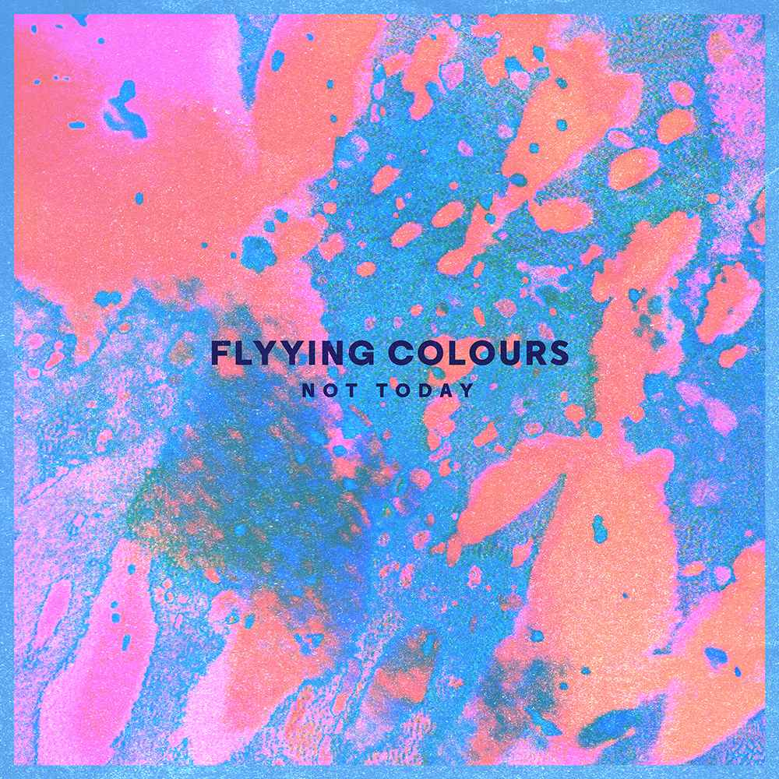
“Chances are this tune from Flyying Colours is going to make a fan out of you! Presumptuous sure, but these guys are belting out a noise that instantly pricks peoples ears up” – Sounds Better With Reverb

“Melbourne has a solid lineup of bands with an ear to early 90s shoegaze, and in an increasingly crowded sub-genre Flyying Colours differentiate themselves with an important feature- they know exactly what they’re doing.” – Tonedeaf
----------------------------------------------------------------------------------------------------------------
The Last year has been a cracker for Flyying Colours. The Australian release of their debut EP through Universal Distribution was an excellent start, as was the amount of radio play and street press attention it received.
But it was the international blogosphere that really got behind them, posting their psychedelic filmclips on sites the world over. It didn’t take long for the international music industry to come knocking and 5 months later in March this year the EP was released in UK/Europe through Club ac30 and USA through Shelflife, being played regularly on BBC, Amazing radio and XFM
“Not Today” is another cracker of a single to follow up from the much loved “Wavy Gravy”. Guitars swirl behind rhythm section brothers Josh and Sam’s most incessant beat yet, topped off with trading boy/girl vocals, with even a hint of a chorus.
The guys have some select single launch shows in July before preparing for their first UK Europe tour in the not too distant future.
“Not Today”: Available from Fri 27th June. Tour Dates Below. Tix via Oztix.com.au
----------------------------------------------------------------------------------------------------------------
“a pitch-perfect rendition of all of the songs from their newest EP with a couple of extras, displaying a passion and energy even more intense than their recorded tracks provide. Far from being a static, shoegazing performance, the lead singer’s onstage antics and the band’s obvious affection for one another made them a joy to watch on stage” – 4ZZZ

Flyying Colours: “Not Today” Launch Tour
Thur July 10th The Capital Saloon Bar, Wagga Wagga
Fri July 11th Transit Bar, Canberra - FREE ENTRY -
Thur July 17th Oxford Arts Factory Gallery, Sydney
Sat July 19th Cambridge Hotel, Side Bar, Newcastle
Thur July 24th Golden Vine Hotel, Bendigo
Fri July 25th Shebeen Bandroom, Melbourne
Sun July 27th Beavs Bar, Geelong
Fri Aug 1st Grace Emily, Adelaide
Sat Aug 2nd Worldsend Hotel, Adelaide

Contact: Marty Brown: marty@storybaker.com 0437 410 649
www.flyyingcolours.com www.facebook.com/flyyingcolours

