MANTECA PRESS QUOTES
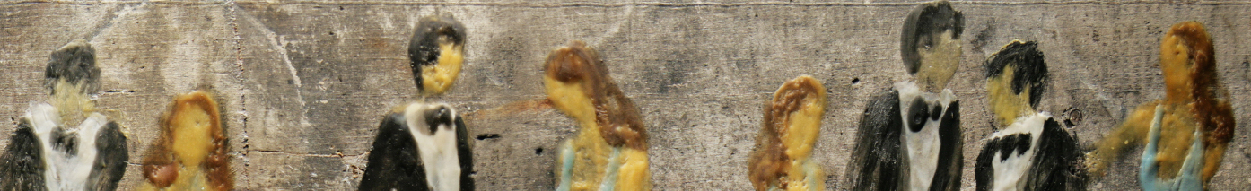

“Gut grabbing…trendsetting innovation.”

PETER GODDARD | TORONTO STAR 9/18/13

“Manteca has comfortably been Canada’s calling card for wicked instrumental vibes. They are everything that one should want jazz to be. Collaborative, energized, moving forward…”

JAZZ FM | 2014

“intriguing melody-driven textures…humour, precision and high energy,in a blaze of lights - Manteca is back without missing a beat…
ASHANTE INFANTRY-TORONTO STAR

“Groundbreaking and fresh”
NOW MAGAZINE

Zimbel is an exuberant showman, humorous raconteur, enthusiastic band- leader, superb percussionist, and mentor to fellow musicians. His leadership in the band is egalitarian, at least on stage-but when you have the kind of exceptionalism Manteca's five-piece rhythm section and four-piece horn line display, one can afford to be democratic.

FYI MUSIC | DAVID FARRELL

Joyeusement festif, tendrement langoureux, comme une brise printanière qui serait la promesse d’un été torride.
STANLEY PÉAN - VOIR

...son meilleur album...superbe palette coloris , un amour de ”harmonie et du rythme avec des arrangement de cuivres superbes...
RALPH BONCY – ACTUALITIE

“Manteca is a friendly, sensuously-attractive place to visit – a musical utopia…it is evocative, even ethereal and yet it can also have great physical presence, it is wildly spirited and yet remarkably controlled. Everything is in balance, Utopian indeed.”
GLOBE AND MAIL - MARK MILLER

“Surging with sassy charts, tumultuous solos and polished ensembles,
Manteca cuts a handsome figure as it struts with a world beat grounded in the best attributes of the big band tradition. Bold, imaginative, and bubbling with joie de vivre, Manteca is a classy outfit worthy of attention”.
JAZZ TIMES MAGAZINE US / CHUCK BERG

