Tomas Sauter „Double Life“
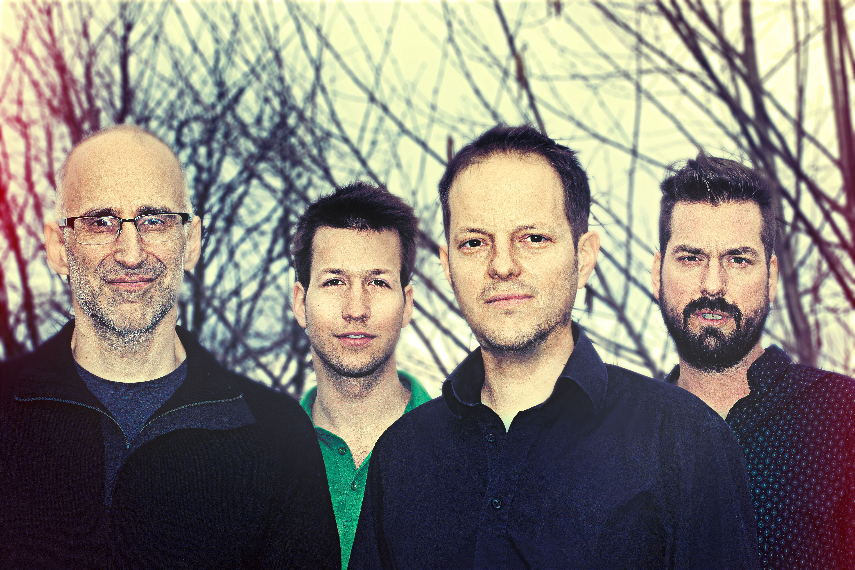
Ralph Alessi –trp
Luzius Schuler –rhodes
Tomas Sauter -b
Dominik Burkhalter –dr

"I enjoyed the process of coming together for the 1st time and finding our way through the music. The music we made exemplifies what I like about music in that it falls in the cracks: equal parts groove music, jazz with elements of free improvisation.” Ralph Alessi

Groove Reloaded
You only live twice … Half a century ago this used to be the slogan with which movie trailers were advertising the eponymous James Bond classic. At the same time Joe Zawinul joined up, on Fender Rhodes, with the band of Miles Davis who was about to start his second or third life as a trend setting artist playing his trumpet through effect devices. The electric bass was recently established in jazz music and the era of fusion music was launched. One could say that all this is ancient history but some might argue that it should nonetheless not be forgotten about. Because despite the vast mass of jazz productions in present time jazz only few artists are able to emerge from the shadows of jazz icons. And only a very small circle of artists is capable of catching people’s attention through authenticity and musical personality, in the echo of the great traditions.

Without any doubt Tomas Sauter belongs to this illustrious circle of artists. A gifted composer, interpreter and guitarist who attracted the attention of the audience with stunning records over the past years and who created a remarkable body of work.
The silent worker is a guarantor for great music and sets a distinctive counterpoint in the gimmicky jazz business. And all of a sudden he breaks in on bass with a profound double life!

… and twice is the only way to live! Maybe the more significant afterthought of the old Bond slogan reveals the secret of true artistry: To be able to choose what one wants to do because one has the skills and the potential to allow full bent to one’s penchants and to put the sheer enjoyment of creativity above career management.
Sauter turns his amazing multiplicity into musicality of rare ease and he changes instrument like a chameleon changes color. He is a musician to his very fingertips driven by his passion to play music.

Licence to play … Bass is quite a world apart from guitar. Sauter’s odyssey into unknown territory could have easily become an aimless journey with a bad ending, if he were not a true musician who is able to find the right place and a pertinent part in every musical context. Despite his skills as a virtuoso guitar player Sauter immerses himself in the role of the bass player in his new quartet, supporting the music and at no time pushing himself to the fore. At the bottom of things and on the pulse of events Sauter is noticeably comfortable in his new role as a motor of the band and accompanist. Whatever he touches becomes music.

All boss on bass, Sauter composed all the music of his new album and manifests that totally different music emerges when it’s thought from a bass player’s perspective. His tunes flow from the magic of musical modes and distinct three-dimensional bass patterns of which the guitar acts as the model for a source of inspiration. Added to this there’s his smooth touch on the instrument and a velvety, earthy and growling sound which would be good for every full time bassplayer to aim at. Following the footsteps of the likes of Paul Jackson or Darryl Jones Sauter provides a bass foundation on which his band instinctively does everything right to evoke the good spirits of „Bitches Brew“. They, in the best sense of this tradition, create a brilliant music which pulverizes our listening habits. Considering how little there is left from the last five decades from the crossover of rock, pop and jazz music towards a vast pile of badly aged fusion music, such an up to date picking up with the past testifies a profound sense of musicality.

That’s one reason for Ralph Alessi to totally lift off on „Double Life“. Alessi is the trumpet player of the moment and not just since his much appreciated ECM debut as a leader. It means something that he should joins in and plays as a sideman of a European bandleader who is making an album on his secondary instrument. And how he does it is literally dazzling. From his first phrase in „Heat Conversion“ one goes to the floor to be given the count slowly and finally being counted out. In general there must have been a good mood at the recording session for Alessi to be enticed to play a few takes on electric bass, his former original instrument. What came out are some intriguing spontaneous duets with Sauter. And besides that, one learns that his substitute bass sounds as good as number one...

Two unjustly unknown musical personalities round out the astounding quartet: When „Double Life“ was recorded young Luzius Schuler was still in his Master’s program at the arts academy. Nevertheless he deeply impresses the listener by his terrific improvisations, melodic flights above modal grooves and his commanding comping. It’s simply impressive how a newcomer displays so much inspiration and serenity on a studio session alongside a crack like Ralph Alessi.

Dominik Burkhalter established his reputation as being one of the first addresses for crisp beats in countless bands and also in his own projects as a leader. With the heart of Bernard «Pretty» Purdie and the technical skills of Marvin „Smitty“ Smith Burkhalter as usual impresses with his powerful precision, crazy beats and reckless fills. What sometimes sounds like spastic stumbling is revealed as risky drum stunts with careful listening. That’s how he creates delicate crazy drumbeats which only John Travolta at his best guided by Tarantinos puppet strings could put on the dance floor.

Groove reloaded would be the category of style for the album „Double Life“. Like a never ending big stream this music pulsates, fizzes and meanders through emotional worlds. It lets us space out and descend in thoughts to finally vanish in ethereal space. That’s what dance music for the future sounds like. It’s a mixture between over-chilled electronica and heart-melting sing along choruses which would honor the „Bee Gees“. The music is played with a nonchalant jazz attitude, improvised on the spot with open ears for pleasant surprises and with sublime awareness for collective sound.

