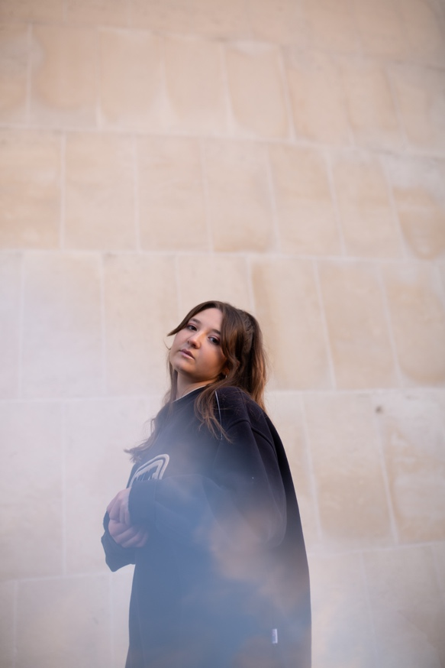

Before she has even released a note of music, Antonia has already made a name for herself as a rapidly developing artist.

Born in Manchester and growing up in Nottingham, Antonia moved to Merseyside to enrol in the Liverpool Institute of Performing Arts, where she found artists with whom she began to experiment and collaborate. “The scene in Nottingham that I was exposed to, was heavily based on singer-songwriters,” she says. “So I would perform with just myself and a guitar. Coming to Liverpool and collaborating with other musicians from different backgrounds has helped me to express myself.”

She started classical singing lessons in school, and developed a love of jazz by the time she reached 16. But her musical obsessions began with the big hairbrush anthems of the day. “Me and my sister used to listen to Lily Allen, Avril Lavigne, Florence + The Machine” she laughs. “Real pop princesses. Then I remember one day asking my parents why they never played us their music. They said they just assumed we wouldn’t like it, but that’s how I discovered ABBA, Fleetwood Mac and The Stranglers”.

Though this seems like a disparate series of influences, they all share one common characteristic; the song is paramount. Whether that comes from the wry humour of Lily Allen, the pop perfection of ABBA or the misanthropic punk of The Stranglers, at their core each of these influences are songwriters who speak to a deeper truth.

The jazz and soul influences came later. Spurred by her grandfather and singing teacher, she delved deeper into jazz and blues, allowing the flair of artists such as Louis Armstrong, Etta James and Aretha Franklin to connect with her own developing vocal style.

For Antonia, it was the freedom of expression and emotion that jazz helped to instil in her. “You go to see a performance of a jazz piece, and it’s completely different from what was recorded. It has the same feel and the same emotions are coming across, but it sounds nothing like the original recording.”

Used to recording bare bones demos, when Antonia began playing live with her band in December 2019, she found they took her music in new directions that she hadn’t previously considered. “It helped me see both what I like about my songs, and what I don’t like,” she admits.

These collaborations informed her subsequent songwriting and helped her to grow artistically; she now knew the sound she was writing for. “Empty Conversations is the most recent song I have written, and it’s the first time I have been set on how I want it to sound. I want it to sound very chill, honest with a main focus on lyrics.”

“When you’re writing on your own, you can hear it back and really hate it. But when you’re writing with somebody else and it’s just two people vibing and bouncing ideas off each other, then you know what’s good.”

In a sense, the naturally humble Antonia readily admits that she is still on a journey of discovery with her own music. But, it is one that continues to offer up fresh, exciting avenues.

Social media links:
https://www.instagram.com/heyitstonez/
https://www.facebook.com/AntoniaWilliamsMusic
https://twitter.com/heyitstonez
https://soundcloud.com/user121727567

