FOR IMMEDIATE RELEASE

Muenster
https://muenstervision.bandcamp.com/

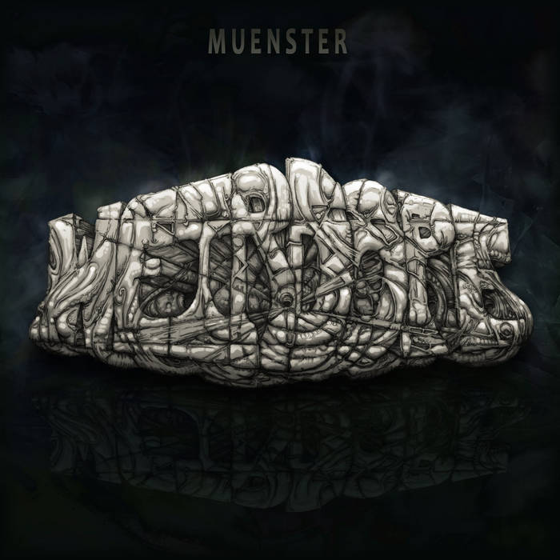

Muenster Releases New Epic Album Titled “Weirdope”
Muenster takes center stage with this thought-provoking Album that shines a light on societal issues

Denton, Texas: Music that is conscious, inspires, anthropological and ignites social discourse is what Muenster’s music represents. Muenster returns after his last gripping album “Radio Dogpile” with this new album titled ‘Weirdope’ which is set to re-release both physically and on all streaming platforms through The Orchard on July 1 2020. This album is a social commentary on the current state of hip hop and the state of the Union. A coming of age for Muenster showcasing his ability to detail the nuances of the world around him.

Weirdope takes a departure from Muenster’s previous releases in not just the style but in the approach to the album as a rapper and a musical artist. The album is a 14 track project split down the middle from a subject matter and production stand point taking on social norms and the current state of what we are being force-structured with by the machine, or the industry standard if you will. By imploding or and re-creating a new sound based on social commentary and observation, Muenster is following a norm or a standard but turning it on its head through his best work yet.

Muenster’s dissection of this masterpiece into two parts, “weird” and “dope” was purposefully done to enable him deal with pertinent socio-political issues one at a time- An artful representation of his mechanical but structured mind. The first part takes on the current state of the hip hop industry and rappers in the new age while the second part comes with a political backdrop, taking a look at the state of affairs in modern America and offering solutions such as being the change we want to see.

Weirdope kicks off with the track “Message” from the weird part of the album. Message reignites the dialogue about abuse of power by the police with regards to treatment of black males in America. On top of this is a proliferation of drugs and the glorification of crime culture through music driven by the “machine”. Many people aren’t talking about or doing anything about these things and Muenster want us to. He then takes us on a never ending ride with hard southern beats, 90’s groove and soft percussion sounds against a background of philosophical poetry on songs like Obey (Ft- Billy Syn, Pterradacto), Didactic, Go Deaf (Ft- SumGuy), Woke, Trinity (Ft- Shotty Automatic, Brujo), AWHIWWLB (All We Have Is What We Leave Behind) and Equinox (Ft- X-Calibur). A relentless rainstorm of sounds and precise hard rapping that questions and entertains all at the same time. All that just from the first side alone!

“Chances are” opens the second side of the album ‘dope’. With its unique reggae vibe, Chances are is a song delivered though effortless fast-paced lyrical runthroughs telling everyone to live now because we have the chance, to rise up to correcting the ills of a cocky government, because chances are “there’s lot to do”. Other songs on this side of the album include Before We Die ( Ft- KoolBRZ, Guillotine), How Long (Ft- Pterradacto), Get It Right, Substance (Ft - Lejend, Flotation) and Vieques.’

Pre-order Weirdope now on https://muenstervision.bandcamp.com/album/weirdope

About Muenster: Born in Austin, Texas, Muenster is a prolific performer, a dexterous wordsmith and a master emcee. Muenster was already in love with music as a young 5 year old boy making up band names in his head and pretending to perform to rocks and dinosaurs on the school bus. Having been heavily influenced by rap music of the 90’s featuring the likes of Eric B, Fat Boys, Rakim, Fresh Prince, Run DMC and artists from the Good Life Café, Project Blowed, Freestyle Fellowship, Hip Hop Kclan, CVE, ATU and so many more, he started rapping publicly in parties and small gigs before moving to Denton and becoming a crucial part in the growth of Hip Hop music there. He has been working as an independent musician touring, performing at gigs and recording songs for the last 15 years. Follow Muenster on Social media through these channels:
Http://www.Facebook.com/Muenstervision
Http://www.Twitter.com/MuensterVision
Http://www.Instagram.com/Muenstervision

