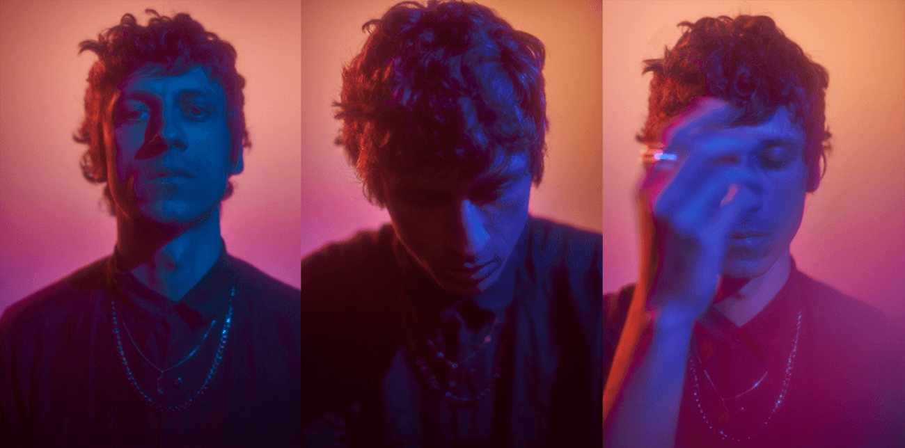
Fot. Dawid Grzelak

Baasch after a year break comes back under cover of a night with his album “Noc”

Baasch is known for his own, original and characteristic music production style. His sound combines industrial coldness and EDM’s trance in well composed, dark songs. Polish jurnalists pointed out that his trademark is expressive, catchy chours and hipnotizing vocals.

Baasch’s third album continues an inteligent dialog between dance music and dark-pop known from his previous releases. The new songs capture variety, wilderness and unpredictability of the nightlife. Baasch in his very own way writes about emotions and relations between people. Moreover, the stories that Baasch sings on this record are inspired by the most knotted corners of human life as they all were wrote and composed at night. You can feel muggy, dense and dark atmosphere in bold lyrics, sang for the first time in his native Polish language. “Noc” (eng. “Night”) is also his first concept album. Baasch about album:

“I have lived mainly at night for the last year. I also wrote and composed all the songs on this album by night. You think differently and listen differently at night. Night became the background of the stories caught in the lyrics. I guess many of us will resonate with them”.

Much of the music on “Noc” - ghostly whisper, back choirs layers, viral riff - was recorded with Baasch's voice. Starting with born-in-haze, “Impuls”, througt anthemic “Brokat” to tearing apart “Przegub”, the album shows Baasch’s masterfully multidimensional and gifted imagination in producing modern electronics. He let “Noc” to took more danceable shape, than previous albums.

Despite of his highly individualistic approach, Baasch’s invited trusted musicians, that he work with for years, to share their talent on this record: Robert Alabrudziński on drums, Aleksander Żurowski took care of synths and Tomasz Mreńca of violin. “Noc” has been mixed and mastered by AGIM.

About Baasch

Producer, composer and songwriter. For few years active and present on Polish alternative and electronic music scene. Both of his studio albums released at NEXTPOP received great reviews and were included in many end-of-year rankings as one of the best Polish albums.

Baasch cooperates with a large part of the Polish ambitious electronic scene. Such artists as: Rysy, Bokka, Mary Komasa, Novika, Wojtek Urbański, Sonar Soul, AGIM, Piotr Bejnar and many others. He also composed music for “Floating Skyscrapers” - an awarded movie by Tomasz Wasilewski.
Baasch live

He played at the biggest festivals in Poland: Open'er Festival, Tauron Nowa Muzyka, Audioriver Festival, Orange Warsaw Festival. He also gave concerts abroad: Germany (Reeperbahn Festival), Norway, France, Iceland, China, Czech Republic (Rock For People Festival), Lithuania (Vilnius Music Week), Romania (TIFF International Film Festival).

Baasch live:
Baasch – wokal, elektronika
Robert Alabrudziński – perkusja
Aleksander Żurowski – elektronika

Baasch pays attention to visual side of his concerts. He finds lighting and scenography as a very important part of his live performances. Baasch delivers his gig with very special stage design.
