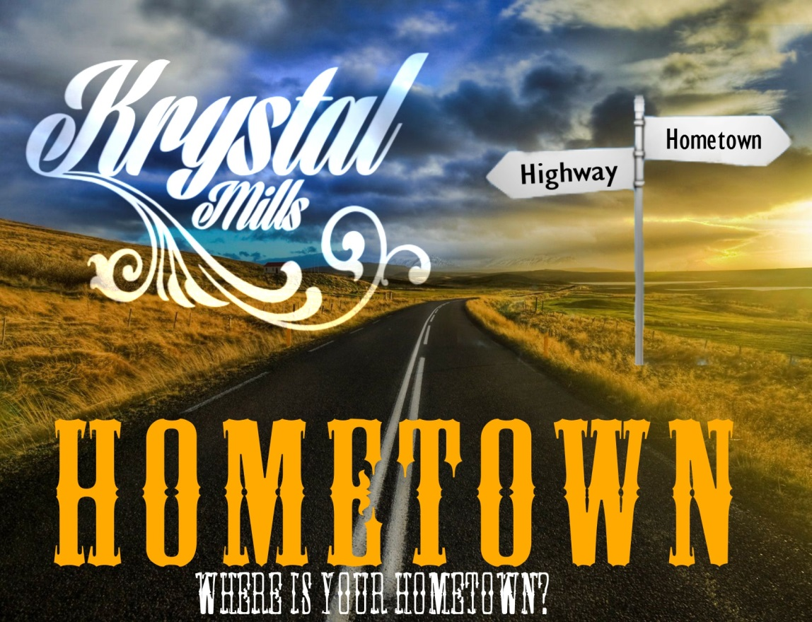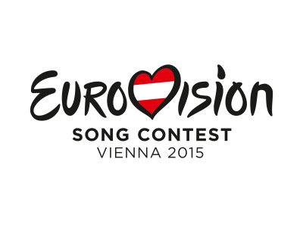

“Hometown”

The American/UK Produced Contemporary Country song which is being put forward as an entry for Eurovision 2015.

Question is will it make it on the finals in Austria?

Hello, I am 21 yearold Singer/Songwriter Krystal Mills and would LOVE to represent Ireland in the next upcoming Eurovision Song Competition in Vienna 2015!!

Teaser Link - <https://www.youtube.com/watch?v=fKVfG0pchu0&list=UUjQMUMLNdt9AbS2SUN4Jocg>

Music Produced by [Russell Steedle](https://www.facebook.com/therussball) (USA)  
Lyrics and Vocals by [Krystal Mills](https://www.facebook.com/thekrystalmills) (UK)

[www.krystalmills.com](http://l.facebook.com/l.php?u=http%3A%2F%2Fwww.krystalmills.com%2F&h=_AQEU565y&enc=AZOkskkS-IOucPMaAH025k5aGZqglf6aMEp3Sn2EfVoArMdTqWQlPwG0Ib6c36XcnsEkd8rAqX6Wn491zTQli_htAEcwe_7uGg5JeYQxyb-OnMiV4xUtDwSi-AuMJvULoifNr25Wee-hW7SativEPLlP&s=1)  
[www.SeraphicProductions.com](http://www.seraphicproductions.com/)

Eurovision Ireland Entry 2015

HOMETOWN

Behind the song “Hometown”

In late August 2014 I got introduced to a young talented American producer/composer in Hollywood called Russell Steedle via Facebook from another music producer I know of in USA who work under the same Producing Team.

I told Russell about Eurovision and this project I wanted to work on for Ireland for this Song Contest. So as we were talking online he sent me a few instrumental tracks which he said that I can use for this contest.

As I was scouring through the 5 tracks he sent me I came across the track made called “Back Then” (Which is now “HomeTown”) and once I listened to it I knew as soon as I heard it that it was THE ONE. So I got in touch and he approved for me to use the track for this purpose.

RECORDING

As soon as I heard the track I automatically came up with a chorus line which has a catchy tune. It’s one I can’t get out of my head for weeks!

I got into my friends studio in Cardiff, Wales called Soundspace Studios who is also Irish and plays lead guitar in my band “Krystal & The Rhinestones”. Once I recorded my vocals dry I then sent off my vocals to Russell back in Hollywood to mix with the track.

Then on 10th October I received the track back from Russell and am now ready for the world to hear! ☺

**Song Description**

HOW “HOMETOWN” BECAME MY ENTRY for 2015 Eurovision!

In late August 2014 I was introduced to a young talented music American producer/composer in Hollywood called Russell Steedle via Facebook from another music producer I know of in USA who work under the same Production Team.

I discussed with Russell the Eurovision Song project I wanted to work on for Ireland. We skyped and chatted online about possible melodies and themes and listened to some of his instrumentals to see if any were suitable. A few other songwriters also approached me with their instrumentals, but when I heard this one from Russell I just knew it was the one for me. We played around with 5 tracks and I eventually chose the one named “Back Then” which now is known as “Back to My Hometown”

***RECORDING***

As soon as I heard the track I automatically came up with a chorus line and with a catchy tune – it’s one I couldn’t get out of my head for weeks!

I booked a friend’s studio in Cardiff called Soundspace Studios which is co-owned by my Irish band member, lead guitarist Richard from “Krystal & The Rhinestones”. Once I recorded my vocals dry I then sent off my vocals to Russell back in Hollywood to mix with the track. On 10th October I received the track back from Russell and am now ready for the world to hear! ☺

***Why I wish to represent Ireland in Eurovision 2015 at Vienna...***

 As a young girl growing up in Cardiff, my Nan always used to play her Irish music to me and my cousins at family get-togethers, which eventually lead to me and my cousins all having Irish dance lessons and performing at many feiseanna in Cardiff and the Midlands. I unfortunately had two left feet and couldn’t quite get the dance moves, but loved to dress up in costumes. My Nan Bridget (Cronin) as she was then, came from Ballina, Tipperary, moved to Cardiff, Wales when she married my Grampy Brian Gardiner but sadly passed away of cancer on their 50th Wedding Anniversary in 2012. She always loved a good jig and my Mum Sharron and Aunty Lorraine used to enter the Welsh Rose of Tralee competitions. So Irish is well and truly in my blood and I love to watch the Riverdance shows when they visit Cardiff.

In August 2012 I had my first Irish gig - singing for a wedding at Knappogue Castle with my one of my Irish band members Richard, accompanied me on guitar and who is from the band “Krystal & The Rhinestones”. It was one of my best experiences and I was given a very warm welcome when by the Irish people. Seeing the green hills was just like home from home. I remember landing at Shannon Airport and immediately felt my feet tapping to the sound of the Irish music playing in the background.

My style of music is very much contemporary country. I was delighted to see The Netherlands Entry, Common Linnets had come second in last year’s Eurovision Song contest which shows Country really is loved my millions of listeners – so maybe my country song entry could have a great chance this year.

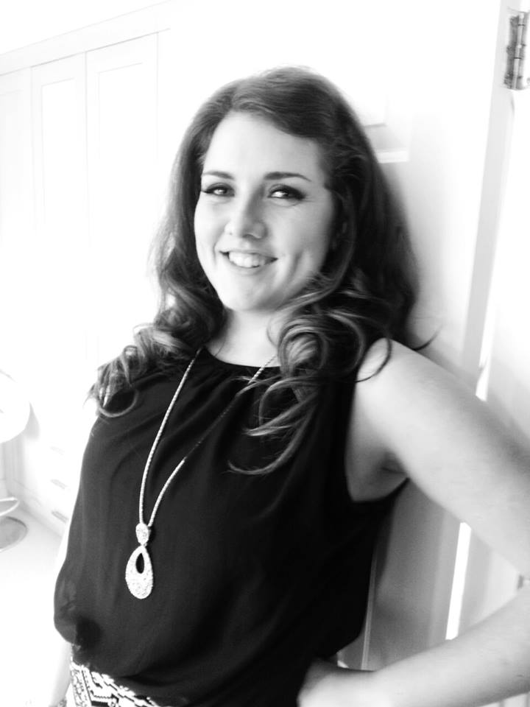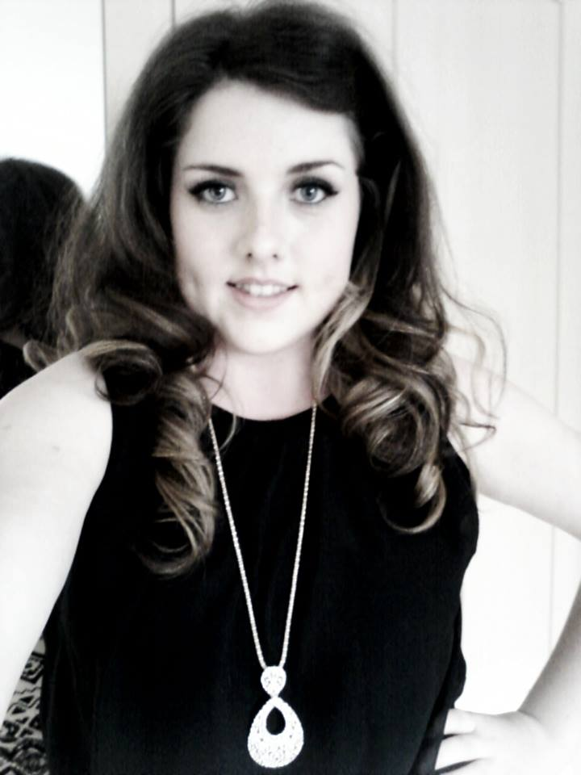

I am Krystal (Jordane) Mills aged 21 years old.

I have been living in Cardiff, Wales, UK all my life and continue to pursue my Contemporary Country Music Artist Career.

Recently I formed a brand new band, called "Krystal & The Rhinestones" We are currently busy rehearsing for UK Festivals and Live Performances that have already been lined up for 2014 - playing to mainly my original songs and some well-known covers.

I compose and produce my own music and perform solo with acoustic guitar and I like to mix my sets with an array of acoustic and backing tracks to suit everyone.

My main inspirations for song-writing and styles of music are Lady Antebellum, The Band Perry, Sugarland, Taylor Swift, Miley Cyrus, Carrie Underwood, Adele, Katy Perry, Jessy J and Lady Gaga....

Past Bio....

I have been singing since I was about 4 years old, singing with my hairbrush to my Mum's tracks on the CD player from artists such as Celine Dion and Whitney Houston, dancing around in circles. When I was 6 years old my Mum and Dad took me on holiday to Butlins (Minehead) where I entered a talent competition and sang "My Heart Will Go On" By Celine Dion which was the first time I had sung in front of a live audience. Even at 7yrs whilst at Birchgrove infants, I remember being so excited when my school installed cctv cameras that I and a friend used to sing and dance to these cameras and amuse the teachers and Headmistress in the staff room. (Best I tell you this story and embarrass myself than you hear it from my mum, hehe)

It wasn't until I was 16yrs that I picked up a mic again and began entering local talent shows for fun and to achieve experience. I knew then that this was a career I would like to pursue so took some singing lessons and then to my surprise I was given a guitar for Christmas 2010 and within 10 days I taught herself the basic chords on YouTube and then booked some professional guitar tutoring, but was mainly self-taught. I never played an instrument up til then.

**Meet the Artist behind**

**“Hometown”**

Competitions and Success Story's...

In 2013 my musical journey took me to many larger festivals and 5 star Hotels, to include St David's Hotel & Spa, Cardiff as well as overseas.

My journey started in 2010 when I won Cardiff's regional Best Western Hotels Talent Contest and was placed second in the UK and again won at their Bristol regional in 2011 and placed 4th in the UK. I also reached the finals of Cardiff's Queen's Arcade Xmas Factor 2011, regional finalist of the Open Mic UK and was a finalist in Cardiff's Got Talent 2012 at the historical Coal Exchange. One of my best achievement to date was when I recorded and upload my debut single to Itunes, which for two months in January - February 2012 reached number one in the World Unsigned Top Charts and remained in the Top 10 in March 2012. That song was called "Waiting For You".

I have also performed at many festivals to include Cardiff's Mardi Gras (Pride Cymru),Wales Millennium Stadium and Coopers Field, Wales Millennium Centre, Glanfa Stage, Godiva Festival (Coventry) - UK's largest free festival, Usk festivals as well as at other large arena's include Peterborough (Waxstock Car Exhibition), The Butts Arena for the Coventry Bears. Launched the Stamtram Charity within the Senedd (Welsh Assembly Building) April 2012 and featured in WalesOnLine and Wales On Sunday (apparently this was the first time live music was performed in the Senedd). I have sung at many festivals and competitions in Romania, performed on Romania TV and performed at the Wild West Theme Park in Port Aventura, Spain in 2014. (Yee Ha)

RODEO CLOWN 1st Album Release....

I released my 1st Album "Rodeo Clown" on 20th March 2013, mainly recorded at the famous Monnow Valley Studios and is a mix of originals and covers, which is available to download on itunes, Amazon, Spotify, emusic and many more music distribution websites. For a signed CD you can purchase at gigs or order by contacting [kikimillsmusic@live.ac.uk](mailto:kikimillsmusic@live.ac.uk).

Other skills....

I have also completed my Level 3 Hairdressing qualification and occasionally I assist with hair and makeup for local musical performances and fashion/pageant shows, which has included the Youth Welsh National Opera and Miss Face of Europe Beauty Pageant Cardiff.

Present....

I am always writing new songs and intend to release a second Album in late 2015.

I have written a new Country song “Back In My Hometown” which I hope will be good enough to be chosen as Ireland’s Eurovision song entry 2015.

My website is [www.krystalmills.com](http://www.krystalmills.com)

Twitter : @theKrystalmills

Facebook Page: [www.facebook.com/thekrystalmills](http://www.facebook.com/thekrystalmills)

YouTube: [www.youtube.com/thekrystalmills](http://www.youtube.com/thekrystalmills)

Russell Steedle – Producer Krystal Mills – Lyrics & Vocals

Lives in: Hollywood, LA, USA Lives in: Cardiff, Wales, UK

[www.SeraphicProductions.com](http://www.SeraphicProductions.com) [www.KrystalMills.com](http://www.KrystalMills.com)