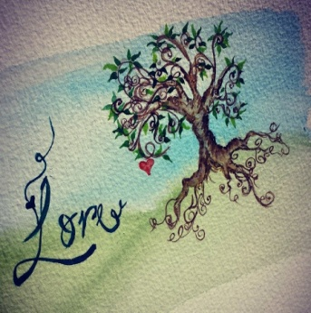
Announcing LORE’s new single release ‘Lost’
&
Self titled debut EP ‘LORE’ for release 17th November 2014
Derry based original three piece folk indie pop band Lore release their debut self titled EP and fan-voted single ‘Lost’. A social media campaign was waged to decide upon the first single off of the rather ample seven track EP.
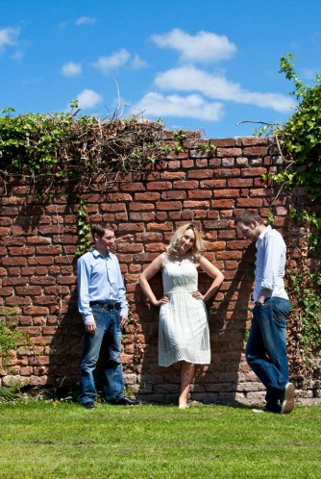
The three piece band has spent the past ten months penning songs and recording in Blast Furnace studios, Derry. They managed to squeeze in competition finals and festival appearances at great events such as the Derry Clipper Festival, Ballyshannon Folk Festival and FSTV Festival among others. They are currently organising the Life.Love.Loss&Fate Tour for 2015.
The band is fronted by singer/songwriter Carolann Carlile. Born in Belfast Carolann was raised in the musical heart of Derry- Stendhal and Danny Boys’ own Limavady. On piano and from rural Dungiven is composer/song writer Raymond O’Kane. Raymond is a degree level music student and has a background in community related arts. Completing the trio is Irish traditional session acoustic guitarist and composer Luke McCloskey, from Dungiven Co.Derry.
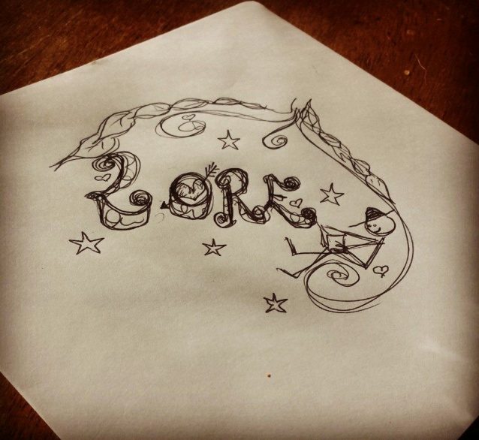

Lore is taken from folklore and refers to the traditional art of storytelling …telling the story of Life, Love, Loss and Fate one note at a time.
www.facebook.com/officiallore
www.breakingtunes.com/lore
www.loremusic.wix.com/lore
Contact: .loremusic@outlook.com Ph: 07889838133

