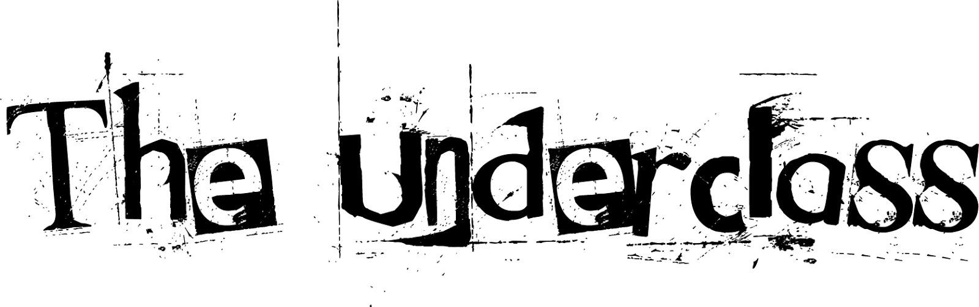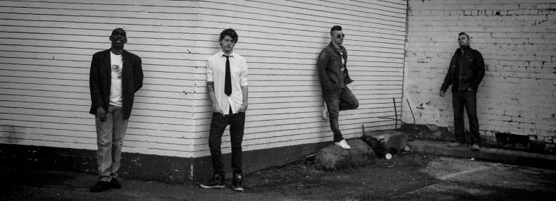
‘The Underclass’ hail from the suburbs of the famous hotbed of reggae, rock, ska, punk fusions; Birmingham. Originally formed in 2012, the line-up was completed this year and the debut album ‘The Rise of the Underclass’, was born. Bringing together a unique blend of musical influences and styles, ‘The Underclass’ have created an original and energetic sound and are hungry for bigger things. From hard-hitting tracks like ‘Fool Britannia’ to feel good grooves like ‘life without you’, this band has an incredible repertoire with something for everyone. With a deserved reputation as a great live band, there gigs are always well attended and positively charged affairs. Do not let these guys escape you. A must see, must listen band……
The band
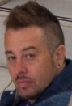 Robb Swadkins – Vocals/Guitars. Robb (a former bassist with ska legends ‘The Beat’) has been performing since the age of 10 and has an impressive list of musical collaborations and has played most major festival and venues in the UK, Ireland and Europe. Growing up in the heartlands of Birmingham, he was influenced by a diversity of musical genres, from reggae to rock. A gifted vocalist and songwriter, he has spent many years sharpening his skills and alongside his fellow band members, is ready to explode onto the scene.
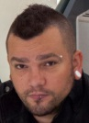 John Ward – Guitars/vocals. John first picked up the guitar at 12 and began an instant love affair. An incredible ear for melodies and musical arrangement, coupled with an amazing song writing ability, make him a force to be reckoned with. With many diverse influences and years of experience performing live and in studios, he is the ‘total musician'.
Sam Harris – Drums. Mr ‘tick tock’ to his friends, Sammy is an incredible drummer and all round musician. Brother of legendary ska drummer Everette Morton (The Beat), the family gift is carried on and utilised to the full in this band. With a list of collaborations which reads like a who’s who of the music world, this gentleman of ska brings a wealth of experience and incredible technique.
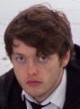 Sam Jones – Bass/vocals. Sam began playing guitar when he was 11, developing a strong passion for acoustic and open tunings. Working as a guitar tech for bands on tour from the age of 15, he learnt the rock n roll trade and embraced the lifestyle. After switching to bass, he has spent several years touring the UK, including playing at ‘Donnington Download festival’. Coming from a punk rock background, Sam has only ever wanted to be on the road with a band, or in a studio working on new material.

To hear samples of ‘The Rise of the Underclass’ go to… http://soundcloud.com/theunderclass2012

