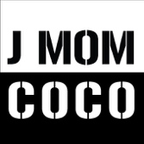

Catering Rider

Refreshments:

- Three Bottles of Water
- One Red Bull
- 5 tickets for drinks (Not imperative)
- No carbs or Aubergine
- Highly allergic to lobster and crab, any fish or oysters is ok

