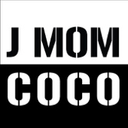

Technical Rider

If the equipment is required, J MOM COCO will provide the following:

- Traktor S2 controller
- Laptop (MacBook Pro)
- Laptop Stand

If the venue prefers to provide equipment:

- Equipment must not be older than 2016
- Two 220 volt power outlets with two separate extension cords\
- A DJ booth is consisting of a rectangular table min: H1.20mts x L1.50mts x W1.20mts.
- A pair of monitor speakers in the DJ booth with ¼ cables for connecting to the Traktor S2 or the equipment provided by the venue
- A couple of XLR cables for the Tracktor S2 master output for connecting the sound system mixing board.
- If the venue provides the equipment, the setup details must be advised 1 week before the performance.
- Multiple socket adapter.

