Patient Hands – Tech Rider

Members:
Alexander Stooshinoff – Vocals, Guitar, Modular Synthesizer, Fixed Media
(306) 370 – 6955
alexstooshinoff@gmail.com
www.instagram.com/patient_hands/

Backline:
I supply all instruments, I only request a vocal mic, mic stand, table, and a stool or chair

Input List:
1 x stereo ¼” DI Line, or 2 x Mono ¼” DI Lines

Frontline/Setup:
Any PA system running in Stereo is good. I don’t require a subwoofer. I don’t require effects. I run everything into a eurorack mixer and send the front of house one stereo ¼” signal.

Stage Plot:
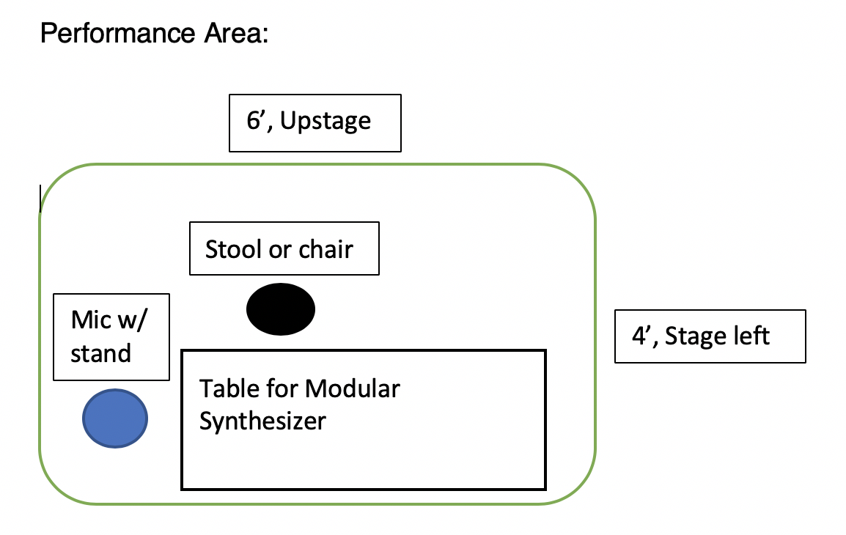
Music Streaming Links:
Spotify: https://open.spotify.com/artist/7hNVZlmfEe50gvlg4Llbs5

Bandcamp: https://patienthands.bandcamp.com/

Soundcloud: https://soundcloud.com/patienthands

Misc: https://ampl.ink/ge54O

Thank you!
-Alex

