Nighttime Revolution the rising stars of Rock!

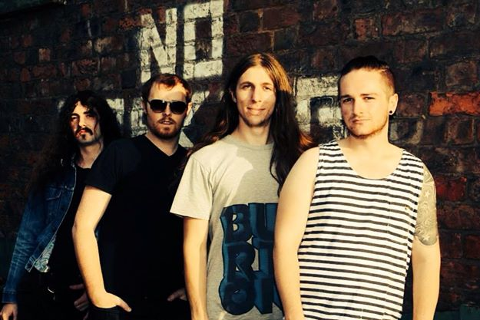
Nighttime revolution are pleased to announce their new single
‘Beachside’
To be released on 13th of December
Nighttime Revolution was Born and Formed in the Musical Fires of Liverpool.
Taking Inspiration from what has come before it and looking ahead to the future. Its heart being powerful drums and grooving bass lines. whilst its soul being driven by cutting guitars and Rocking Vocals.
Nighttime Revolution will release there highly anticipated first studio single titled Beachside on 13th of December, produced and recorded by Canvas Sound Studio’s . After much success wining Battle of the bands and playing Liverpool’s O2 Academy this band are on the up. With Family ties to the band Familiar Looking Strangers and other successful Liverpool band The Skylarks, this band are one to watch steeped with a rich musical heritage.
After Releasing the Demo Tapes the band received a tremendous buzz from the music community with such reviews by Forkster Rocks - http://forksterocks.net/nighttime-revolution/
"Nighttime Revolution are brilliant ‘front & center’ rock n’ roll band hailing out of Liverpool, England!
This terrific band had me ‘rocking out’ in my ear modules to brilliant music genre elements of blues rock, psychedelic rock and 70′s rock feels. They were electric and huge in rock music stature!"
Emerging indie bands http://emergingindiebands.com/nighttime-revolution/ :”This is a quartet who will stretch your speaker system to it’s limits as both sub-woofer and tweeters grapple with the extrodinary range of the quartet and what a delight it is to hear
For more information, visit:
https://www.facebook.com/pages/Nighttime-Revolution/363158957152723
https://twitter.com/NighttimeRev
http://instagram.com/nighttime_revolution
To Listen to the Demo Tapes, visit:
www.reverbnation.com/nighttimerevolution

https://soundcloud.com/nighttime-revolution
For more information or to book, contact us at:
nighttimerevolutionofficial@hotmail.com
Or Contact:
Alan Platt at 07749888667

