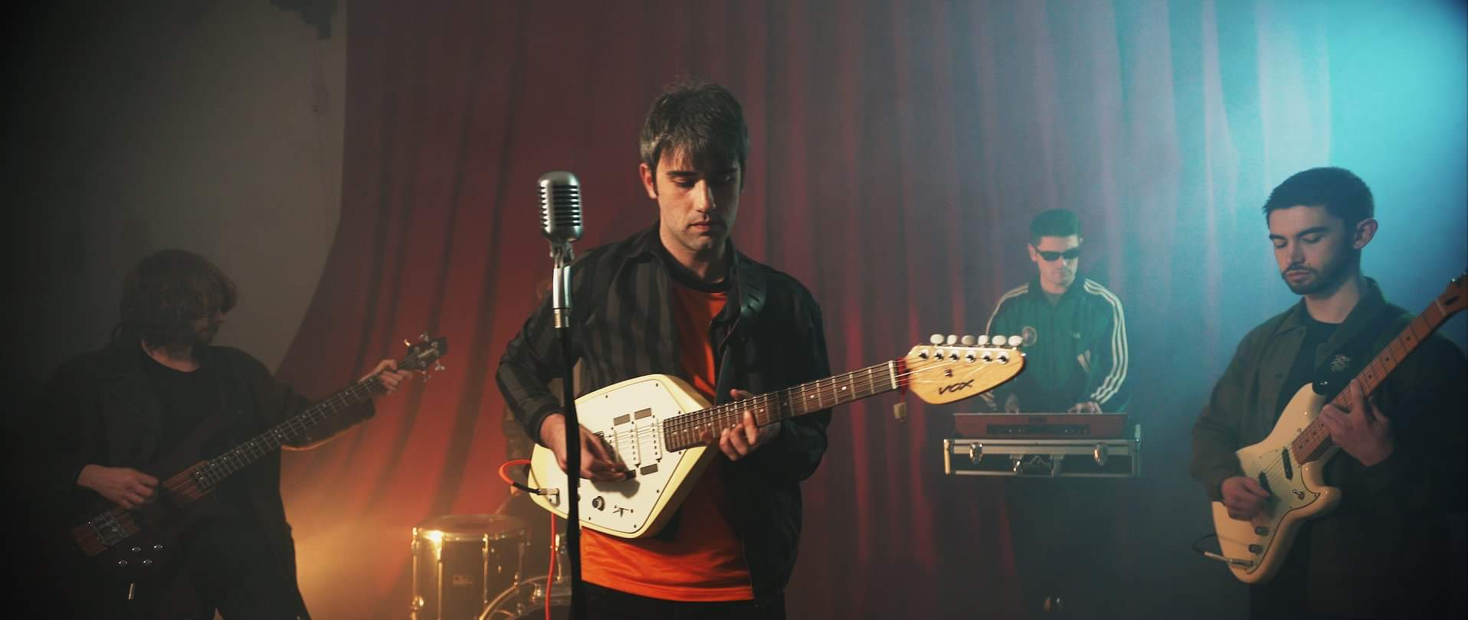
Oranj Son release latest single ‘Whole Hunger’.
Watch here:
https://www.youtube.com/watch?v=oHOq2dW1uZo
Oranj Son’s latest offering, Whole Hunger, is a disco infused pop doozy drawing upon influence from the likes of Scott Walker, Pet Shop Boys, The Teardrop Explodes, The Human League & Air.

Whole Hunger draws upon the 1960’s pop sentiment of baring all. That absolute unapologetic and untamed devotion to another person. It is the 2nd single released this year by the Ellesmere Port 4-piece, Oranj Son.
Bio:
Oranj Son are a 4-piece band hailing from Ellesmere Port, diversely influenced by a range of artists such as the Talking Heads, Lou Reed, The Jesus & Mary Chain, George Michael, & Can. Having formed in early 2016, they consist of Kieran Linford (vocalist and lead guitar), Matthew Linford (keyboards), Harry Parr (bass), & Nick Jones (drums). They’ve released a string of singles which have gained national airplay featuring on BBC 6 Music, BBC Radio 1 and BBC Radio Merseyside.
Quotes:
“absolute pop perfection” – Phil Taggart (BBC Radio 1)

“Oranj Son give us a reverb-filled electropop banger of a track. You get completely lost in the atmospheric bliss of ecstasy and spiralling melodies” – Fresh On The Net

“a tripped out take on wonky psychedelic, gritty northern Fall style grooves and laced with great melodies” – John Robb (Louder Than War)

Plan of action:

We have recently had interest from Matt Bates, head of Primary Talent (Live Booking Agency) who we’ve also held some talks with. We’ve also previously had discussions and interest from 1965 Records (James Endeacott) & Modern Sky (Dave Pichillingi & Shen Li Hui). We’ve submitted our tracks to the BBC Introducing Uploader and Amazing Radio. We’ve had some airplay from BBC introducing of our latest single Whole Hunger on BBC Merseyside on Dave Monks’ show. We’ve also previously had our song Break Yr Fall played by Phil Taggart on his BBC Radio 1 show. The song was also recently chosen as part of Batch 344 on Fresh on the Net’s ‘Fresh Faves’ list, picked by the listeners ( https://freshonthenet.co.uk/2019/11/faves344/ ). Gary Crowley has played our song Radio Wires on BBC Radio London and the song was also played on BBC 6 Music, featuring on Tom Robinson’s Introducing Mixtape. We gig regularly in Liverpool and are applying for festivals in 2020. In regards to the future, we are playing in Birmingham & Manchester in January 2020 with a 4-track EP being released in February 2020. We are also seeking management as well as a record label. We currently self-release our work.

Please contact kieran.linford@ntlworld.com for interviews and further info.
Instagram: https://www.instagram.com/oranjson/
Twitter: https://twitter.com/oranjson?lang=en
Facebook: https://www.facebook.com/OranjSon/
Spotify: https://open.spotify.com/artist/0ZqIKqwmfBVvVWQ9TXWVy8?si=239Thq5DSc-SKptkkoQA3g
Soundcloud: https://soundcloud.com/oranjson/

