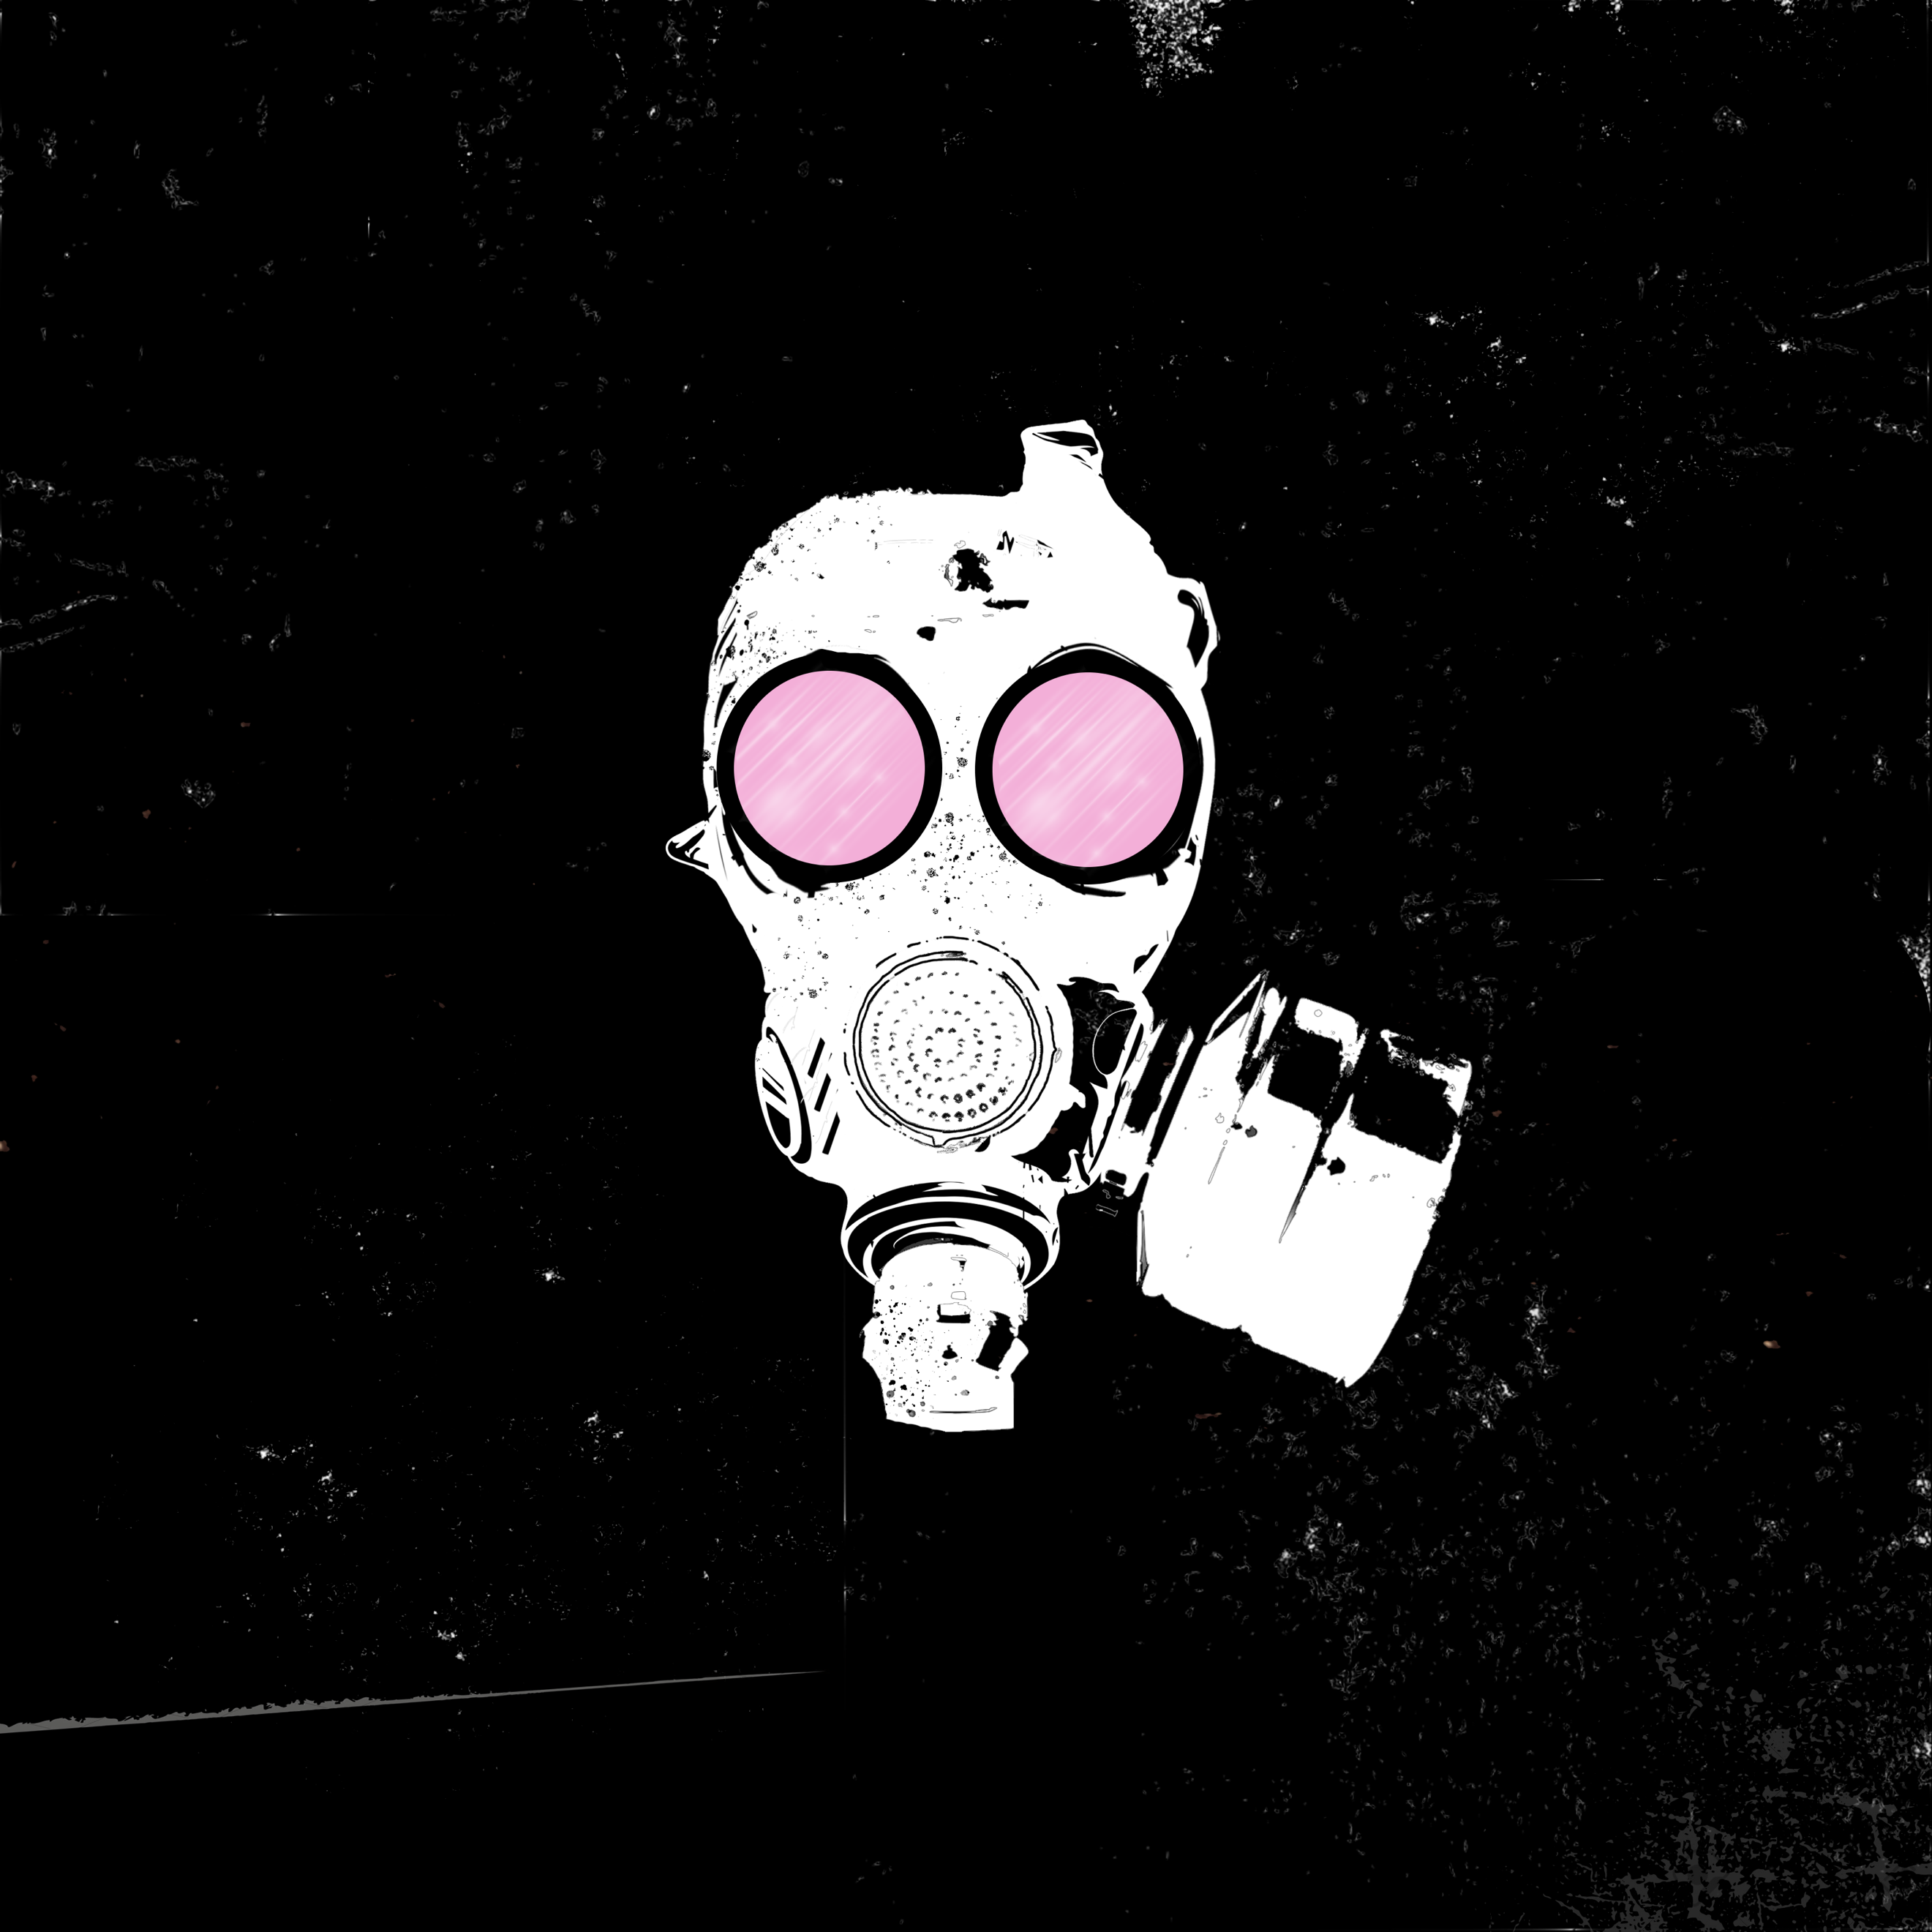

CHEMICAL ROULETTE

Chemical Roulette is a is the new single by London-based alternative artist Jennings Couch, which he describes as a song about risks and a testament to the monotony we face in our day to day lives. The title of the song reminds us that we need to get up, take the risk, and break the cycle.

Musically, Chemical Roulette takes a slightly different direction than most of Jennings’ previous releases, with a primarily electronic sound, led by edgy synths and a deep, distorted bass, yet it still keeps the edgy alternative pop-rock sound that is typical for Jennings.

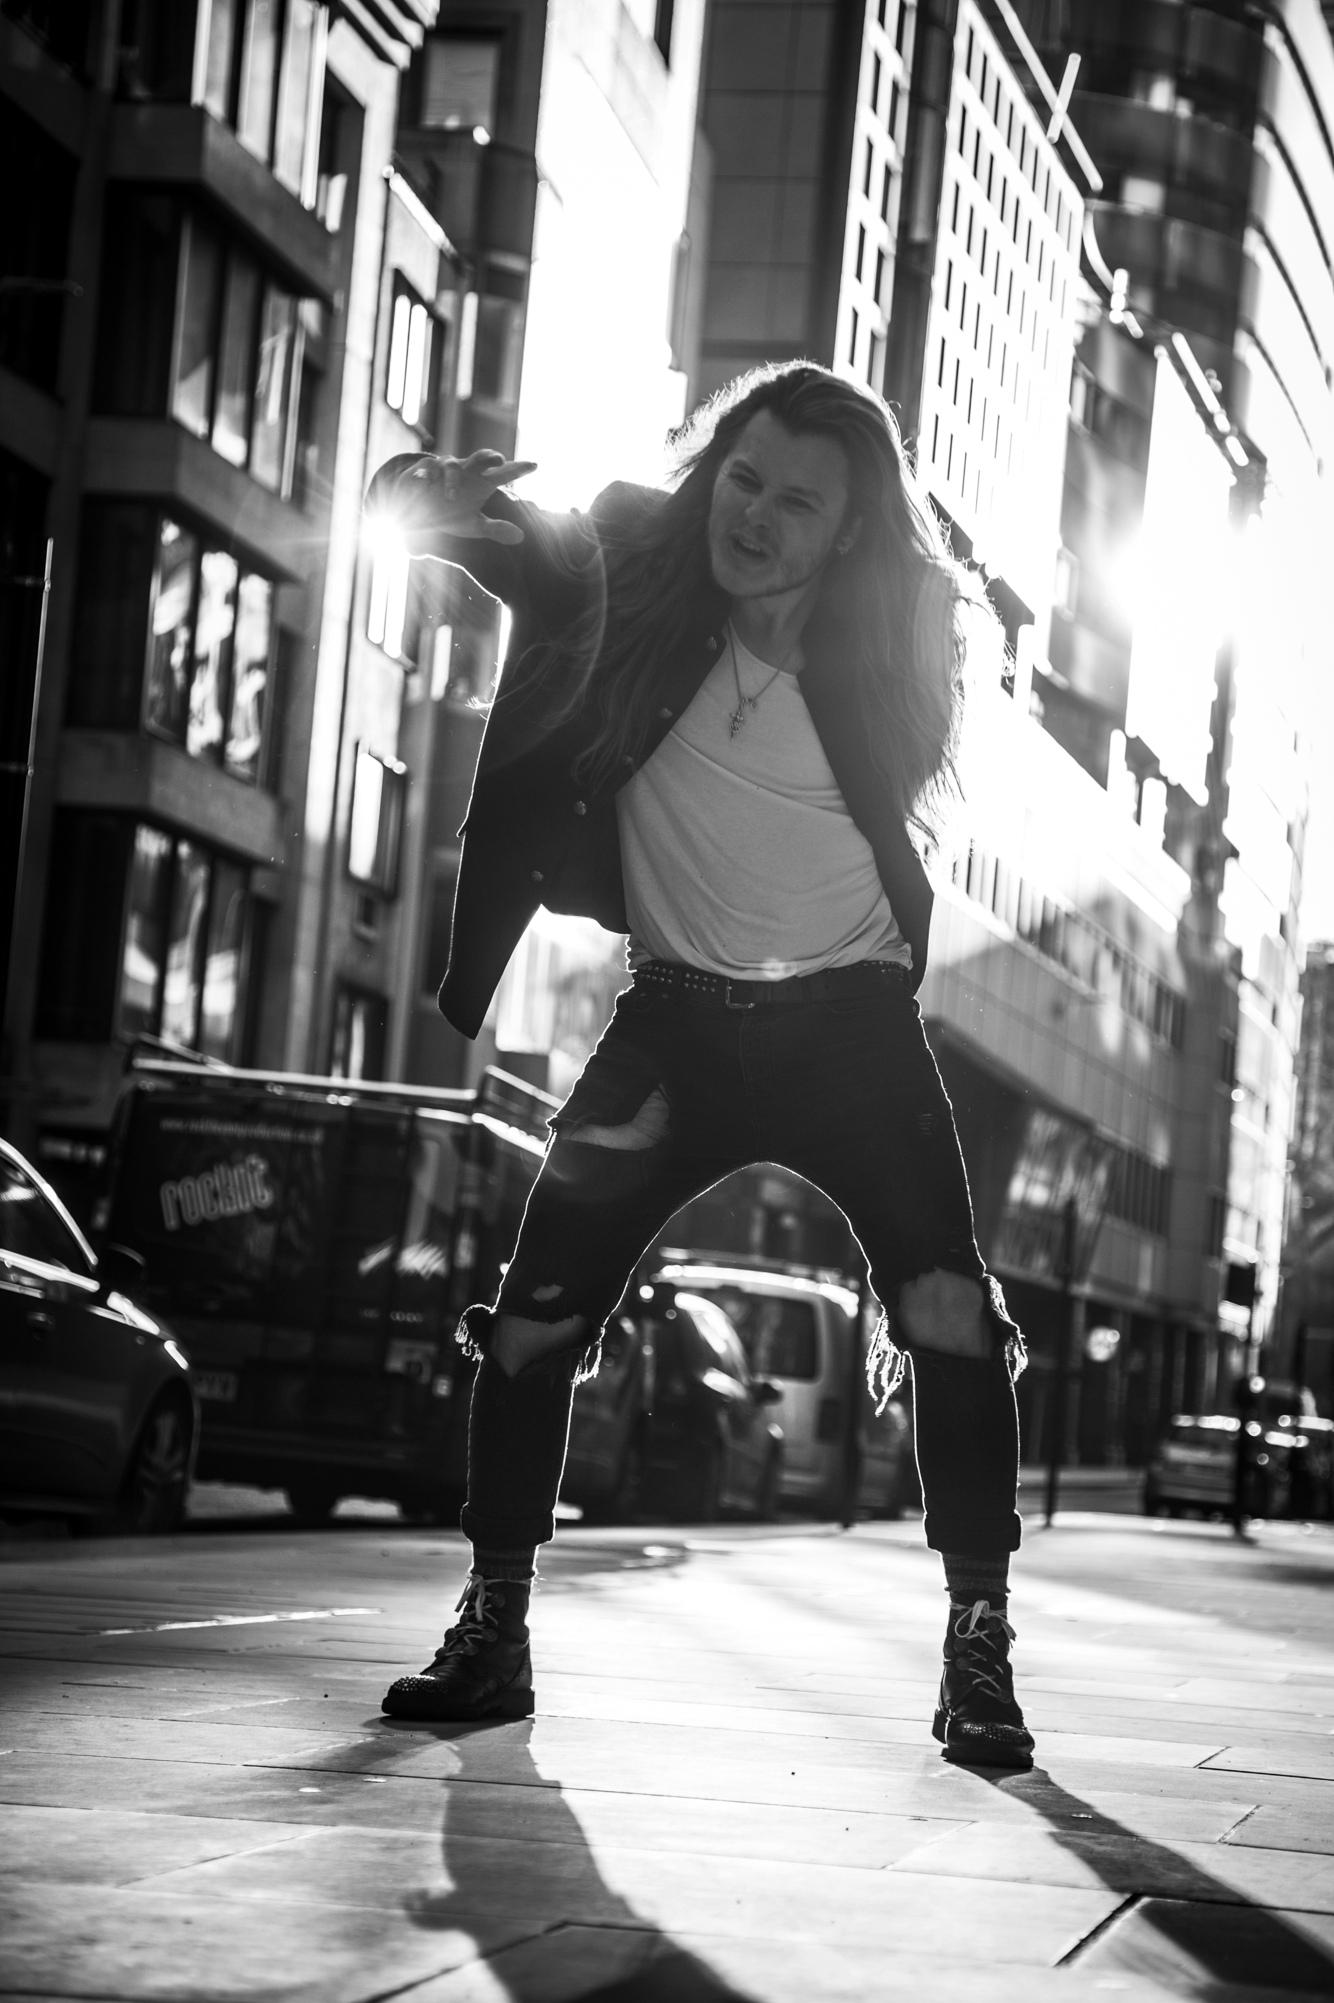
Shot in the urban London and directed by Jennings’ long-term collaborator Cyrus Mirzashafa, the music video elaborates on the idea of the toxic monotony that today’s environment produces, whether is social, political or otherwise. The gas mask, worn in the music video by the amazing drag artist Stella Marbles, is another detail connecting the song with the music video.

Born in the wilderness of New York City, raised in rural England and made on the streets of London, Jennings Couch is someone who embraces change.

Jennings is carving his own niche in the alternative scene by making use of anthemic choruses and thought-through lyrics and drawing an inspiration from the gritty vocals of Grandson, the huge soundscapes of Imagine Dragons and the genre-crossing sounds of Twenty One Pilots.

Chemical Roulette is now available on the streaming platform of your choice: https://ampl.ink/LanJr
Watch Chemical Roulette Music Video on YouTube:

