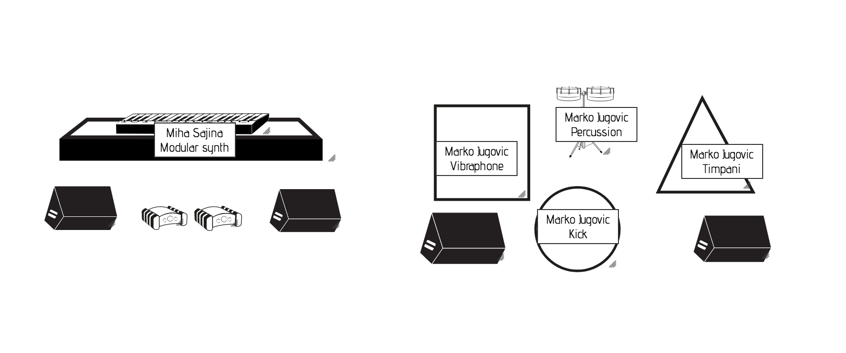
4x monitors
2x DI
4x small condenser mic for vibraphone + percussion
1x kick mic
1x timpani mic

