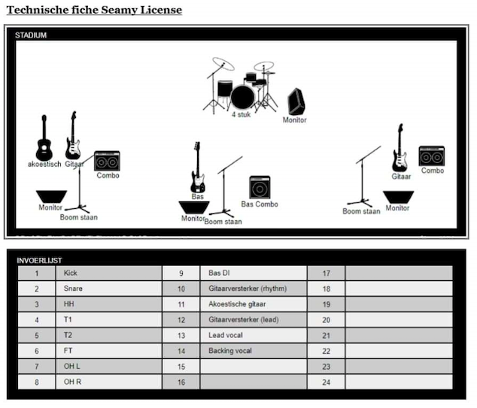

NOTE: If possible, all musicians can be provided with a mic, for interaction (before and during gig).

Chesney Vermeulen – lead vocals, bass guitar
Tijmen Van Loo – rhythm guitar (electric & acoustic), backing vocals
Yari Van Hecke – lead guitar
Peter Degroote - drums

