
ALFREDA RELEASES NEW SINGLE
‘THIS ROOM’ – OUT NOW

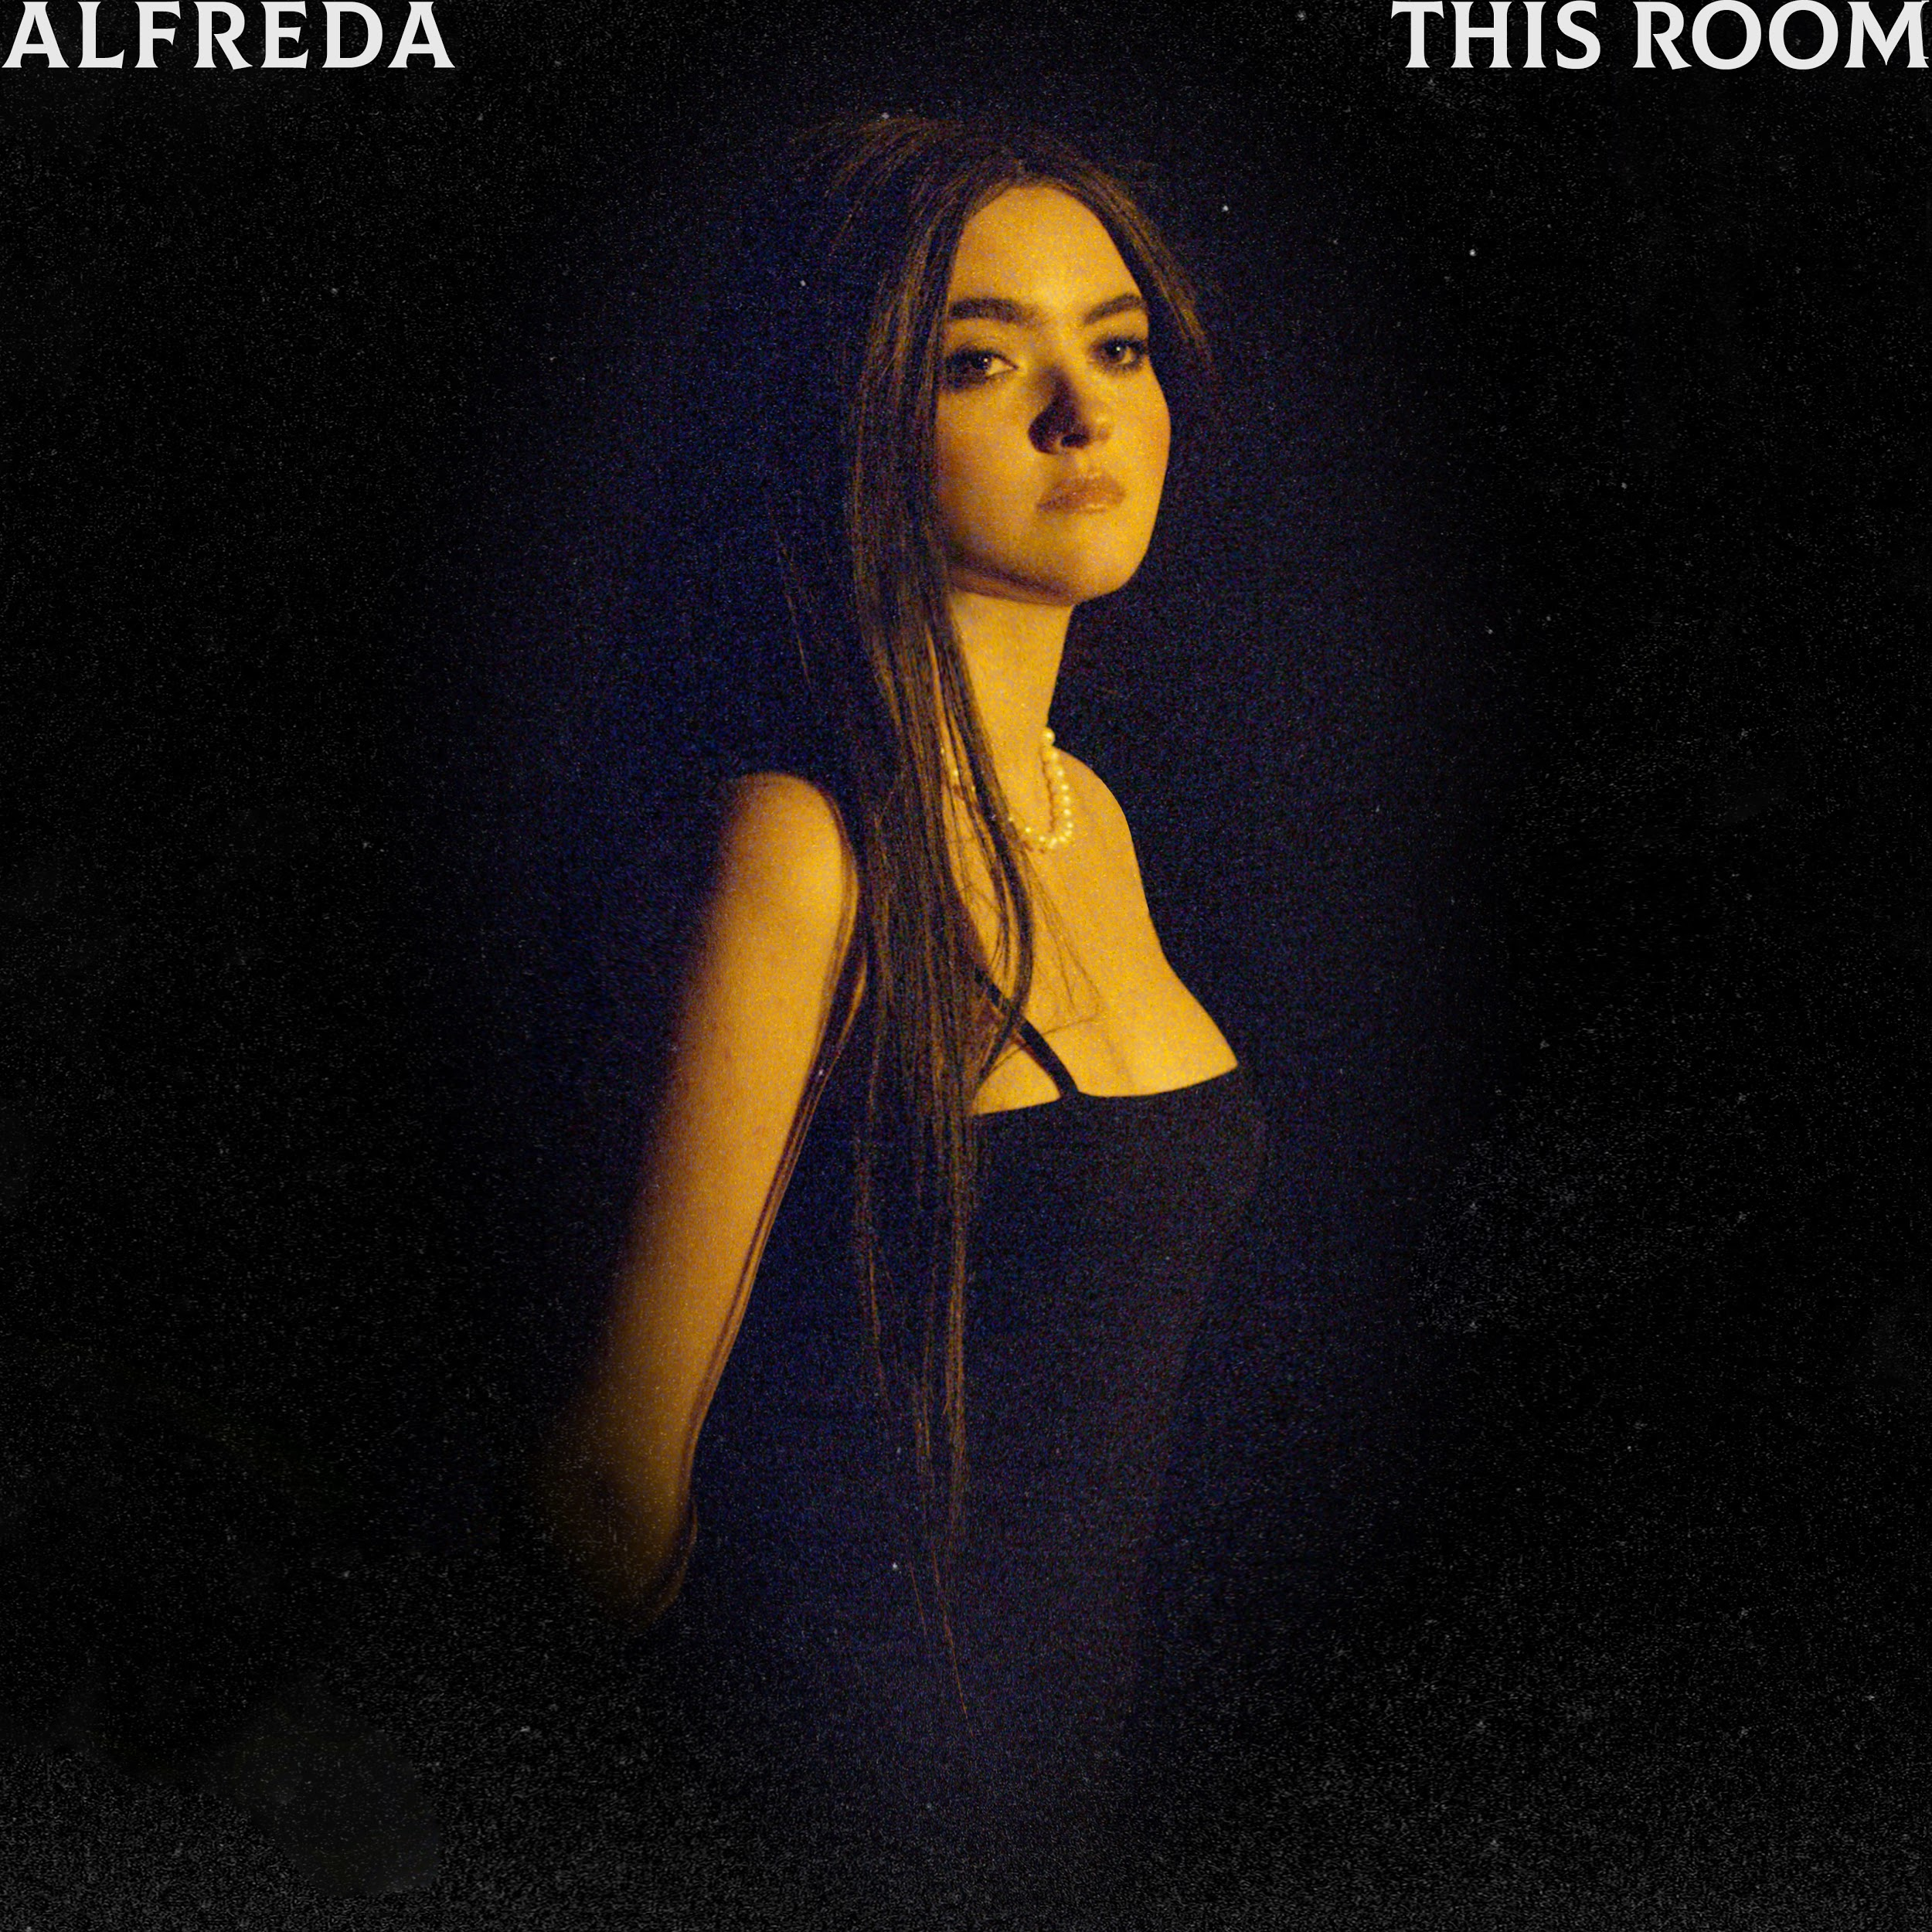

WATCH OFFICIAL VIDEO HERE
BUY AND STREAM HERE

[13th December 2019] Emerging alt-pop artist Alfreda shares the mesmerising official video of her dreamy new track 'This Room' – out today.

‘This Room’ video was directed by Roger Spy, Spy is an award-winning multimedia artist and film director who has worked with the likes of Cara Delevingne, Yoko Ono, Boy George and John Foxx. 'This Room’ was inspired by the works of various graphic artists, mainly Jonathan Barnbrook and Lars von Trier, as the video takes place in a plexus reality. With shots inspired by the Mona Lisa portrait, Alfreda’s vulnerability is visible throughout the video, and the intention of bringing the naivety behind the lyrics to life is enhanced only by the purity and simplicity of her performance. Heavily informed by the use of text, director Roger Spy approaches the editing using collage and analogue film texture as a tool to lead the viewer into an upside-down existence, observed in reverse.

On the video, Alfreda says “I knew I wanted the video to explore the feeling of desperately trying to put something back together, as the song does. And I feel we achieved this through the visual of the set, as well as Roger’s reversed editing.”

Filled with spacey synths and hypnotic riffs, ‘This Room’ demonstrates the gradual process of coming to terms with reality. Alfreda’s sultry vocal is woven within a subtle yet lively beat, which gives her latest single its introspective allure.

"‘This Room’ expresses a softer side to the same toxic relationship I was in," Alfreda says. "I really wanted to make things work, and in the chorus I devotedly express this, but in the verses I slowly start to compile all the reasons it was never going to work. In terms of the structure of the song, I wanted all the verses to have a different melody and style to give the feeling of something progressing. But the chorus always stays the same, as that message never goes away."

‘This Room’ follows on from Alfreda’s well-received single ‘Anyone’, which gained praise from Clash, Official Charts and Spindle Magazine.

With influences from Amy Winehouse, Roisin Murphy, Lana Del Rey and Janelle Monáe to David Bowie, Radiohead, and Frank Ocean - Alfreda’s confessional songwriting style is rooted in her New York City upbringing. She later moved to Sussex, UK prompting the indie artist to experiment with music software and recording her own songs. Finally moving to London aged sixteen to pursue music full-time, Alfreda dedicated this time to building her live shows throughout the city. Not long after, Alfreda was introduced to the Berlin music scene by long-time collaborator Craig Walker. Whilst there, she got to know many new producers and songwriters which has helped develop her own distinctive production style of elegant, high-class pop, working with the likes of: Tyler Pope (LCD Soundsystem) and Knox Chandler (Lou Reed, Siouxsie and the Banshees), and producers Victor van Vugt (Nick Cave, PJ Harvey) and Jan van Der Toorn (Outkast, Snoop Dogg). Alfreda now splits her time between London and Berlin. Alfreda headlined Laylow in London last month.

Alfreda attributes her fascination with storytelling fashion to her late godmother Isabella Blow, whose influence in the fashion industry includes propelling the careers of milliner Philip Treacy and Alexander McQueen.

‘This Room’ and ‘Anyone’ showcases Alfreda as a confident rising artist unfolding, whose distinctive sound and style resonates with listeners. With more music set to be released soon, Alfreda is gearing towards an exciting 2020.

Connect with Alfreda online:
Facebook | Instagram | Twitter | YouTube

For more information contact:
cat.lazarra@wma.agency

