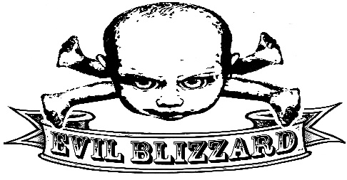
Evil Blizzard

When The Guardian (UK) Newspaper puts a band on the cover of their entertainment supplement and announces them as the pioneers of the “New Wave of New Rage”, then it’s time to reassess the current British music scene.

Preston’s Evil Blizzard have stretched the boundaries and imaginations of music above and beyond the turgid manufactured dross polluting the current airwaves. A mixed swathe of bass driven angst and anthemic ritualistic tribal assaults, have had the music media singing their praises, whilst simultaneously scratching their heads in disbelief.

Four basses, who now amongst their ranks, can boast the #49 on Kerrang! Magazine’s “50 Greatest Rock Stars in the World…Today” list in the shape of Filthy Dirty, alongside Kav, Stomper and Prowler. Evil Blizzard are completed by Side, their singing drummer, a baby’s head Theremin and the ever so unhinged ladies favorite, the “Blizzpig”.

Mark E Smith once described the band as “The Future of music” and promptly took them on tour with the Fall. Not long after, Rough Trade (NYC) announced that Blizzard were “Filling the void, currently in the British music scene” whilst many have simply said they are “Like being stuck in an endless, colourless Rubik’s cube for all eternity.” – They are the Marmite of rock!

The Liverpool Echo have given them their own musical genre “Poly Rhythmic Gumbo”. A hedonistic cornucopia of musical theatre and self-induced spiritual highs. Evil Blizzard are truly a unique live experience. Musically; Hawkwind, Zappa, Pil, Killing Joke, Numan, Pink Floyd.. Who have been paid homage too in one form or another. But then again, Blizzard have never shied away from their musical heritage. In fact they embrace it. So much so, longtime fan Dibs of Hawkwind is one of a long line of bassists asking, nay pleading with the band to let him don a mask and join them onstage. Who else can say they’ve had everyone from Emmerdale cast members to ex Wonderstuff bassists, become transformed for one night, into a Blizzard!

In 2013, the album, The Dangers of Evil Blizzard, released via John Robb’s (The Membranes/Goldblade) Louder than War records, was met with such high acclaim, it sold out of its initial run. The Quietus went as far as to say “If this album had come out in 1988, which it could have quite feasibly done, certain parts of the UK music press would have called Evil Blizzard an ‘arsequake’ (Sonic Youth) band.”

Evil Blizzard are indeed an enigma. Nothing comes close to them. They’ve appeared with everyone from Ruts DC, Killing Joke, Sleaford Mods, Bo Ningen and Hawkwind and critically acclaimed appearances this summer at Strummer Camp, Kendall Calling, Supersonic Festival and Rebellion 2014. They even had the honour of playing at the very first gig on top of the Blackpool Tower!

New material is being written and recorded. Gigs are coming and Evil Blizzard continue to arouse and annoy audiences in equal measure. Batten down the hatches, hide the kids and put on a mask and your boiler suit. There’s a very Evil Blizzard coming!

Live Reviews
Kendal Calling 2014
“Evil Blizzard have been the highlight of the weekend showing how rewarding it is to explore the smaller stages.
http://www.cumbrialive.co.uk/home/surreal-kendal-calling-set-from-evil-blizzard-1.1152539

The Guardian (UK)
“When we supported the Fall, half of the crowd said: That's the absolute worst thing I've ever seen. The rest thought it was fucking brilliant' Side, Evil Blizzard
http://www.theguardian.com/music/2014/mar/06/eagulls-girl-band-evil-blizzard-sleaford-mods-bring-the-noise

Supersonic Festival (Birmingham) 2014
“Stop stroking yer beard mate and shake your arse for fuck’s sake. Blizzard are the pure dumb joy of loud rock ‘n’ roll, remember that?”
https://hickeysonic.wordpress.com/tag/evil-blizzard/

Music Ohm (Evil Blizzard, the Lexington, London May 2014)
“So Yeah. Evil Blizzard. Definitely not boring. Quite possibly something wrong with them. Definitely not an experience you’ll forget, even if you wanted to.
Read more at http://www.musicomh.com/reviews/live/evil-blizzard-lexington-london#dUZW1Z3CwHMxOw59.99

Getintothis (Manchester Academy, September 2014)
There’s a barrage of bludgeoning tunes; think a twisted PIL with the rhythmic funk of Ege Bamyasi powered by an oil tanker full of gack. (http://www.getintothis.co.uk/2014/09/sleaford-mods-evil-blizzard-academy-manchester/

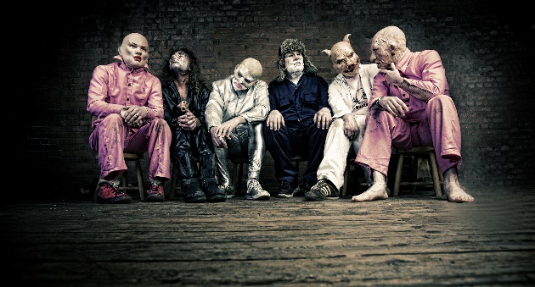

- Forthcoming shows: http://www.ents24.com/uk/tour-dates/evil-blizzard

- Noise : https://soundcloud.com/evil-blizzarrd/are-you-evil-demo?fb_action_ids=10152269127486519&fb_action_types=soundcloud%3Alisten
- Banter & Admiration : https://www.facebook.com/groups/108778672481677/?fref=ts

- Contact: Ramone (Manager)
- Tel: 07764939017 Email: david.woosley@hotmail.co.uk

