January 17, 2014
REVIEW: Ellen Foley, after 30 years, still catches glimpses of 'Dashboard Light' in Philly
Total People in Discussion: 0
Categories: Concert Reviews, Music, Music News, New CDs
Posted by John J. Moser at 02:51:53 PM on January 17, 2014

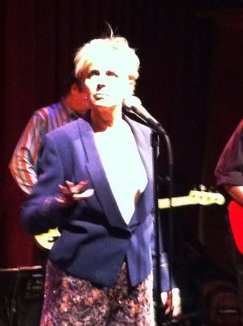It’s been 35 years since Ellen Foley cemented her place in pop culture by singing the female foil part on Meat Loaf’s song “Paradise By the Dashboard Light,” and more than 30 years since she released her third and last solo CD.
But Foley returned to music last year from a career of TV, stage and movies to release her first album since the early 1980s -- entitled, appropriately, “About Time” -- and stopped Thursday at Philadelphia’s World Café Live to support it.
Ellen Foley at World Cafe Live in Philadelphia
“Lovely to be here,” Foley told the audience of about 55 people after her opening song, the new “Worried Woman.”
“Took long enough. [pause] We’ve been on the road three days.”
As that joke acknowledged, it would be senseless to ignore that Foley hasn’t been away or hasn’t changed in three decades. Now 62, she’s clearly no longer the pixie-ish singer she once was, and her voice no longer belts as it did on the Meat Loaf’s signature line, “Stop right there! I gotta know right now.”
But Foley’s 20-song, 85-minute show was entertaining none the less – filled with twists and turns, a broad array of musical styles and backed by a sharp and talented four-man band and backup singer.
And when the spunky and dramatic Foley – still sporting a spiky shock of blonde hair -- would strike a pose or roll her eyes or, even better, catch a particularly good note, you could see the younger performer come out.
Not that her new songs aren’t good. Foley played 11 of the 12 songs on the disc, starting with the opener, which found her still spunky. The disc’s first single, “If You Can’t Be Good,” ended with Foley singing an impressive high note.
“Madness,” which had a dirty blues groove, was an especially good fit, and Foley’s guitarist, Slim Simon, played sharp licks as Foley camped. And she was equally as playful on another guitar workout, “Nobody Ever Died from Crying.”
A couple were even country. That was true of “Any Fool Can See,” and “I Can See” was more country rock. “All of My Suffering” was bluesy pop rock and the album’s cover of Randy Neuman’s “Guilty” was very nice, straight-up blues.
She also did a cover of The Hollies’ 1972 hit “The Air That I Breathe” that, as treacly as that song is, was pretty good – more straight-forward than the sappy ‘70s style. “Except for the sex part, I always though that would make a great lullaby,” Foley said.
Foley also played a couple of Rolling Stones songs. She said “Sway” represented the group “at the height of their decadence.” But “Stupid Girl,” which Foley also sings on her new disc and which she did as a duet with her female backup singer Ula Hedwig, was far better – thumping ‘80s pop.
That demonstrated something critical about Foley. Hers is not, and never was, a conventionally great voice, but it’s theatrical for sure. That meant is seemed a better fit for Meat Loaf and ‘80s new wave.
The two songs off her debut disc that she played showed that, as well. “What’s a Matter Baby (Is It Hurting You),” her 1979 debut single, was sassy, and she sang with intensity, her band especially tight. And “We Belong to the Night,” that disc’s opening song, was among the night’s best.
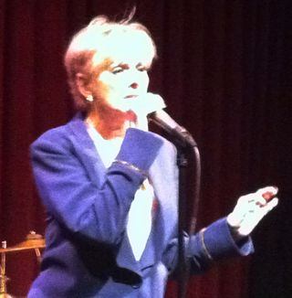Even new songs in the 1980s style were good. “If You Had a Heart” not only had a good ‘80s sound, but its lyrics had that sardonic ‘80s vibe, as well: “If you had a heart it would be breakin’/But you don’t.”
She close with some of the better new ones. She introduced “Carry On (Party’s Over)” by saying, “This is when I get to rock with the boys.” And, indeed, it did rock. “Everything’s Gonna Be Alright,” which close the main part of the set, was gentle, her voice accompanied only by sparse guitar.
Foley returned for an encore of two covers, both excellently chose. She sang Wilson Pickett’s “I Found a Love” with gusto, then closed with The Clash’s “Should I Stay or Should I Go.”
That song, which legend says The Clash’s Mick Jones wrote for Foley while dating her (and about which Foley said, “It’s been said I have some connection to this next song, but I can neither confirm nor deny it) was flat-out great: The band sizzling and Foley singing at her best.
That song, released the year before Foley’s last CD before her new one, was the point in the night where it really did seem as if nothing had changed.

