Queen Marilyn 1 New Pop Enigma

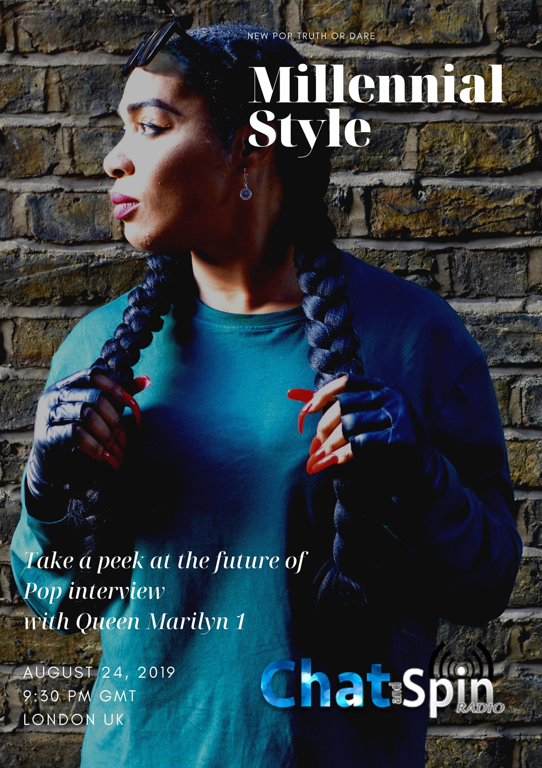
Today's music industry involves a lot of experimental creativity and eclectic approaches to keep Music moving forward. Often times, music has a deep array of sounds because of the way genres are becoming more expressive and kept open to the modern-day movements like fusing various musical genres together until a musician gets the exact sound that makes them who they are as a musician. Multi-talented artist Marilyn David, also known as Queen Marilyn 1, (read as Queen Marilyn The First) fused together Pop, Hip-Hop, Dance music, and Cinematic nuances in ways to bring about her talent as a composer, producer, and musician. One of her recent covers of Metallica's Nothing Else Matters explains how this dynamic combination works amazingly together. Her cultivated creativity will leave a great impact on the world of music. Also redefining style in amazing ways, she has many gifts to share with her audience in an empowering type of way. Be inspired! #NewPop

Megan Hatfield ~ Style Redefine

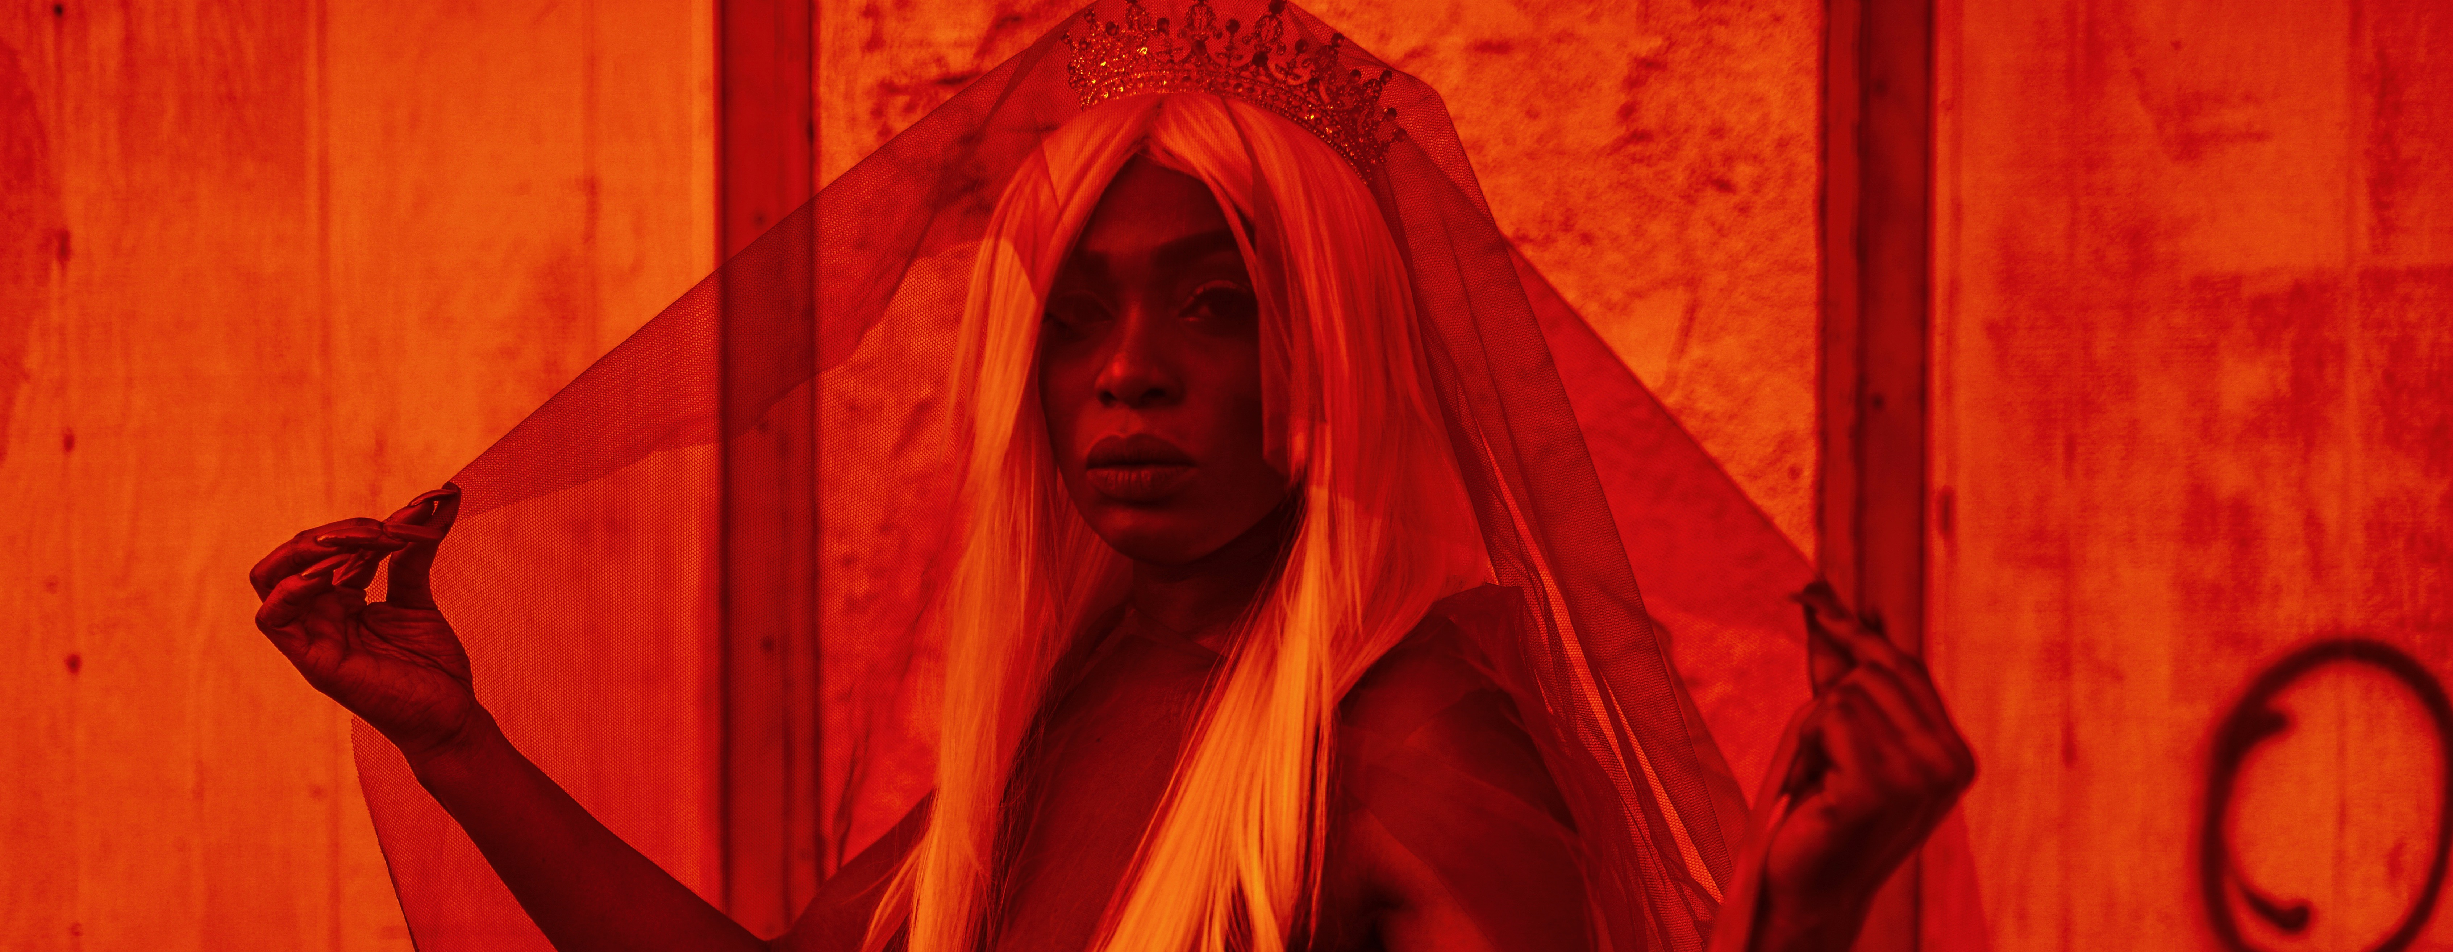
Queen Marilyn 1 prior to her re-invention has previously toured under her real name Marilyn David performing at World-Class stages including, Live 8, Stade de France, Cannes Festival, Milan Fashion Week and Olympia, Paris.

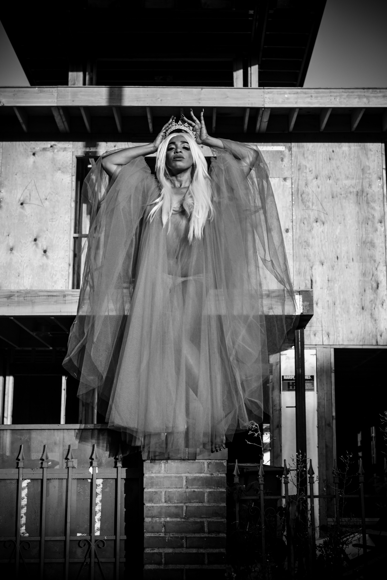
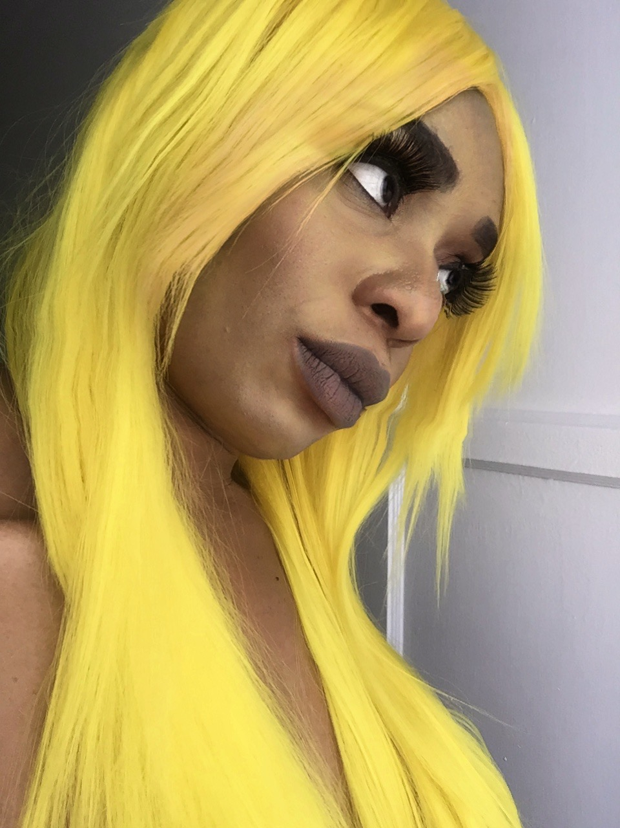
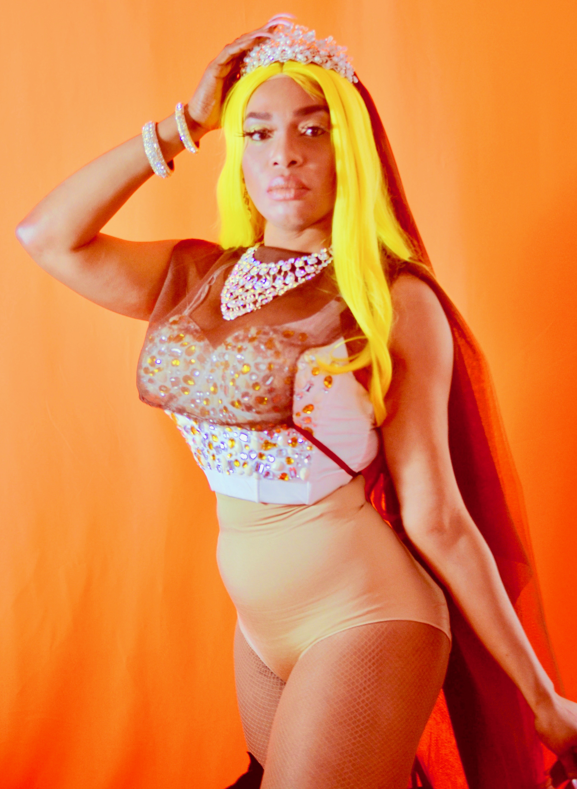
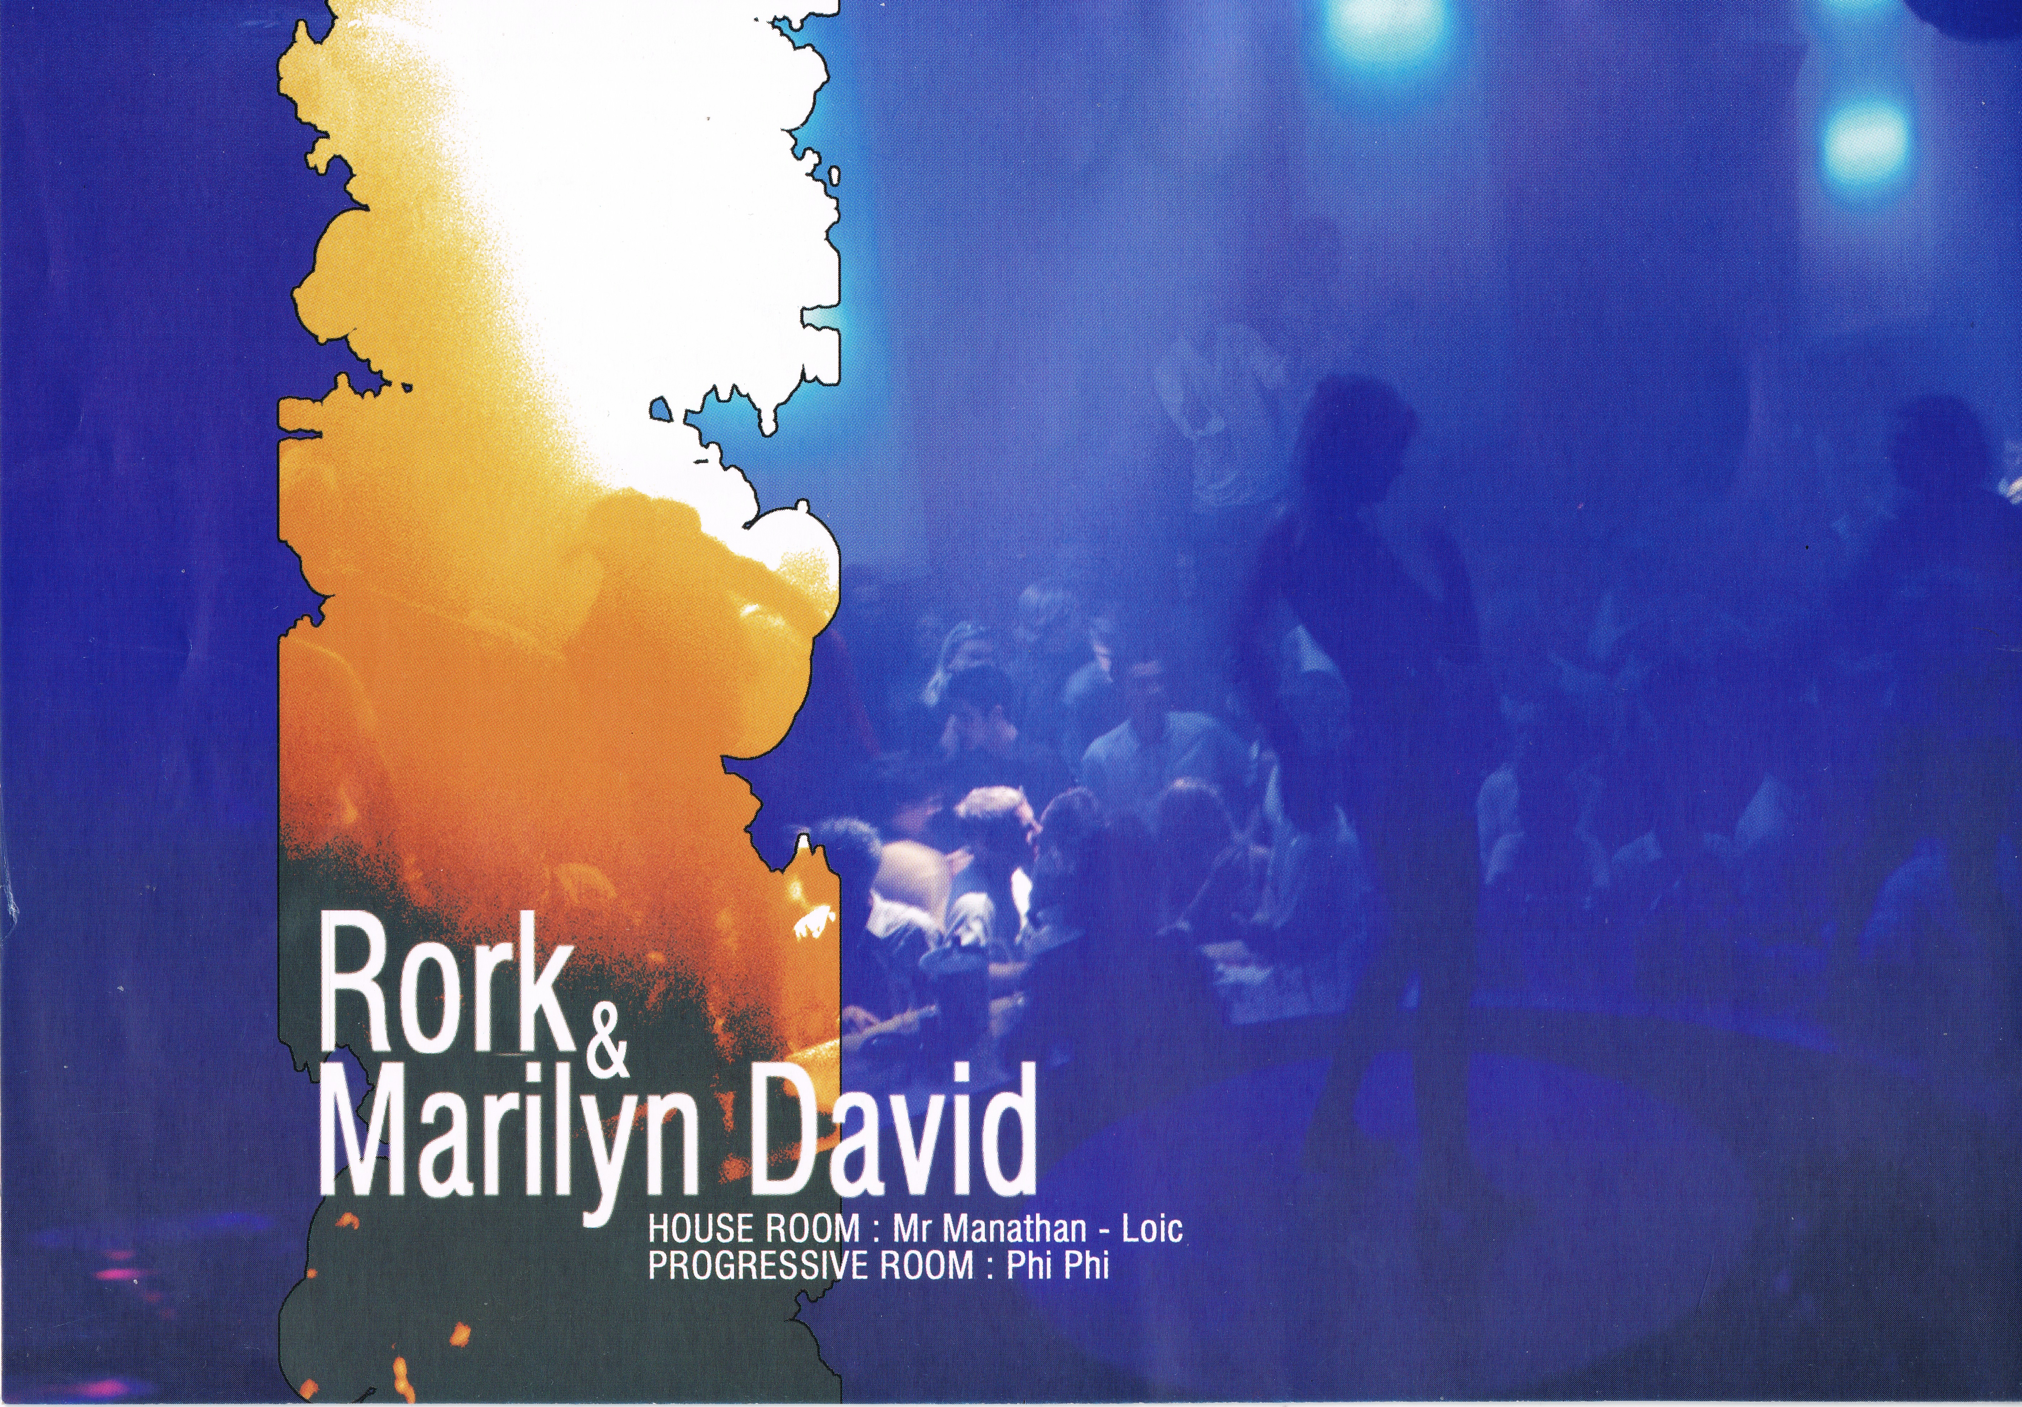
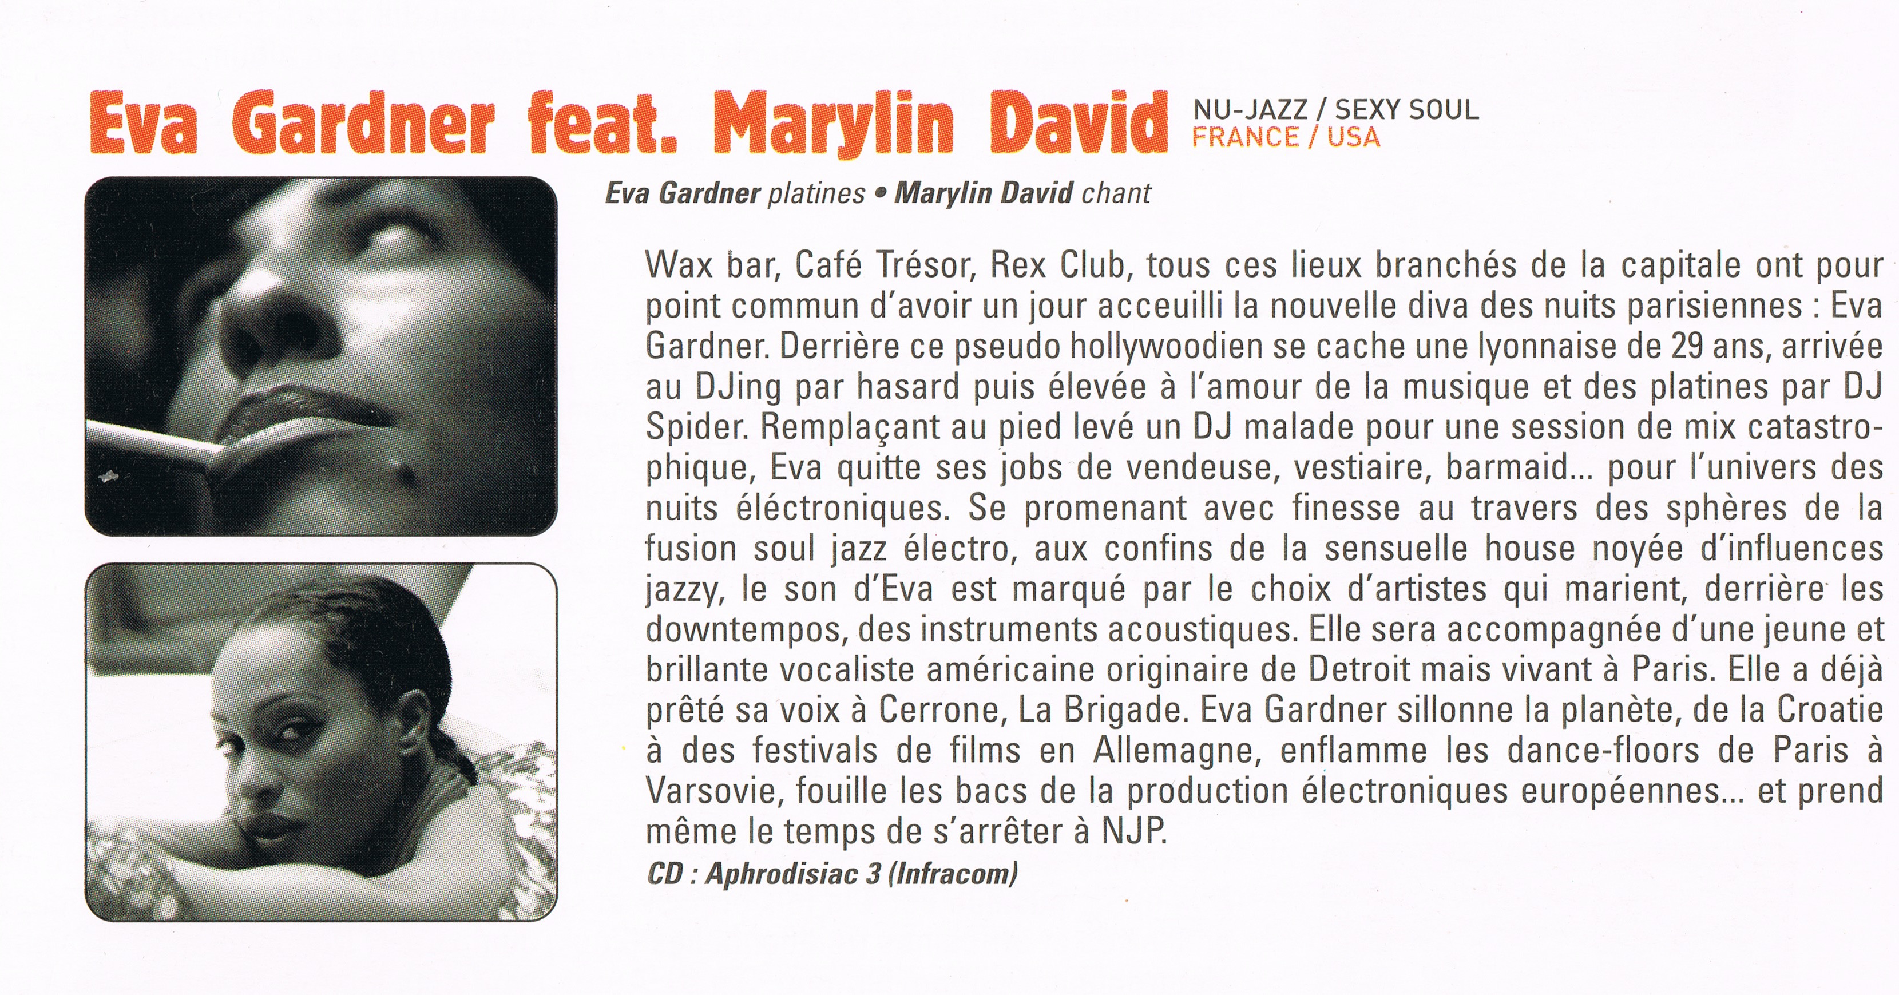
Montreux, Switzerland Nancy, France

St Petersbug, Russia Cargo, London

Fabric, Paris

Live 8, Chateau de Versailles
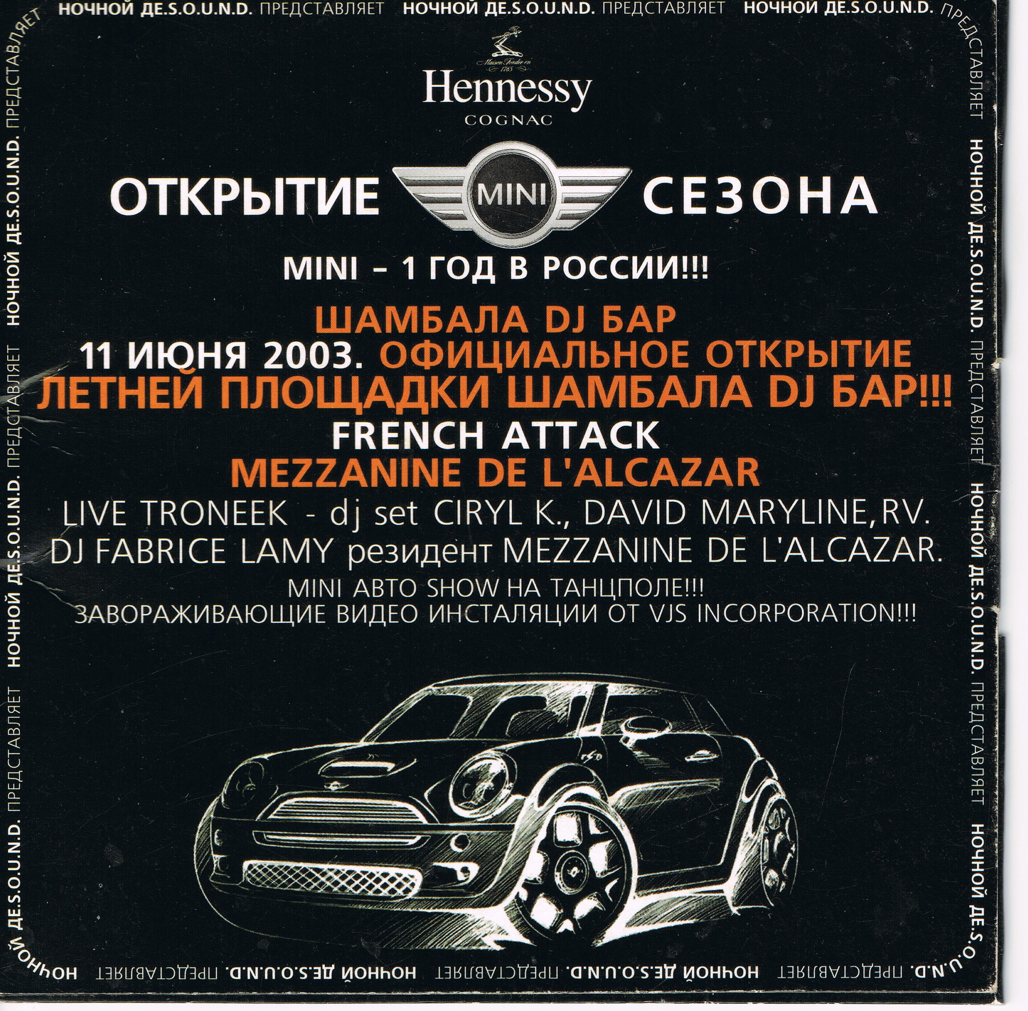
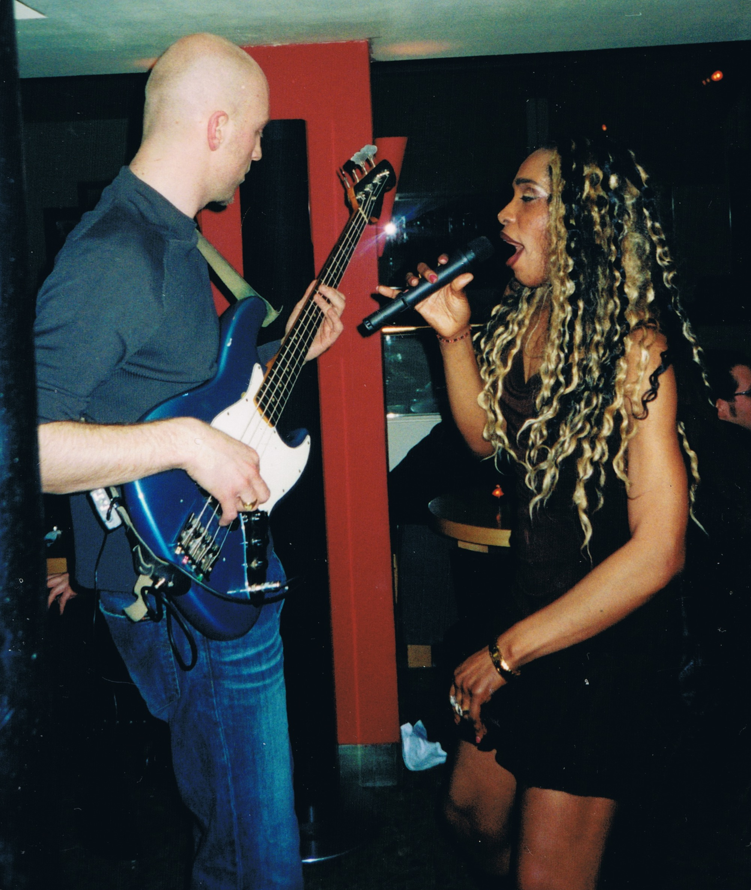
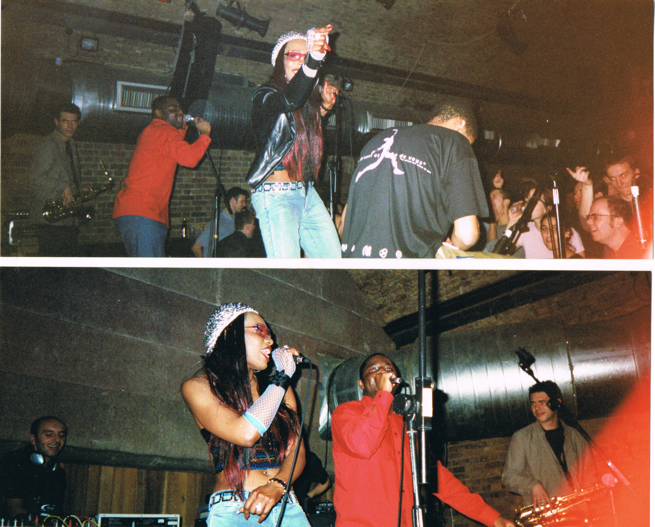
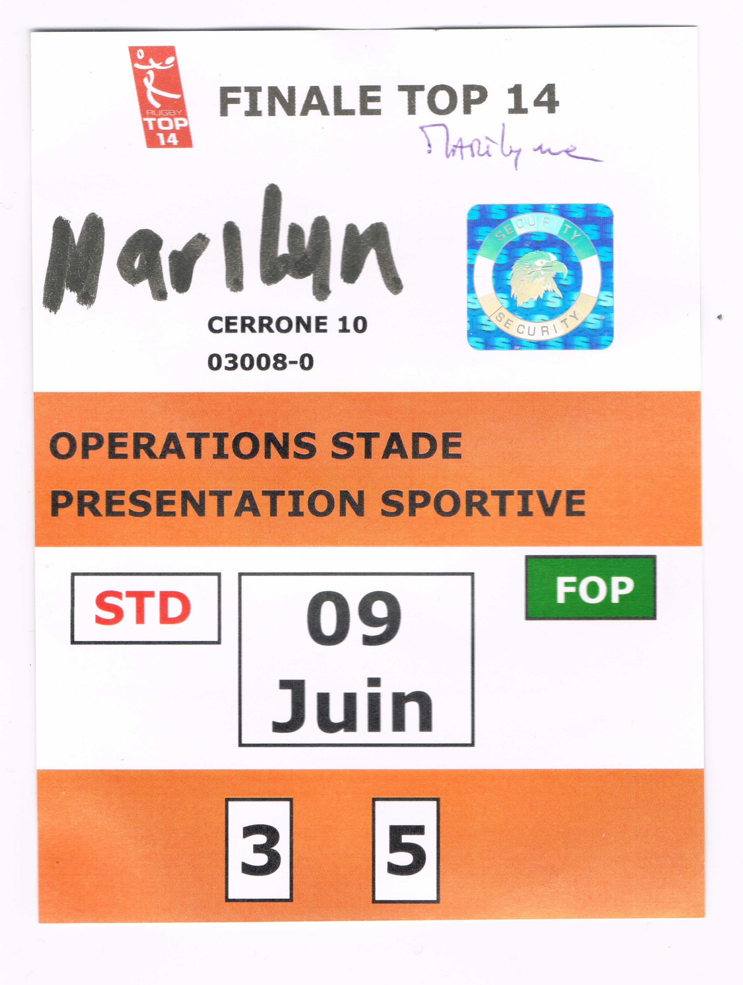
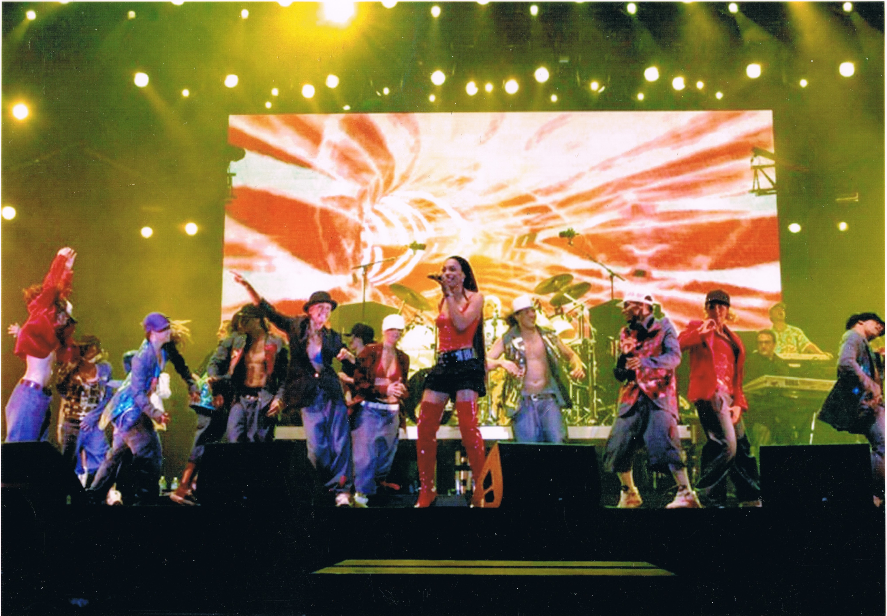
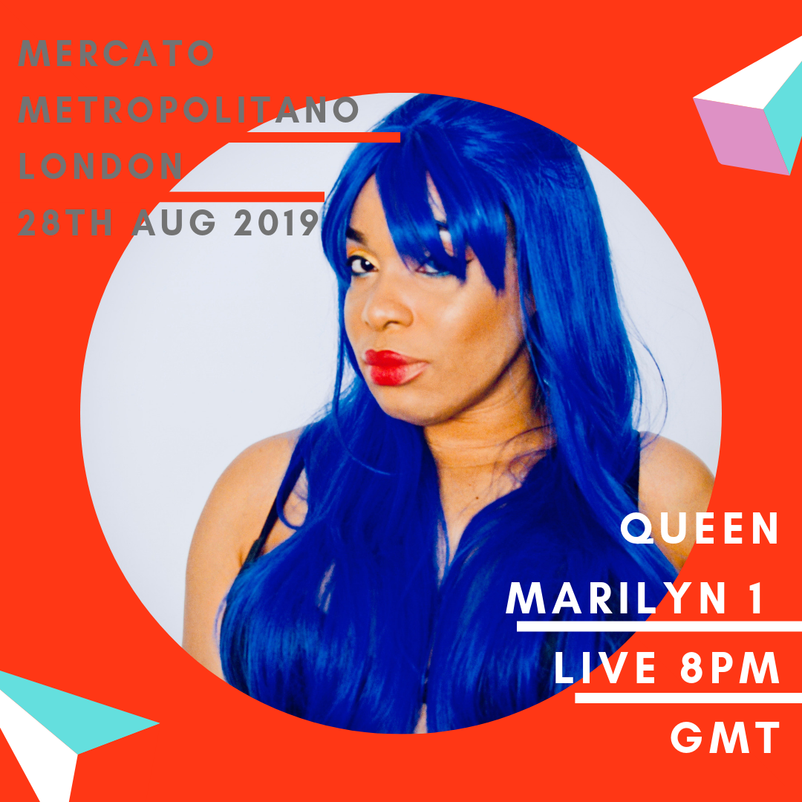
Stade de France

M Music / M Radio Mercato Metropolitan London

Booking / Enquiries Contact:
Andrea Belles.
info@queenmarilyn1.com
+44 7852617770
www.queenmarilyn1.com

