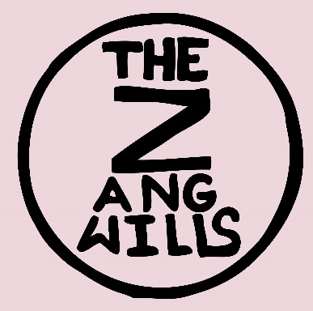
The Zangwills are a young, North West based band. They formed in May 2017, Jake Vickers, Ed Dowling and Sam Davies met at sixth form college in Northwich, Cheshire and the line-up was completed by drummer Adam Spence from Chester.
Each of them bring very different influences to the band and this, along with Jake’s unique voice, is reflected in their distinctive sound which is instantly recognisable as The Zangwills. Described as being, ‘Like nothing else out there, an immensely valuable quality when so many bands disappear into a slurry of sameness’ – by Getintothis.
They are a charismatic band who are generating a lot of interest as their unusual, youthful vibe and energy sets them apart. The four-piece have gained a reputation for their strong live sets, steadily increasing the capacity of host venues around their North West base. They have a growing army of enthusiastic followers who seem to be prepared to travel in significant numbers to watch them play live and can somehow already sing along to the lyrics even before the tracks are released.
The band’s debut single New Heights was released in December 2017 followed by The Horrors of Sobriety, on 30th March 2018 both received great feedback from press and industry connections and most importantly - audiences. September 2018 saw the release of the 3rd single, Patio Paradise taken from their debut EP, It’s Really up to You. Followed by Sunlight at Midnight which came out on 1st February 2019. Their 2nd EP, In Amongst the Glitter is due for release in September 2019, Spielberg Sweethearts taken from the EP, is out on 16th August.

‘The Zangwills took the stage by storm’ – Gigsandtours
‘These are dead, dead, DEAD good! Keep an eye/ear out @Huw Stephens’ - Adam Walton, BBC Introducing
‘The Zangwills are showing all the early indications that bigger things await them’ – Getintothis
‘You are immediately drawn in from the start of the set’ - Northern Alive
‘The Horrors of Sobriety can reasonably be described as a true banger’ - Halfway 2 Nowhere
‘A young band with a lot of talent’ – The Pentatonic
‘The Zangwills have smashed it’ - Popped Music
LIVE – Their 2018 live performances have included headlining at Manchester’s Club Academy in April and at Chester Live Rooms in July. Support slots with Yungblud for SJM Concerts and playing alongside Fun Lovin’ Criminals at Warrington Festival along with a much-coveted satellite support for The Charlatans at their North by Northwich takeover event with the likes of The Slow Readers Club in May. Autumn 2018 saw them venture outside the Northwest region along with headlining Gorilla in Manchester in November. In 2019, the band played their first dates in Scotland and London. Their 2019 festival performances features Liverpool’s Sound City, Focus Wales, Dot to Dot, Rivfest, R-Fest, Goosegreen and a Saturday mainstage slot at Wychwood Festival. They will also headline Manchester’s Deaf Institute on 6th September to coincide with the release of their 2nd EP.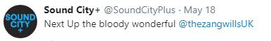
WEBSITE - https://thezangwills.com/
https://www.facebook.com/thezangwills/
https://twitter.com/thezangwillsUK
https://www.instagram.com/thezangwills/
https://open.spotify.com/artist/5Qj5Wwn5TrlAC3Tdr0AVMT?si=761_Nr-JRoigcUg_UKXF5w

MANAGEMENT CONTACT – Jackie Lees jelmusic@outlook.com

