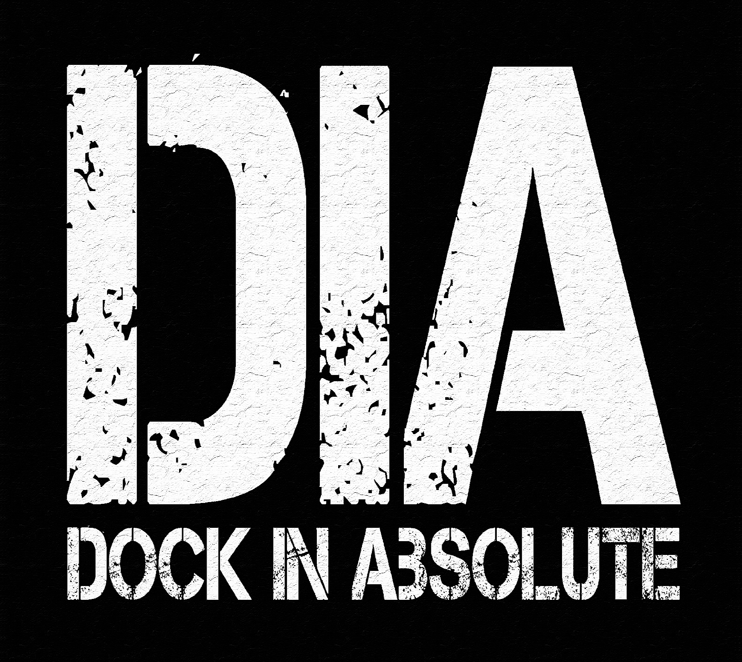
TECHNICAL / HOSPITALITY RIDER

http://www.dockinabsolute.com
https://www.facebook.com/dock.in.absolute

TECHNICAL CONTACT

JEAN-PHILIPPE KOCH -> +352691829359
Contact: jpkoch9@hotmail.com

DAVID KINTZIGER -> +32495230915
Contact: david.kintziger@gmx.fr

TIMETABLE

Setup on Stage: 30 min
Soundcheck: 45m

INSTRUMENTS & BACKLINE TO PROVIDE

1 x Concert Grand Piano:

Good acoustic piano, Yamaha CFX, (CF4, C7, C5), Steinway D (C, B).
The piano must be tuned prior to the concert. Tuning: A= 440 - 442
Sustain pedal in order of operation

2x overheads mics + DI for pickups
1x presentation microphone

1 x Bass Amp:

Preferred : Markbass Mini CMD 121P (8 Ohm) 1x12” / Fender Rumble 25 v3 Bass combo Amplifier / Ampeg or Gallien-Krueger combo amp.

1x Electric Fender Jazz-bass stand
1x Bar Stool
1 Line out (direct box) from pickup

IMPORTANT : We need to use a 220 volt power socket (EU) for the effects pedal rack !

1 x Jazz Drum Kit :

Preferred GRETSH drums, YAMAHA or SONOR.

SPECIFICATIONS :

Bass Drum - 18'' x 14'' or 20'' x 14'' 2 Cymbal Stands
Tom Tom – 12'' x 8'' 1 Hi Hat Stand,
Floor Tom – (with legs please) 14'' x 14'' 1 Foot Pedal
Snare Drum – 5,5'' x 14'' or Deeper 1 Drum Throne

1x table on the left side with soft support (Sheet, towel)
Hight approximatively of the snare drum or less with one microphone
Dampening pads and dampening sheet for the bassdrum

! Use of an Audio Wave file in the first song!



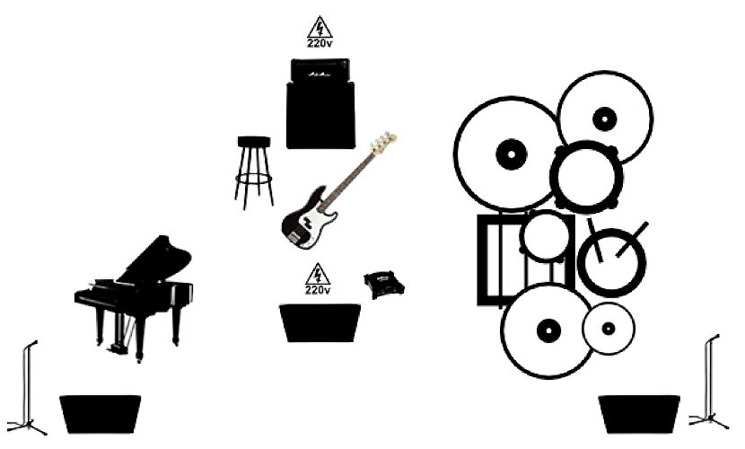

HOSPITALITY

Dressing Room: Clean, dry, well lighted and heated / air conditioned dressing room with chairs, table and a mirror.

Catering: On arrival of artists to be provided in dressing room; mineral water, coffee, green tea & some sandwiches. Promoter will also provide dinner or give a cash buy-out.
Some cold drinks (soda and local blond beer) in the dressing room before the concert.

Hotel: 3 quiet single rooms with private bathroom and internet connection to be ready upon artist arrival.

Local Transport: from and to airport or train station to hotel and between hotel and hall.

CD’s: Promoter will provide a table in an appropriate place as well as a person to sell Artist’s cd’s after the performance.

Complementary Tickets: Promoter will provide artists with guest tickets if needed.

