WEREFOX
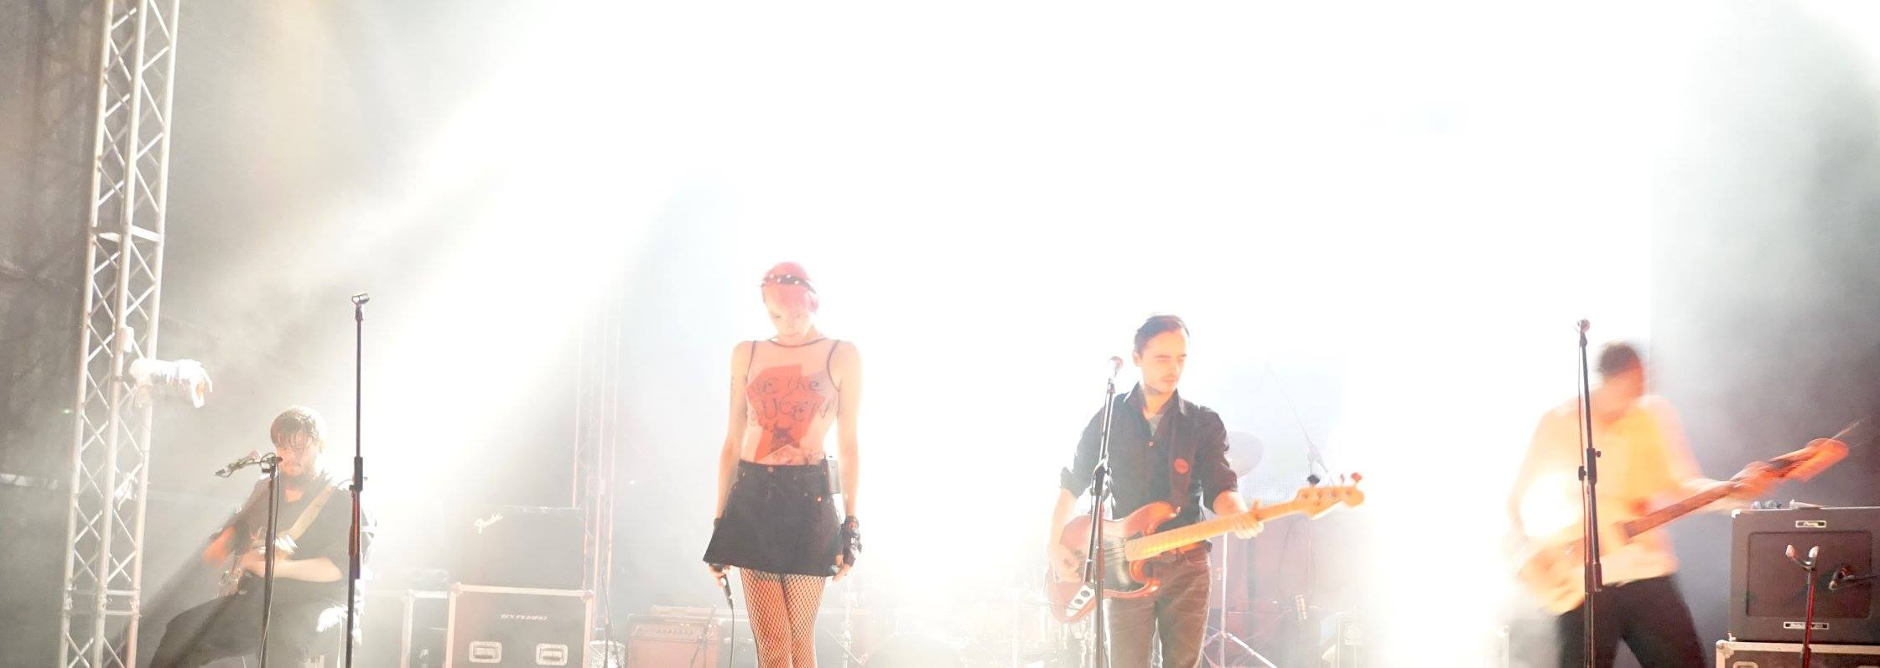
An eclectic combo of dirty sonic to dark-doomish guitar riffs, twisted approach to pop melodies, rich and diverse arrangements - Werefox are a 5-piece alternative rock band from Slovenia, made up of experienced musicians with a rich musical background, who slay with their raw and hypnotic energy on stage.

They have been together since 2011 and have released 2 albums sofar: their debut album "I Am Memory" (GBTM) in 2013 and their current album
"Das Lied Der Maschinen" (Monlee Records) in 2016.

Werefox are by no means newcomers to the music scene, since they are experienced musicians with an impressive concert mileage under their belts. The vocalist Melanija Fabčič - Melée and the guitarist Sašo Benko - Bekko (who is also known for his work in Manul, Bekko, Kleemar´s live band), first crossed paths in the legendary Psycho-Path, who in their 16-year long career released 5 albums and played close to 500 shows all over Europe. After their band split up in 2009, it made perfect sense for them to join forces with colleagues from the regional scene - drummer David Halb and bassist Manuel Hahn who were bandmates in Sphericube and Kleemar's live band. David was also a member of the Croatian Lollobrigida in their most fruitful period. In November 2016 they were joined by guitarist Hannes Jaeckl (of the Sans Secours/Ampersand fame), who is also the producer of their latest album, so they are now a five-piece, which contributed largely to their now even more powerful and edgy sound.

While their critically acclaimed debut album, supported by stylistically sophisticated videos for March of the Finest and The Redneck Genius Story, established them as one of the most intrigueing protagonists in the alternative rock scene of the region, their sophomore record "Das Lied der Maschinen", on which Werefox joined forces with Moonlee Records, takes a step into a different, tighter direction. The album kicks off hard, yet manages to surprise with each following track, displaying rich arrangements, dynamics and diversity. Dirty sonic guitar riffs flirt with anthemic catchiness and take almost pop melodies on a wild ride in a rusty furious machine across a vast stoner desert.

They also collaborated with the American experimental hip-hop group Dälek, who remixed the song Orange Red from their latest album "Das Lied der Maschinen", transforming the original song into a transcendental, meditative 8+ minute odyssey: https://youtu.be/NJKHKYW3ACQ

For Werefox 2016 and 2017 were marked by promoting "Das Lied der Maschinen", appearing on several festivals in the region (including Exit, Lent, 2 Super Dana and Styrian Sounds) and doing club shows in Slovenia. In the fall of 2017 they embarked on their first tour of Croatia, Bosnia, Macedonia and Kosovo, which was so successful, that they returned to the Balkans in the spring of 2018; this time they also visited Serbia, Romania and Bolgaria. In the fall of 2018 their third tour of the Balkans followed, which took them to Serbia, Macedonia and Kosovo; as part of this tour they also performed at the PIN conference in Skopje.

In November of 2018 Werefox released their single PRETTY GIRL NEEDS A BATH, enhanced by a video created by the band’s bass guitarist Manuel Hahn and his brother David Hahn, featuring the roller-skating skills of Katja Djukič. The video is the first in the series of conceptual videos, announcing their upcoming third album (scheduled to drop in the beginning of 2020).

In March 2019 their second single THIS IN-SYNC-THING was released. The striking accompanying video, directed by the Hahn brothers, paints a surreal dream vision of a split personality experience, starring the acclaimed dancer Rosana Hribar and the band´s singer Melée.

Right now the band is preparing for the fourth Balkans-tour, which starts on April 27th.

Lineup:
Melée – vocals,
Sašo Benko – guitar, vocals,
Hannes Jaeckl - guitar,
Manuel Hahn - bass, vocals,
David Halb – drums.

LINKS: www.werefoxband.com
http://werefoxband.bandcamp.com/
www.facebook.com/werefoxmusic

Current single: TRIADS (https://youtu.be/Cns7FR5zxP0)

Booking: Goc Manasievska @ AKASHA BOOKING (booking@akashabooking.com)

