SonicTribe d.o.o.
Podmilščakova 16,
1000 Ljubljana, Slovenija
st@sonictribe.net

MRFY
TECHNICAL RIDER

The band’s team

BAND MEMBERS
Gregor Strasbergar | main vocal, guitar
Tomaž Zupančič | kitara, back vocal
Lenart Merlin | bass guitar, back vocal
Rok Klobučar | drums

CONTACT
Gregor Strasbergar | 070 831 705
Žiga Blazinšek | 040 878-380

AUDIO ENGINEER
Gregor Bajc | 051 606 820

ADDITIONAL INFO
mrfy.official@gmail.com
facebook.com/pg/MRFYnm
instagram.com/mrfy_band/
About: www.sonictribe.net/mrfy

Requests

SOUND CHECK
- at least 15 minutes for preparation of stage needed and
- at least 45 minutes for soundcheck needed

2x Vocal
Front stage, center and right

2x Guitar
Lead Guitar 2 amplifiers (combo Crate Vintage tube 30 2x12 + mini Vox ) + pedalboard
Vocalist – Rhythm guitar (DV Mark Galileo amplifier and DV Mark 2x12 box) + pedalboard + DI box for acoustic

Bass Guitar:
Markbass amp, box Markbass 4x10

Drums:
- 1x Snare,
- 1x Kick
- 1x Hanging tom,
- 1x floor tom,
- 1x crash
- 1x ride
- hihat

STAGE PLOT
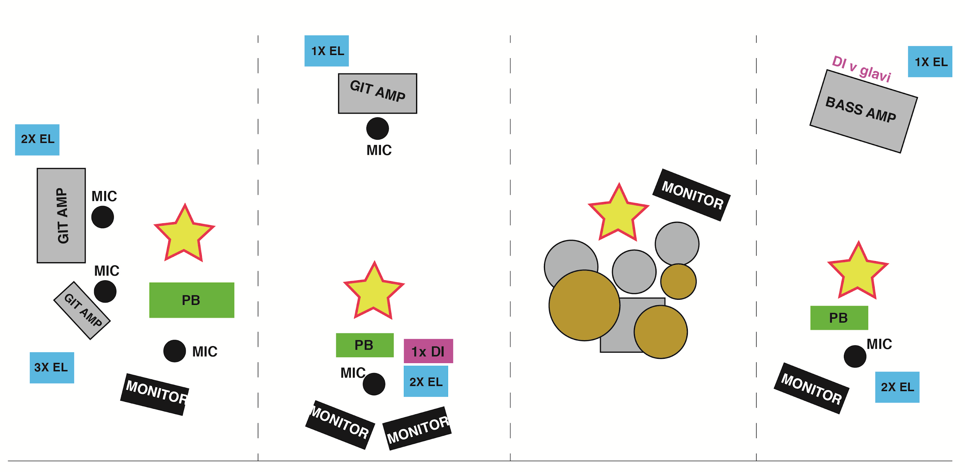

IMPORTANT
The doors of the club should be closed until the soundcheck ends.
Front of the house requirements

A MINIMUM REQUIREMENT
An analog/digital mixer with at least 16 inputs/outputs and 2 send/return FX channels (4 if available for optimum sound performance)

INPUT LIST
(May vary depending on the venue, please ask the SE for opinion at venue, also the choice of microphones must be discussed, based on availability)
- Kick / Insert: Gate>Compressor
- Snare Top / Insert: Compressor
- Snare Bottom / Insert: Gate>Compressor (if possible)
- Floor Tom / Insert: Gate>Compressor
- Hi Hat
- Ride
- OH L (if place needs overheads)
- OH R (as before mentioned, if place needs them)
- Bass DI (DI BOX) / Insert: Compressor
- Bass Mic
- Guitar Left (solo guitar)
- Guitar Right (singer guitarist)
- Vocal Front Left (lead guitarist)
- Vocal Front Center (Main Vocal,Rythm guitarist) Insert: >Compressor
- Vocal Front Right (bassist)

FX
2 FX are a minimum for the band perform, 4 are optimum if available.:
- Reverb #1: Drum Room (1,2 sec, Wide, If available)
- Reverb #2: Hall Reverb (3-4 sec) (Minimum!)
- Reverb #3: Plate Reverb (1 sec) (If available)
- TAP Delay #4: (MINIMUM!)
Each of these sends should have stereo returns tracks, on which the sound engineer should have the possibility of signal processing.

Hospitality rider

- Warm meal
- 2 litres of wine
- 2 liters of sparkling water
- Jameson+Sprite or Gin+Tonic or Vodka+RedBull
- 1 litre of orange juice
- Bottled water

