Astra The 22’s Press info

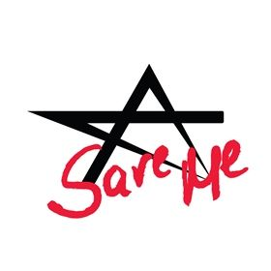
05.06.2014.
Listen to „Save Me”:
https://soundcloud.com/micrec-publishing/astra-the-22s-save-me
The Latvian singer/ songwriter Kerija Kalēja and the American musician/singer Eric Jayk magnetic duo „Astra The 22’s” are releasing their second single „Save me”. Bands first single „Catwoman” was released beginning of March and has been played on Latvian, Estonian and Lithuanian and a few US radio stations, where they have received great reviews about the duo’s new single. The song was mixed in New York by Kyle Kelso and mastered in Los Angeles by Howie Weinberg.
American actress and TV show star did not hide her excitement about the song (Sandra Bernhard)"Save me is a driving moody and sexy ballad, the kind you want on in the background of your first night of love or for a dramatic breakup, the perfect hot soundtrack''
The Satellite Radio on air personality Lüc Carl is short and sweet: - "Electrified hair sprayed pop, Eric Jayk does it again!"
The main voice of the song Kerija Kaleja talks about the song: - ‘’ The story and the meaning of the song is that no matter, where people are in this world or what is happening to them; they all have the same emotions, such as sadness, loneliness or love and pretty much everyone is looking for the same emotions.’’
Soon to be released full video of „Save me” , which has taken place in Riga, Berlin and New York.
In the beginning of September Astra The 22s are planning to perform in the Baltic countries.

Interview With Astra The 22’s
Posted on March 10, 2014Vanessa PintoInterviews, Music
Duo band Astra The 22’s is comprised of Latvian singer/songwriter Kerija (Kerry) Kaleja and the American singer/multi-instrumentalist Eric Jayk. The band’s music encompasses styles of indie pop and dance, combined with rock influences and elements. Kerry has highly valued Eric’s talent and experience in music from previous projects such as Wildstreet Music, a New York City 80’s arena rock n’ roll band. After a while, Kerry and Eric found out that they were musically synced and decided to unify their musical talents.
Their first single, Cat Woman, has been released on iTunes and on SoundCloud. Their music video is on YouTube with the captivating phrase, “how can you see the world without blinking?” as a preface to their song. Cat Woman was recorded and mixed in New York with Jayk and Kyle Kelso, whilst a master of the song has been made by Howie Weinberg, who has received 4 Grammy nominations, 200 Gold albums in the US and worked with major acts like The White Stripes, Nirvana, Red Hot Chili Peppers and others. Astra the 22’s is currently based in Riga, Latvia and New York, NY, with the band performing in both cities. I caught up with Kerry and Eric to talk about their music and how it’s progressed over the years.
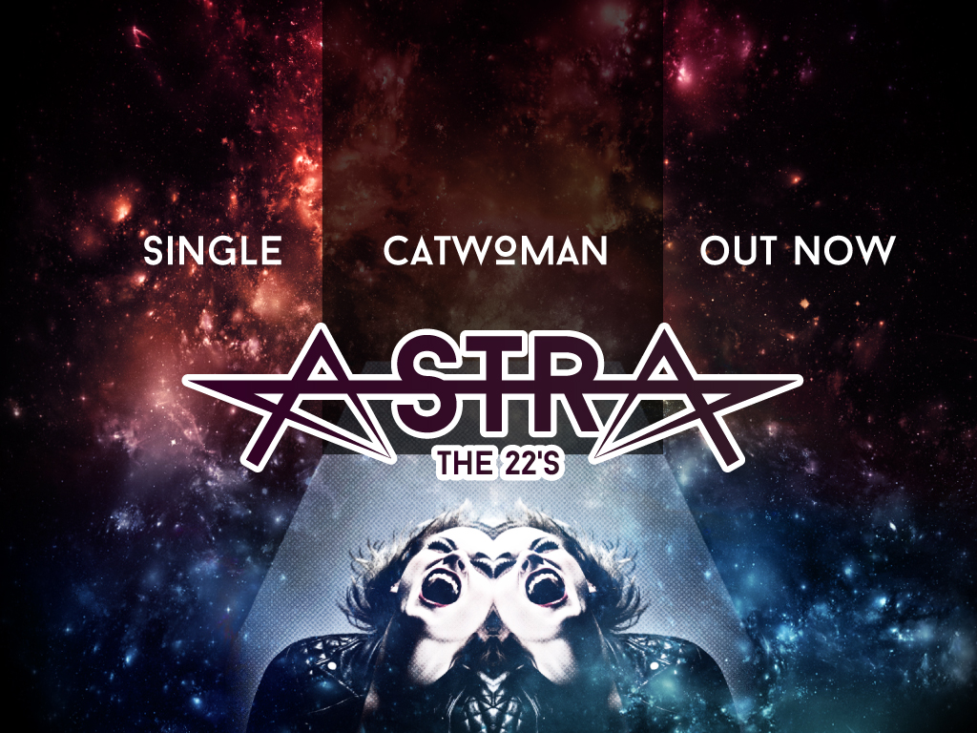
CF: Astra The 22’s was founded in New York City. Describe the startup and how New York City served as the backdrop.
Kerry: Let’s just say Astra The 22′s was founded in NYC on the 22nd day and in the 22nd building! First it was a different band but now the main components of the band are Kerija Kaleja and Eric Jayk.
CF: New York verses Latvia…how do your fan-bases in each location differ?
Kerry: Music is something so universal that there are not many differences when it comes to fans and the people that listen to your music. Yes, there are many other differences like cultural, social etc., but when it comes to music it unites everyone across the world.
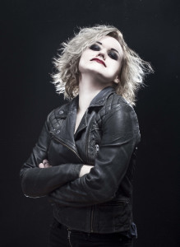CF: What are the challenges of performing as a multi-instrumental artist?
Eric: Deciding which instrument to play or which would suit the sound of the part you’re writing best. One can achieve any sound on any instrument with the right tools and technique.
CF: What were your first instruments and when did you begin playing them?
Eric: My first instrument was guitar. I started playing when I was 8 years old and began playing professionally when I was 11.
Kerry: My main instrument is my voice. I started studying vocal techniques when I was 12. Meanwhile, I have studied piano and guitar.
CF: How has your style of music transitioned over the years?
Eric: My musical ear is a constant state of evolution and flux. I never limit myself to one musical style for very long. I get bored easily. I think artists need to push themselves in every sense…learn from everything and everyone, from artists of all mediums, and the world around them.
Kerry: My musical style has changed in the way I write music, but I have always been interested in various music genres from Frank Sinatra to Led Zeppelin to Michael Jackson, Queen and some heavy metal. I have always been interested in all aspects of music no matter what genre.
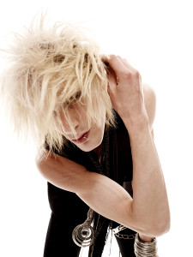CF: How are your interests and personal style highlighted in your music?
Eric: I think songs are snapshots of where my interests are at in a particular moment of time. As an artist you’ve got to try not to get stuck in that moment. You have to create the best work you can without judging, and then accept it for what it is/was and move on.
Kerry: I agree with Eric, I think you have to look for something new out there in the world and people as well as, and look into yourself to create the best possible work. Then let it live out there in the universe because someone out there will get you and the emotions you have.
CF: In what way does your mood influence your music?
Eric: It’s art, pop art shall we say. Emotions, physical/mental state and mood are the fundamentals to determining the sounds, style, beat and tonal choices we make.
CF: What personal mantras do you both live by?
Kerry: To know what you want to do and do it. While you are doing (whether it be writing/creating) what you want to do, your personality and ability show.
Eric: If you bring forth what is within you, what you bring forth will save you. If you do not bring forth what is within you, what you do not bring forth will destroy you.
CF: How can future fans follow your updates?
Kerry: Visit our Facebook page: https://www.facebook.com/astrathe22s and Twitter:https://twitter.com/AstraThe22s.

