MÖRK TECHNICAL RIDER

CHANNEL NUMBER | CHANNEL NAME | MIC/DI | OWN/REQUEST
1 | KICK I | BETA91A | OWN
2 | KICK O | PREF. B52 | REQUEST
3 | SNARE T | SM57 | OWN
4 | SNARE B | SM57 | OWN
5 | SNARE 2 | SM57 | REQUEST
6 | R TOM | PREF. MD421 | REQUEST
7 | F TOM | PREF. MD421 | REQUEST
8 | COWBELL | SM57 | REQUEST
9 | HH | PREF. SM81 | REQUEST
10 | RIDE | CM3 | OWN
11 | CRASH | CM3 | OWN
12 | STACK | PREF. SM81 | REQUEST
13 | SPD L | DI BOX | REQUEST
14 | SPD R | DI BOX | REQUEST
15 | BASS | DI BOX | OWN
16 | GTR | SM57 | REQUEST
17 | NORD L | DI BOX | REQUEST
18 | NORD R | DI BOX | REQUEST
19 | KORG | DI BOX | REQUEST
20 | DRMS BV | SM58 | REQUEST
21 | BASS BV | SM58 | REQUEST
22 | VOX L | DI BOX | REQUEST
23 | VOX R | DI BOX | REQUEST

ALSO REQUESTING:
-IN HOUSE ENGINEER
-4 SMALL BOOM MIC STANDS
-3 BIG BOOM MIC STANDS
-25 XLR CABLES
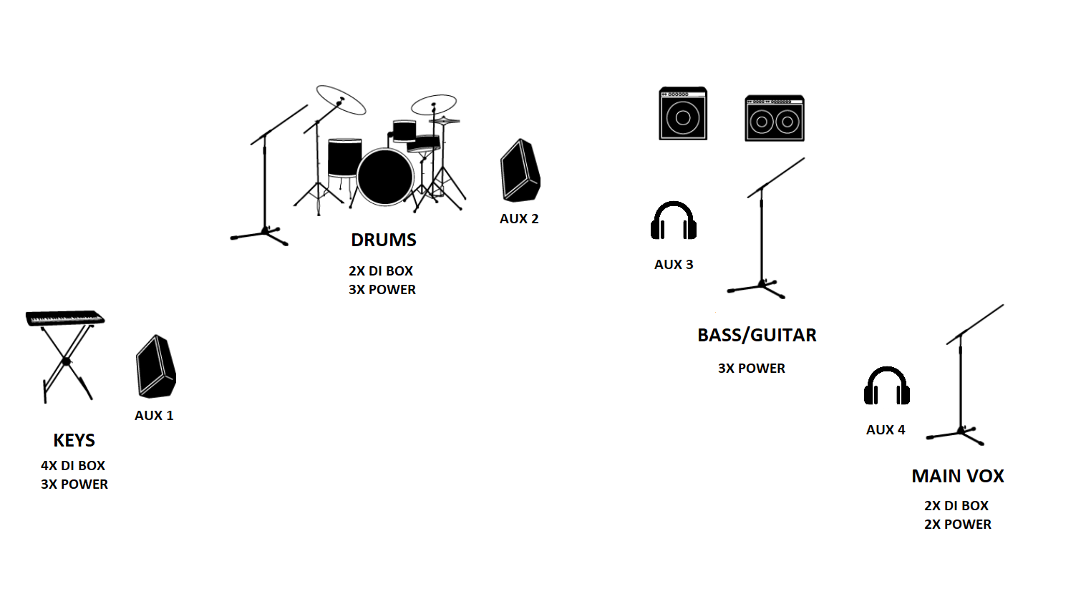

TECHNICAL CONTACT

ABEL ZWICKL
+36 30 720 9086
ZWICKLABEL@GMAIL.COM

BAND MANAGER

DENES PECSI-SZABO
+36 20 999 9885
DENES@UPMUSICBUDAPEST.COM

