The Ills (SK)

"An awesome expressive instrumental rock band. I love them. I need their music."
- Kevin Cole, KEXP

"Post-rock, experimental, shoegaze, prog-rock - they do it so well! An excellent band."
- Vic Galloway, BBC Radio

"Ethereal and gentle one minute, dark and chaotic the next; here’s a band to stand next to Red Sparrows, Explosions in the Sky and Mogwai in depth and extremity."
- Clash
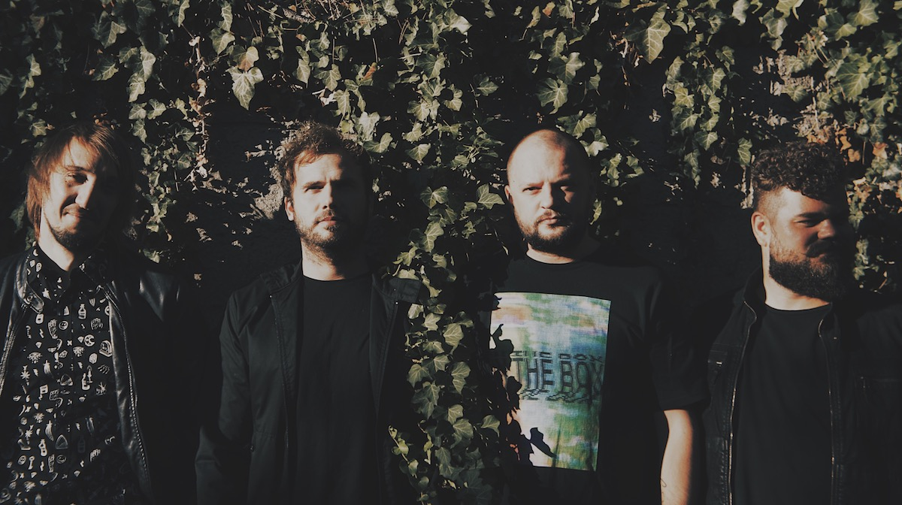
The Ills are Martin Krajčír (guitar), Ľuboš Hodás (drums), Peter Berák (bass) and Miro Luky (guitar).
Starting back in 2008 as more of a bedroom project in a tiny flat in Bratislava, a place full of different kind of instruments which they first picked up in what had to be just a little break in a gaming session on playstation, The Ills soon became a regular band.
The Ills are being put into a post-rock box, however it is also shoegaze and elements of math-rock and prog-rock that can be heard in their songs. They are definitely most characterized by their live performances where their musical skills, intense atmosphere combined with intimate parts meet with punk attitude and almost hardcore drive.
With two guitars, bass, drums and no vocals The Ills have played at various places from small pubs and cellars through art galleries and clubs to festivals such as Iceland Aiwaves, Eurosonic Noorderslag, Pohoda, MENT, Incubate, Colours of Ostrava, DUNK!, Waves Vienna, Waves Bratislava, Wilsonic, Creepy Teepee or Rock For People.

Over the years they have played in Iceland, Denmark, Sweden, Netherlands, Belgium, Luxembourg, Germany, Austria, Slovenia, Hungary, Poland, Croatia, Serbia, Macedonia, Czech Republic. They toured with Japanese band Tricot in March 2016 and have also shared stages with the likes of And So I Watch You From Afar, God Is An Astronaut, Russian Circles, Rosetta and many others.
The Ills have so far released four albums. After the debut album To Wish Impossible Things (2010) and critically acclaimed Splendor (2012) and Zoya (2014), they released their fourth and so far best received album Ornamental or Mental in 2016.

The latest album Ornamental or Mental has been praised and played by the likes of Kevin Cole of KEXP, Vic Galloway of BBC Radio Scotland, Klaus Fiehe of WDR 1 Live and Byte_FM. Moreover the band's music and live performances impressed media like Drowned In Sound, Clash, IQ Magazine, Arctic Drones and many others.

Their track "4:17" was selected the Song of the Day on KEXP in March and both "4:17" and "Waltz On Mars" made it to the Music That Matters podcast as well on KEXP. Consequence of Sound even selected their concert into the list of 25 Most Exciting Performances At Iceland Airwaves 2016.

The Ills' new album called Disco Volante / Mt. Average will be released on 19th February 2019 on Deadred Records. First single "Squarevoucher" on 17th January 2019.

Links:
Web: http://theills.net
Soundcloud: https://soundcloud.com/the-ills
Bandcamp: http://ills.bandcamp.com/
Facebook: https://www.facebook.com/theills
Twitter: https://twitter.com/theills
Instagram: https://instagram.com/theillsmusic
Youtube: https://www.youtube.com/channel/UCcORhh1csgJsgmfYzHYgDTw/videos
Spotify: https://play.spotify.com/artist/4bw6dczMWjx5X4wUqeSKP7
Deezer: https://www.deezer.com/en/artist/1148907
iTunes: https://itunes.apple.com/us/artist/the-ills/78200262
Video:
Elsker (live, 2018): https://youtu.be/zqiAuCRGqrk
Fire Flies (live, 2016): https://youtu.be/cD2J82RUXX8
4:17 (live, 2016): https://youtu.be/Tl6GW2tnrSg
Cross The Seas My New Disease (live, 2016): https://youtu.be/8nzzbSSx-ho
Born Under The Mournstar (2014): https://youtu.be/JoeudSJ2wrU
Contact
Management & Booking: Tatiana Lehocká, tana@realsomething.com
Press Quotes

"Mixing elements of shoegaze, math rock, and punk into pretty, melodic swirls, they sound like a more laid-back Foals, and aren’t afraid to dial down the intensity and reveal a more introspective side. Heroes who have carried the Slovakian flag far and wide."
- Drowned in Sound, 2017

" I had a hard time picking a song, because I love the whole damn album, Ornamental or Mental. Today’s featured song, “4:17″, surprises with light flourishes and transcendent riffage that explode out of the dark, relentless, heart-tripping propulsion that anchors the song. They were fantastic live… locked into the groove, riding a wave of sound."
- Kevin Cole, KEXP, 2017

"Sprawling post rock darkness, lightness of jazz and floating shoegaze."
- Gigwise, 2017

"With deft musicianship, interplay and melodic ideas all of their own, they pack an emotional punch in the world of instrumental rock."
- Clash, 2016

"...Slovakian quartet’s massive, heavy post-rock/math/shoegaze slabs more than rewarded (my) curiosity. Thanks to my stumbling and lucking into their instrumental swells, I felt like I was floating a few inches off the ground."
- Consequence of Sound, The 25 most exciting performances at Iceland Airwaves 2016

"The band's live performances are electric, with their musical skills fostering an intense atmosphere."
- IQ Magazine, 2016

"Post-rock, experimental, shoegaze, prog-rock - they do it so well! A really powerful, passionate performance on a big stage, they looked like they owned the stage. They are in the line up of Iceland Airways and I am sure they won’t get lost there. An excellent band."
- Vic Galloway (BBC Radio), 2016

"Very well composed and played. They have everything that is needed, power, emotion and style."
- Ruud Berends (Eurosonic Noorderslag)

"(The Ills) have just delivered a blinder at Pohoda Festival.... – a name to watch, we hear."
- 9/10 review for concert at Pohoda 2016
- Virtual Festivals, 2016

" The Ills are a great prog band, really strong production value. Very interesting, very tight. I became a fan."
- Jeremy Hulsh (Oleh! Records)
"The Ills I really liked. I would like to hear more and definitely stay in touch."
- Adam J Ryan (The Great Escape)

"The four guys (two guitars, bass and drums) from Bratislava are so perfectly in tune with each other that they don’t need to sing along to their astonishing and intricate arrangements."
- Mokant, 2016 (AT)
"The Ills are famous for their magical mathematic guitar work. Everything is right, everything fits perfectly, melodies work with and within each other, the wheels are turning."
- Full Moon (CZ)

"The Ills' music takes you on an exciting journey through picturesque landscapes. Plus they successfully avoid falling into the classic post-rock dreamy monotony of constant tempo changes and dynamics. Just when you are complacent, you jerked. Just when you get excited, they calm you down. They totally play with it and have fun with their instruments and the audience, while not caring in the least for the rules of the genre."
- Terapija.net (HR)
"No one does shoe-gazing in Slovakia as well as Ills. Their latest LP, “Zoya”, is once again a slow, noisy, climatic joy."
- Beehype (PL)

