FOR IMMEDIATE RELEASE

OUT OF NATIONS: GLOBAL SOUNDS IN DIVERSE SOUNDSCAPES ON THEIR DEBUT ALBUM
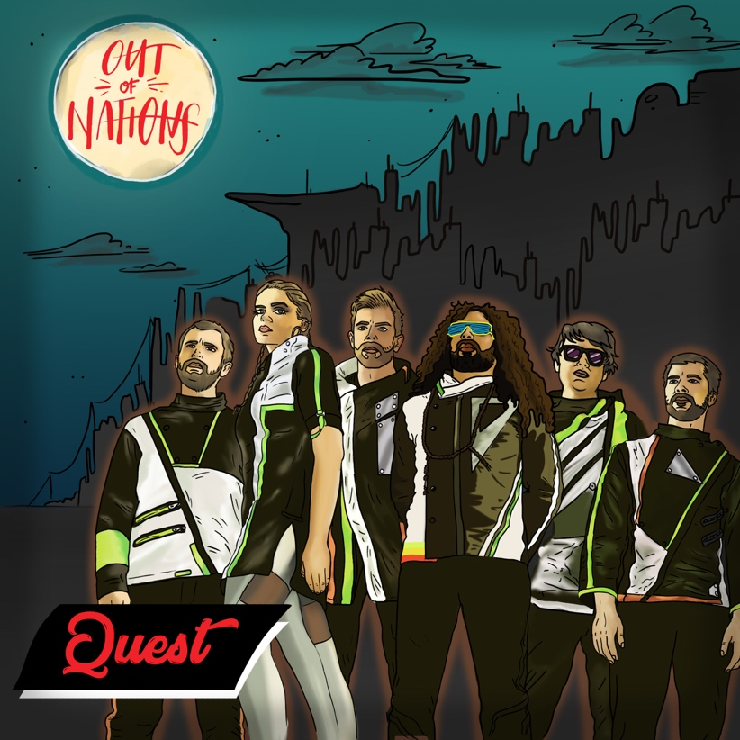
Artist: Out Of Nations
Title: Quest
Catalogue No: TUGCD1115
Barcode: 605633011524
Label: Riverboat Records
Release date: 31 August 2018

Out Of Nations releases their debut album August 31st 2018 on Riverboat Records/World Music Network, celebrated by a pre-release tour with stops at the UfaFabrik Berlin, MeYouZik Festival Luxembourg, and NeuStadt-Lab in Bern, Switzerland. Fueled by a global span of influences and inspiration, Out Of Nations is a band that looks to break down the preconceived limitations of music and geography. The six elements on stage provide an eclectic mix of electronica, funk, pop, jazz, rock, and spin elements of traditional music from Latin and Arab countries — an alternative-world soundtrack to match the visual wonderland they create on stage.

Out Of Nations is a dream for a future world where people take each other as humans before they see each other as members of a certain nation. The team connected on a musical level before realizing that most of them carried different passports.

The melodies featured on the album “Quest” were written between New York City, Cairo, Beirut, and Berlin by Lety ElNaggar a Columbia University educated reeds player and composer born to Egyptian and Mexican immigrant parents in suburban America. She and producer Khalil Chahine developed album tracks that each tell part of a global story of music with a modern sound, taking inspiration from their Middle Eastern and Latin heritage and the pop-classic, funk, rock, electronic, and jazz artists that were always spinning in the background.

Lety, whose travel was sparked by a Fulbright fellowship in 2012, was inspired by experiences traveling through the USA, Europe, and Middle East throughout the past decade. Throughout her travels, she witnessed waves of increased xenophobia, border security, and violence – trends she viewed as obstacles in the way of ordinary people traveling, thinking, and living “Out Of Nations.”

“Having lived in four countries where I'm immediately recognized as foreign (including the US where I was born), ‘where are you from’ is one of the first questions people ask me,” explains Lety, “I'm American but I'm also Egyptian and Mexican so my answer is usually a bit complicated, and within Out Of Nations we all have a multi-layered answer – almost no one lives in the city they were born in, so everyone is a migrant, and we also still hold on to some passport that designates where we can live, work, and travel. We're living in an age where we can share information and transfer money at the speed of light, so we hope the diversity of our music can draw attention to the idea that these kinds of global ranking systems that advantage and disadvantage different groups of humans based on their heritage or where they were born are outdated for our times.”

The recording process was a journey in itself, with sessions in Brooklyn, Berlin, Beirut, and Cairo. Though they originally planned to record at Egypt’s renowned Studio Layla, a fire unfortunately consumed the studio just before the first session. Within 12 hours the studio had burned down, suffering a total loss, including a rare Neve mixer and countless other pieces of high-end equipment. Though shocking and sad, what amazed the team was the effort of the Layla team and musicians to find another place and time to record on short notice to get the optimum result from the trip.

The band's futuristic take on “World Music” challenges norms that musicians performing music from non-Western parts of the world emphasize the difference of their home countries through traditional, exotic dress and performance. Out Of Nations instead performs in sleek futuristic garments, reflecting a post-racial, post-national future world.

Out Of Nations' first released single was a twist on Egyptian classic “Sellem Alay,” briefly titled “Sellem,” that garnered thousands of plays and created a buzz across social media. Followup single “Fiebre” received rave reviews in the Huffington Post and by Worldbeat Canada. “Sellem 2.1 Remix ft. Fayrouz Karawya” remained in the first 10 tracks of popular Middle Eastern streaming site Anghami’s “EDM Gone Arabic” playlist for over 5 months.

A music video for “Quest,” the album’s title track, will follow the record release, featuring an international production team drawing influences from contemporary fashion, dance, filmmaking, and animation to match the track’s variety of soundscapes. “Quest” represents a journey between cultures, inspired by a single melody composed on clarinet and developed into many musical visions based on images of global destinations. Listeners are invited on a trip through the city, jungle, and desert, with a cinematic touch seamlessly tying them together.

Out Of Nations' concept, visual aesthetic, and music are produced by Khalil Chahine.

# # #

