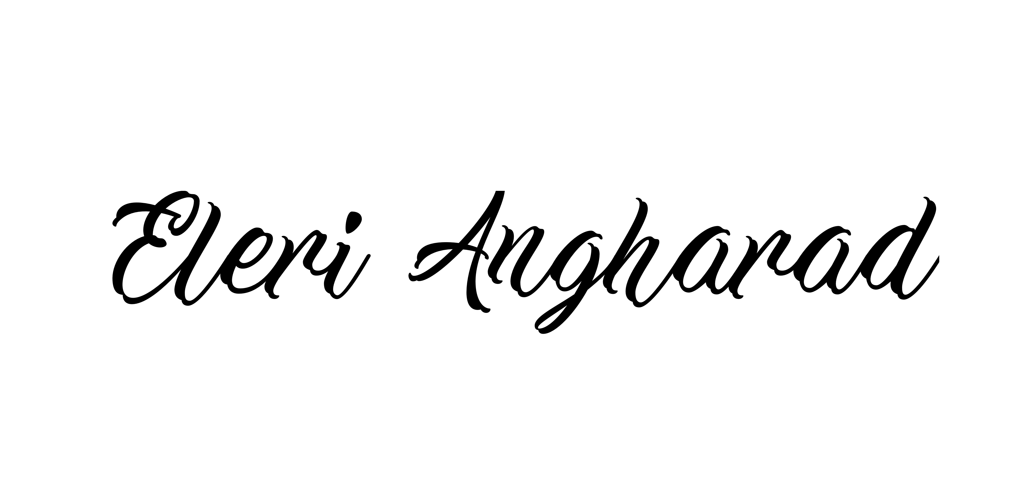
Country Artist from Swansea releases NEW SINGLE ‘This Ship’ October 26th!

Eleri Angharad is thrilled to announce that her new single ‘This Ship’ will be released through Train Track Records on October 26th 2018, the first song from upcoming debut album ‘Earthbound’

Eleri is a Country artist from Swansea, drawing influences from James Taylor, Kacey Musgraves and early Taylor Swift records. Her new sound was inspired by a North American road trip she embarked on at the age of 19, writing, busking and performing in cities such as Chicago, New York and of course Nashville. Ever the traveller, Eleri has also performed at the Edinburgh Fringe Festival and Stockholm’s Folkcentrum.

Eleri has previously gained airplay on BBC Radio Wales, BBC6 Music, Nation Radio and BBC Radio Cymru – with her last EP funded by the BBC Horizon’s scheme. ‘What a beautiful and crystalline voice!’ – Adam Walton, BBC Wales

‘I am currently busy writing and recording tracks for my debut album 'Earthbound', a body of work based on stories of my travels and performances around the US, Ireland and Sweden. My new music is fuelled by my passion for Nashville guitar driven, organic sounds blended with the roots of my Welsh upbringing.’ – Eleri Angharad

The single was recorded at Woodcroft in Cardiff and produced by Lee House, previous sound engineer at Acapela Studio who has also worked with Welsh Artists Amy Wadge and Cerys Matthews. The track features local musician Scott Mckeon, of the band Rusty Shackle, on violin, mandolin and bohran. This blends seamlessly with Eleri’s crystalline vocals and Lee’s electric slide guitar to create a modern country feel.
‘‘This Ship’ is based on a turbulent relationship between two people who feel like they’re constantly on stormy seas, trying to ride each wave and keep off the rocks. The girl in the song realizes she had the power all along to sink the ship and walk away. I really hope it can empower someone to realize they can always take control of a really out of control situation.’ – Eleri Angharad

Eleri has also been filming a video for the single with the award-winning, Cardiff based videographers Fine Rolling Media, which will be released in November this year.

‘This Ship’ is available online from Friday 26th October at http://www.eleriangharadmusic.com , iTunes & Spotify, or the following Soundcloud link:

Soundcloud ‘This Ship’ - https://soundcloud.com/eleri-angharad/thisship

Social Links:
https://www.facebook.com/EleriAngharadMusic
https://twitter.com/EleriAngharad92
https://soundcloud.com/eleri-angharad
https://www.youtube.com/eleriangharad

