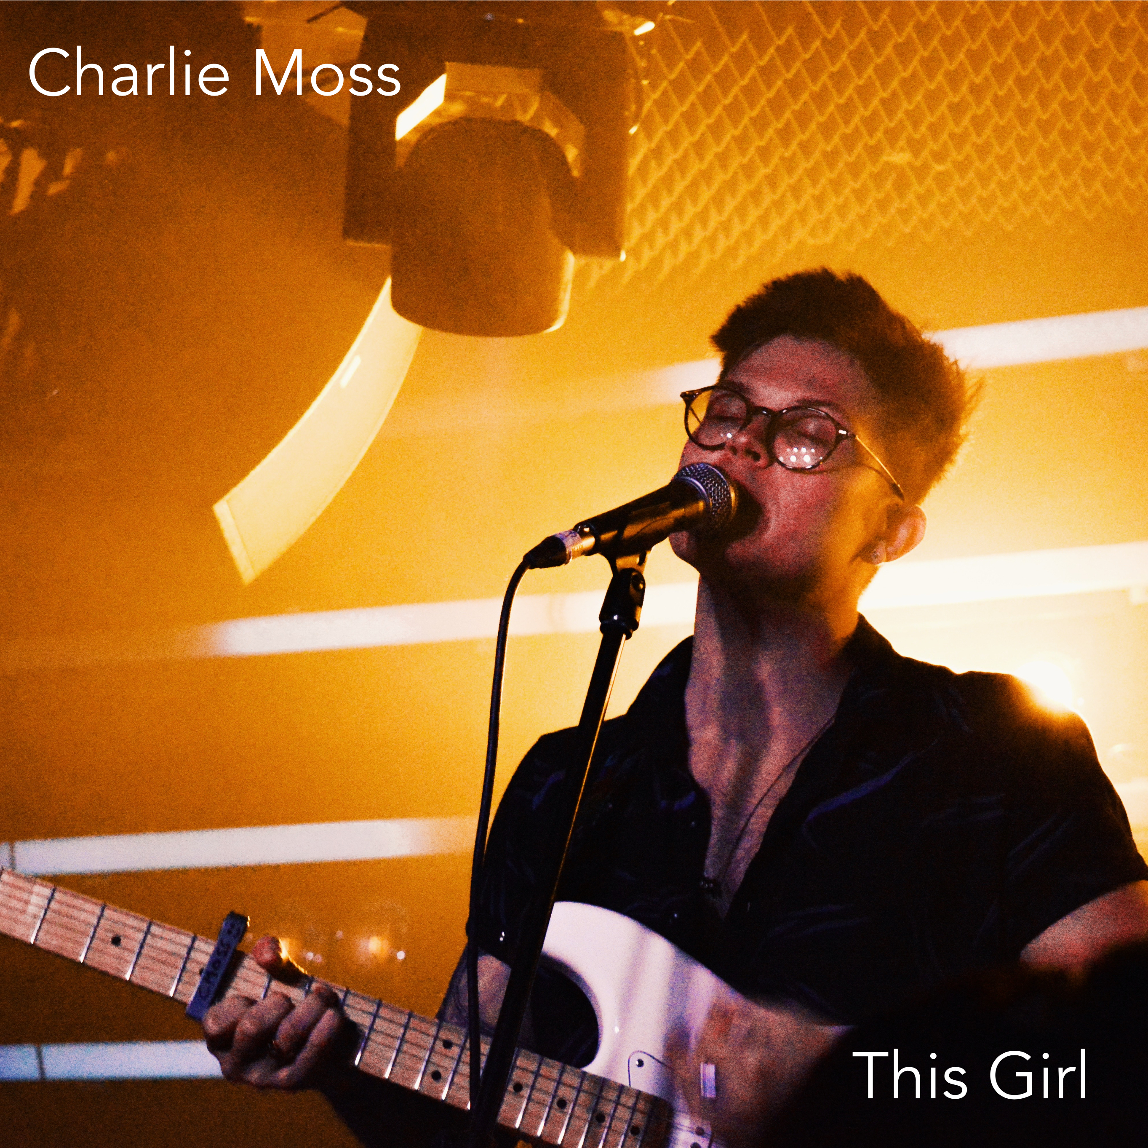
Critically Acclaimed Artist Charlie Moss Returns With His New single!

For fans of The 1975, George Ezra & James Bay; this is Charlie Moss.

The 22 year old singer-songwriter from Brighton has been releasing music and steadily gaining a dedicated following, already having received chart success through iTunes & Spotify in the UK & Germany.

Charlie grows in strength with each show he plays, having recently sold out prestigious venues in his hometown to being booked at UK Festivals for summer 2018 as well as touring the South alongside established artists including The Sherlocks, Trampolene, Louis Berry & Maisie Peters to name a few.

Following support from BBC Introducing South he has also been championed by local radio stations, independent music stores and press outlets.

We are therefore delighted to announce the release of Charlie’s latest single ‘This Girl’ available in all stores and music distributors from Friday June 29th along with a music video.

The single is available worldwide from June 29th.

See below for the video from his latest single ‘This Girl’
YouTube

Socials
Website
Twitter: @_CharlieMoss
Youtube: @CharlieMossMusic
Spotify

For more information, review tickets or guest list please contact CharlieMossMusic@hotmail.co.uk or visit www.CharlieMossMusic.com / (+44) 07393 194958 /

