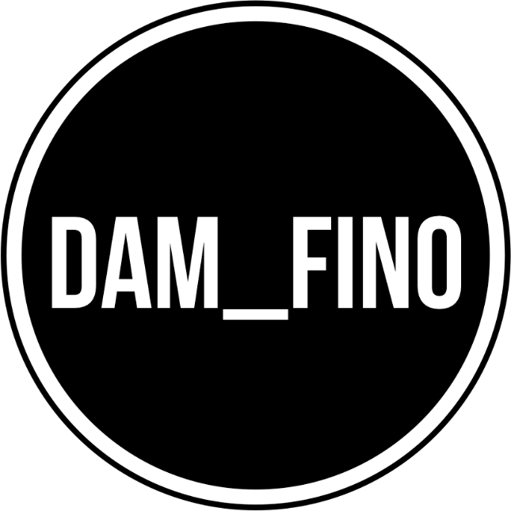
DAM_FINO Catering Rider

- 16 x standard beers
- 12 x 500ml water
- 1 x litre orange juice
- 1 x litre apple juice
- Assorted vegetarian snacks

