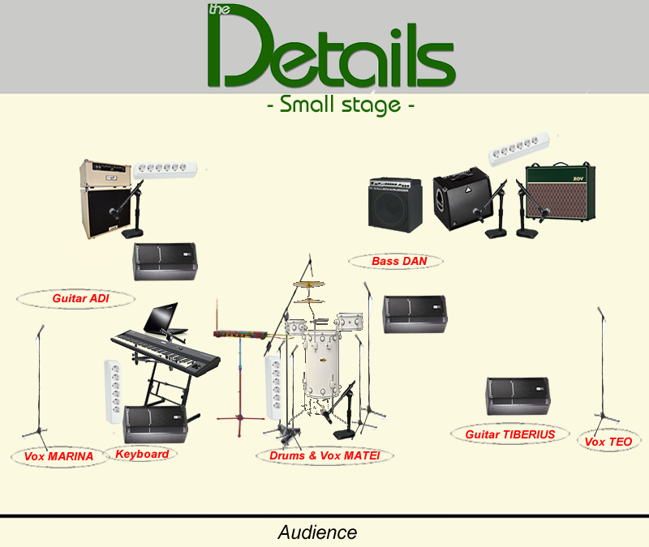

Need from the venue:
Item | Qnty | Preferred | Notes
Mic - dynamic - for snare/toms | 3 | Shure SM57; 3 boom stands
Mic - dynamic - for bass drum | 1 | Shure 52A; L-shaped boom stand
Mic - condenser - OH | 1 | AKG C-series; high boom stand | Cymbals on the left
Monitor | 4
IN-EAR monitors | 4
Sockets | 3 | 3 x three outlet
Mic - dynamic - for guitar amps | 3 | Shure SM57; L-shaped boom stand
D.I. box + XLR cable | 2
Jack-jack cable | 2
COMBO Guitar Amp | 1 | VOX AC30 / Fender Twin Reverb
Bass Amp | 1 | Gallien Krueger / Ampeg

