Artist: Rees Sorby

Stage Plot
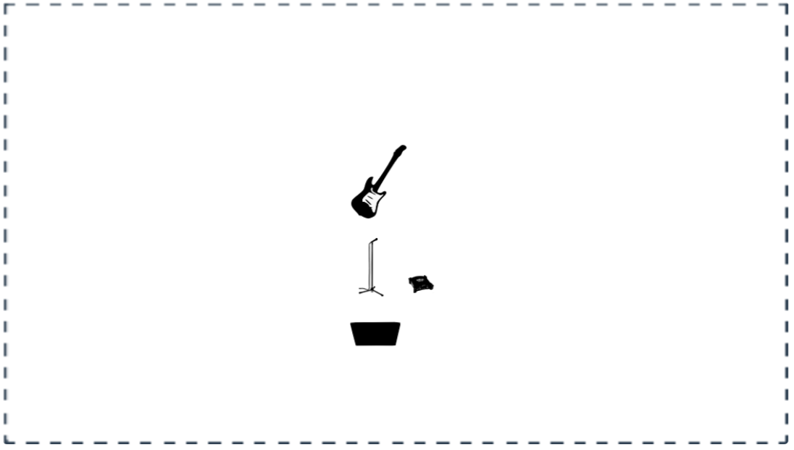

Revelation Stratocaster guitar plugged into a Chromatic Tuning pedal, then a DI box into the mixer to PA.

SM58 vocal microphone or equivalent on a stand to mixer.

Floor monitor facing me.

Very simple setup with only added reverb required.

Contact number: +447421462182
Email: rees.sorby@gmail.com

