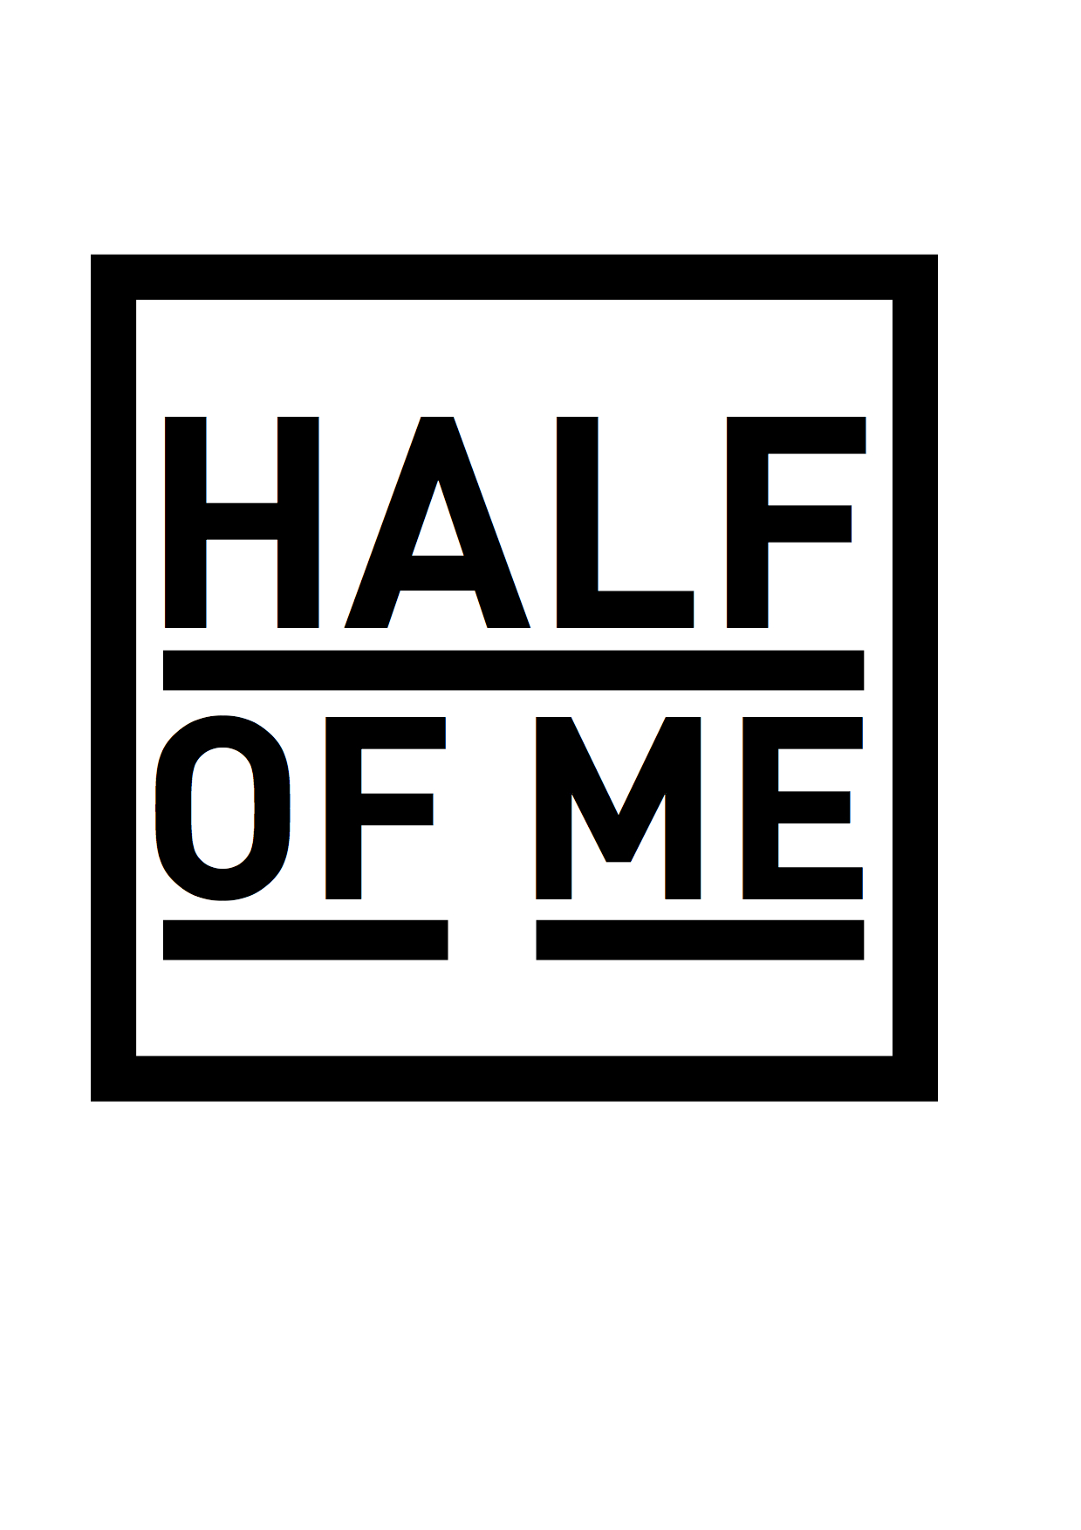
Hospitality Rider
6 Medium sized bottles of still water.
Fresh fruit and unsalted nuts.
1/2 case of beer.

Technical Rider for gigs not in the republic of Ireland:
Drum Kit – Two Floor Toms, One Rack Tom, Kick Drum, Hardware.
100W Bass Amplifier
100w Guitar Amplifier
3 SM58s
2 DI’s

