GLÜ page 1 of 3

tech rider
(update May 2018)

MIC LIST

ch |  | instrument | mic / d.i. |  | mic stand |  | insert foh
1 |  | bassdrum | Shure Beta 52 |  | short boom |  | 2 x comp d
2 |  | snare | Shure Sm 57 |  | short boom |  | on A // Group
3 |  | snare bottom | Shure Sm 57 |  | short boom
4 |  | hihat | Neumann KM 184 |  | short boom
5 |  | snare 2 Left | Shure Sm 57 |  | short boom
6 |  | snare 2 Right | Shure Sm 57 |  | short boom
7 |  | piccolo snare | Sennh E609 (TBC) |  | clamp or short boom |  | gate
8 |  | floortom | Sennh E609 |  | short boom |  | gate
9 |  | o/h Left | Neumann KM 184 |  | long boom
10 |  | o/h Right | Neumann KM 184 |  | long boom
11 |  | bass d.i. | active d.i. |  |  |  | comp
12 |  | bass Amp | Sennh MD421 |  | short boom
13 |  | Microkorg | d.i.
14 |  | Korg MS20 | d.i. |  |  |  | comp
15 |  | Rhodes Amp | Shure Sm 57 |  | short boom
16 |  | keys Left | d.i.
17 |  | keys Right | d.i.
18 |  | instrus FR Left
19 |  | instrus FR Right
20 |  | lead voc Left | d.i.
21 |  | lead voc Right | d.i.
22 |  | FX returns
23 |  | FX returns
24 |  | FX returns

MONITORPATCH

ch |  | output to | monitor |  |  | stage position |  | insert
1 |  | machines | floormonitor |  |  | back Left |  | eq 31-band
2 |  | bass | floormonitor |  |  | Right centre |  | eq 31-band
3 |  | drums | floormonitor (2) |  |  | centre |  | eq 31-band
4 |  | keys | floormonitor |  |  | Right |  | eq 31-band
5 |  | vox + FX | floormonitor |  |  | Left centre |  | eq 31-band

GLÜ page 2 of 3

tech rider
(update May 2018)

REMARKS

MONITOR DESK : minimum 24 INPUT + 4 AUX SENDS + MONITOR ENGINEER

IF NO MONITOR DESK :
6 AUX from FOH (4 AUX PRE for monitors + 2 POST for FX’s), NO LINECHECK

MONITORS : 6 identical wedges (2 for drums) + 31 bands EQ’s inserted

FOH DESK: minimum 24 INPUT with phase reverse and param EQ
1 verb TC or lexicon and 1 delay TC

IF ANALOG DESK : 4 comps DBX / DRAWMER + 2 gates
1 x stereo comp on mix buss
1 x graphic EQ on mix buss
1 x TC M3000
1 x tap delay

IF DIGITAL DESK : Please call or email to specify type ! Desk should be configured before soundcheck

VIDEO ARTIST(S) / VJ NEEDS

for multi-camera recording and realtime-streaming :

1 – video mixtable Edirol v4 / v8
2 – four rolls of BNC cable (50m / 100m)
3 – ethernet cable (connection test is mandatory)
4 – two multiple sockets
5 – one table for the video equipment (50 x 120 cm)

for VJ’ing :

1 – screen and video projector with VGA or DVI inputs
2 – VGA or DVI cables between stage and control room
3 – one multiple socket
4 – one table for the VJ’ing equipment (one Macbook Pro + one Midi-controller) (80 x 80 cm)

GLÜ page 3 of 3

tech rider
(update May 2018)

STAGE PLAN

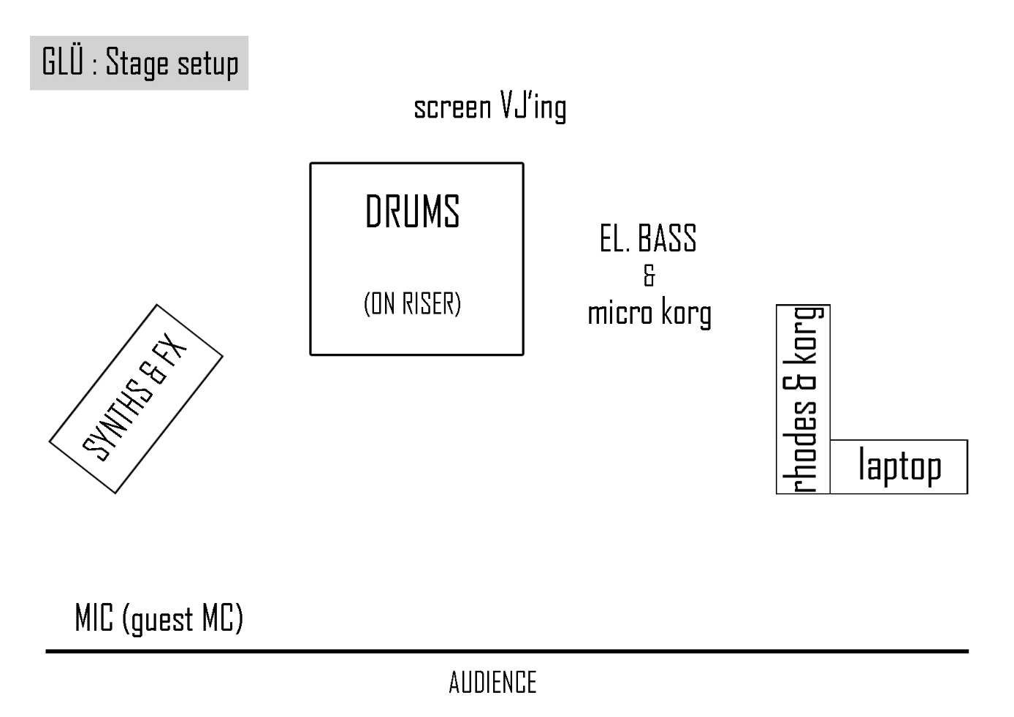

CONTACTS

production | Herbert Celis | +32 (0) 486 351035 | herb@naff-rekordz.com
mix | Renaud Houben | +32 (0) 496 121259 | renaudhouben@hotmail.com
artist / band | Martin Daniel | +32 (0) 479 761092 | contactleglu@gmail.com
VJ | Charles Bruere | +32 (0) 496 691245 | charlesbruere@gmail.com
official website |  |  | www.leglu.com

