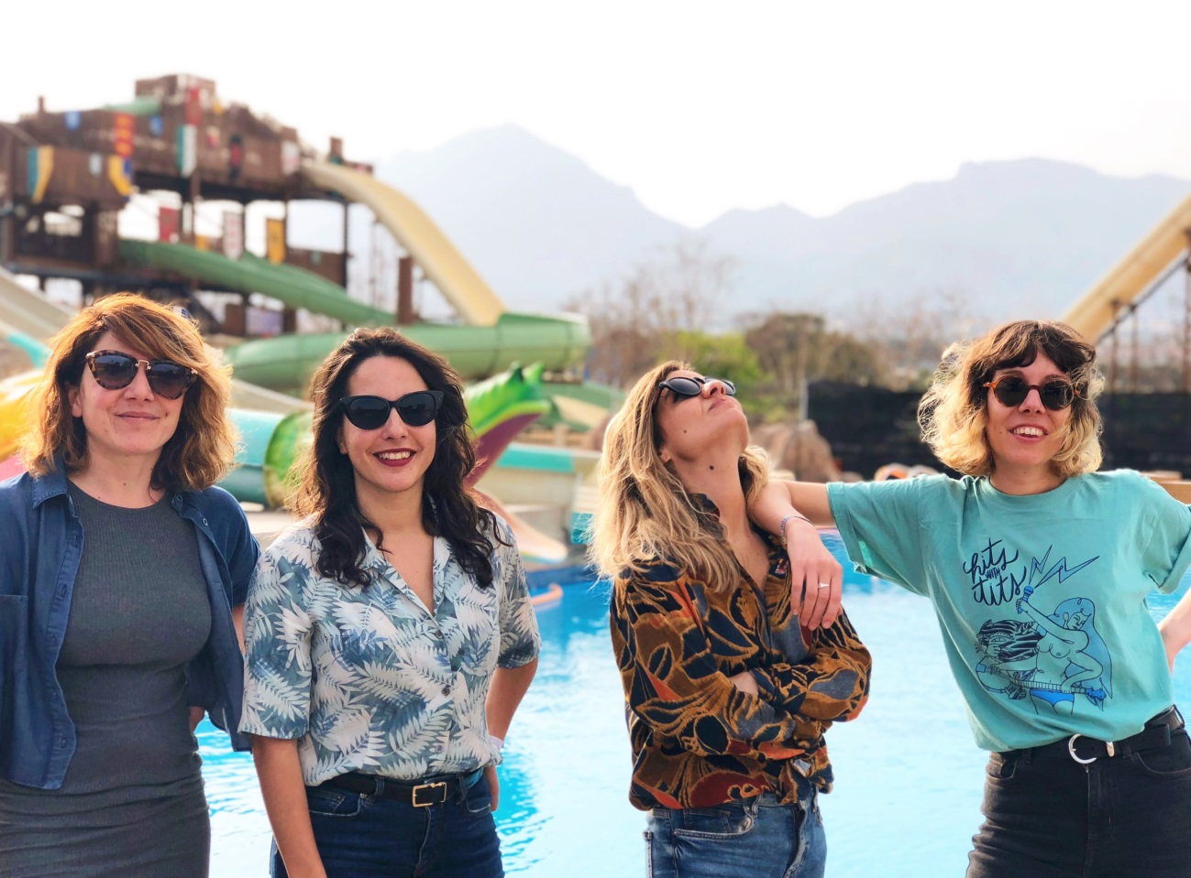

**Name**: **AMPARITO** **City:** MADRID

**Email:** amparitoband@gmail.com **Telephone:** +34 680343491

**Music Link:** Amparitoband.bandcamp.com **Style:** GARAGE/PUNK/POP

**Members:**

* OLALLA URIARTE - Voice and guitar player
* VANESA TORRES - Guitar player
* MARTA ALONSO - Bass player
* BEATRIZ MARTÍN- Drums

**Rider**

* 2 guitar amplifiers
* 1 bass amplifier
* Drum set: Bass Drum, bass drum pedal, rack mounted toms, snare drums, floor tom, ride , crash cymbal and hi hat clutch.