Contract Rider
Current as of March 2014

Thank you very much for engaging The Konincks. We are really looking forward to the concert day. The following concert rider is not a list of demands; it is a list of guidelines that will allow us to successfully fulfil our obligations in a professional manner.

Payment / further conditions
As confirmed there is a payable fee of EUR 200.00. Fee should be handed cash to one bandmember of The Konincks at the concert day.

Rain or shine: In the event this show is not presented because of inclement weather or any other reasons caused by the promoter, The Konincks must be paid in full if present and ready to perform.

Force Majeure: In case of sickness, inability to perform, accident, and means of transportation, and any act or order of any cause the band may cancel the gig and will not be paid.

Taxes: Promoter shall pay, at its sole cost, all taxes, fees, dues, licences, insurances and the like relating to the engagement.

Catering
As confirmed, one warm meal and drinks are included on the concert day.

The Konincks do not have any persons suffering from an allergy. The Konincks do not have any vegetarians travelling with them. Please do not cook any spicy meals.
Band party: 4 persons

Hotel
Unless otherwise negotiated, promoter provides an overnight accommodation. Please book 4 single rooms in a well situated, clean hotel. Approval 1 week before the gig is required. Please inform the band about check-in/-out times and full address of the hotel.

Parking
The Konincks are travelling with a van. Please inform the band about your (/ the hotels overnight) parking opportunities.

Backstage
If possible, The Konincks would like to have an own backstage room. Please make sure that the room is heated in winter and is running with warm and cold water.
Basically, all the band needs in there are seating facilities, still water, beer and a teasmade coming with black tea. Naturally, any other items are welcomed.

Please inform the band beforehand the gig about on-site-bathroom facilities.

Security
Please ensure at all times that the stage, dressing rooms and mix position are secure.

Miscellaneous
Please use only artwork, photos and/or promotional materials provided or approved by The Konincks in all advertisements. No product, service, or publication utilizing the name or likeness of The Konincks may be produced, sold, or distributed without the prior written consent of the band.

There will be no technician travelling with the band party. Hence The Konincks are glad your house technician contact them beforehand the show if there are any questions to the tech rider.

Guestlist
Please provide 6 tickets for bands guests. Final guestlist will be sent as soon as possible.

Band & Booking
If there are any questions please do not hesitate to contact us.

Mike Wegmüller
Mobile +41 78 801 45 40
info@thekonincks.com
www.thekonincks.com

Members
Vocals: Jules Herzog
Guitar: Mike Wegmüller
Bass: Marc Wermelinger
Drums: Julian Wettach

Agreed and accepted by

Promoter

Date

Band

Date

Tech Rider The Konincks
Current as of March 2014

If you have any problems, or if any of the items listed below will not be available, please contact us as soon as possible. If no contact is made, we’ll assume that this rider will be fulfilled to specification. Please also look at our web page, www.thekonincks.com as the tech rider on this page is regularly updated.

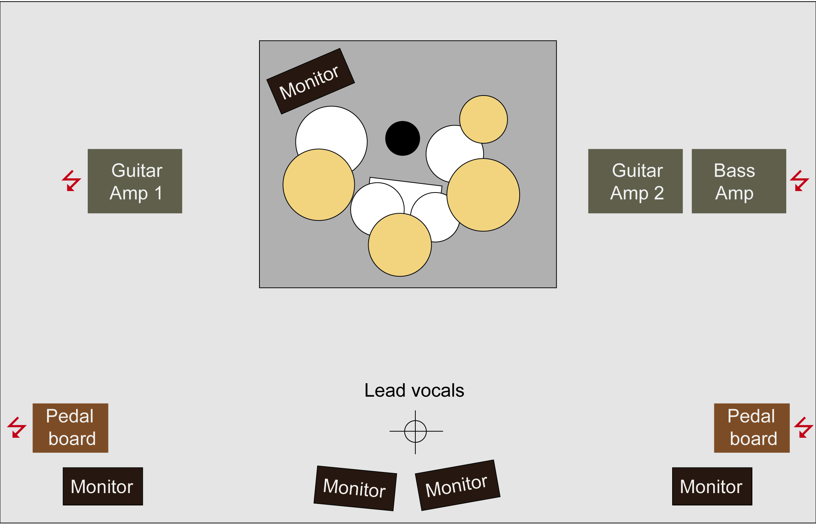

Provided by promoter
4-5 high quality stage monitors
1 high quality vocal microphone (Shure SM58 or similar)
Microphones for Drums and Guitars, DI-Box for Bass Guitar
Electricity for 3 Amps and 2 pedal boards

Provided by band
Lead guitar amp
Full drum set (if needed)
Second guitar amp and bass amp (if needed)

