Jens Malling
Jens Malling is an international reggae singer/songwriter originally from Denmark now based in Malaga. He is a signed recording artist working with the MIE Record label from Barbados. With the recent release of his fantastic first album ”Simple Pleasures”, things are moving very quickly. Jens is now planning a European tour, the Simple Pleasures Tour 2018, with many exciting possibilities in Denmark and, of course, Spain.

His song lyrics are all his own and reflect the time we live in, with social injustice and sustainable living as important subjects. But above all, music, and especially reggae music for him, is about happiness and love and the joy of being.

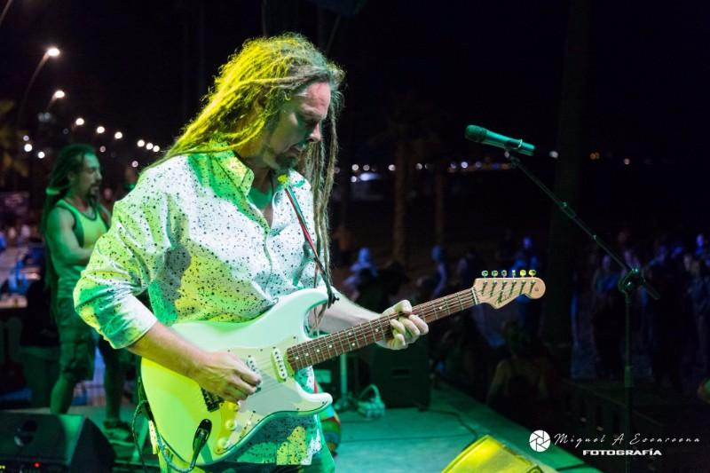
Since the release of Simple Pleasures in April 2017, Jens has been playing at a variety of amazing venues and events in Spain including the Estepona Reggae Festival and the Benalmadena Auditorium in support of Cudeca.

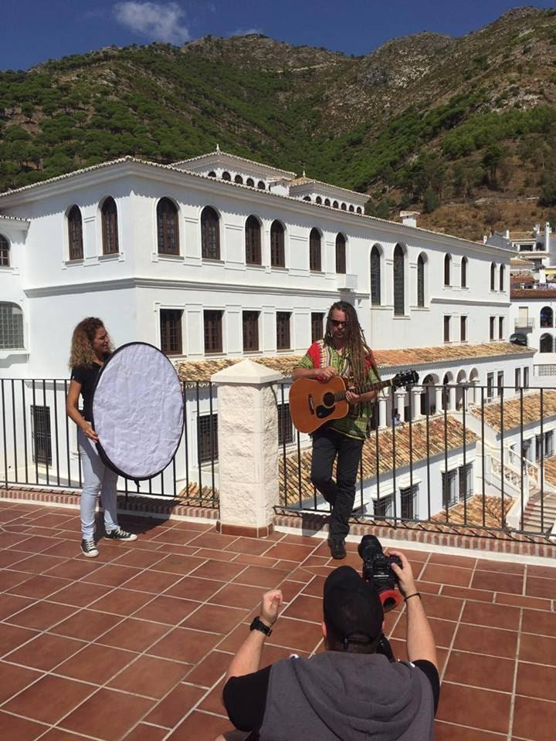
Keep your eyes and ears open for the release of Jens' first official music video for the song Sunny Day, a collaboration with Magnet Man from Barbados. Sunny Day is currently on airplay on Slam Radio in Barbados and on radio stations here in Spain. Official launch date to be confirmed very soon as well as dates for the Simple Pleasures Summer Tour 2018. You can expect to be seeing and hearing much more of the affectionately named “Reggae Viking” very soon.

Music Links:
Spotify: https://open.spotify.com/artist/0scBGBFOi4ejO9Zp3e6VGi

SoundCloud: https://soundcloud.com/jens-malling

YouTube promo video:
https://www.youtube.com/watch?v=NR6DbsGT7Bk

Follow Jens Malling:

Instagram: https://www.instagram.com/jensmallingofficial/

Facebook: https://www.facebook.com/JensMallingMusic/

