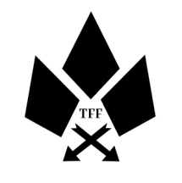
The Fireside Family
Contact no.’s : 07504351834 / 07941165771 Email : thefiresidefamily@gmail.com
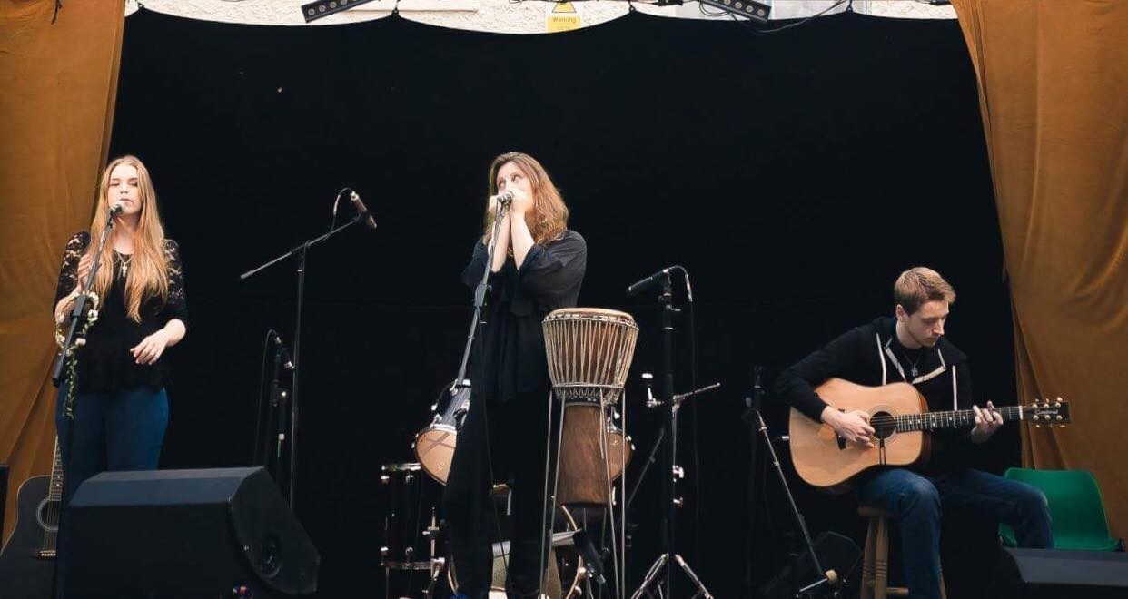
http://www.thefiresidefamily.co.uk
https://www.facebook.com/thefiresidefamily
https://www.instagram.com/thefiresidefamily
https://www.youtube.com/user/TheFiresideFamily
https://thefiresidefamily.bandcamp.com/music

Surprisingly, they really are a family! With influences of Ed Sheeran, Of Monsters and Men, First Aid Kit and Annie Lennox to name but a few, they have been delighting audiences since 2014 with their alternative Indie folk vibes.
The folk roots run deep through the group, which is apparent in their style of writing and musical content. With four previous generations of professional musicians (that can be traced so far), they really couldn't do anything else.
Their emotive lyrics are supported by Sky's intricate and percussive finger style guitar, Amanda's dynamic djembe and shakers and Lorien's rhythm guitar filling in the gaps. Add some choral harmonies to the mix, that can only be achieved with relatives, and you have The Fireside Family.

