vetka

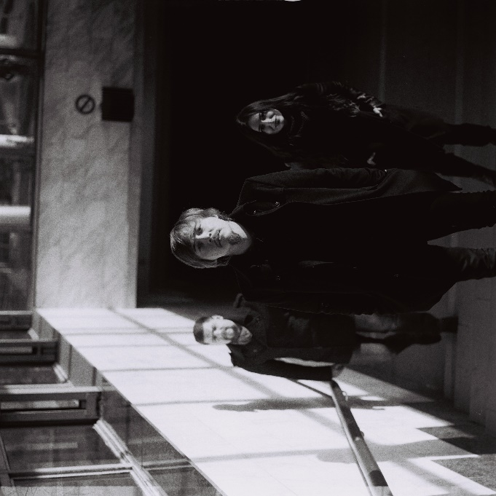
VETKA (branch of a tree, rus) is an emotional-lyric band from Ukraine. The band was formed in 2015 by Denis Vasiluk, who moved from Donetsk region, because of the war conflict on the east of the Ukraine. and has already had more than 250 concerts and performed at 15+ festivals.
VETKA plays music of different styles − from driving dance rhythms with folk and country melodies to indie rock songs with lyric and emotional colors.
Band plays both in fully acoustic way and full sound. Concerts include poetry readings that pervades gig and especially made for band songs arts visualization that adds special atmosphere.
In January 2017 VETKA issued their first single called “З тобою” (UKR, "With you"). To support the record and to share some music from the depths of their hearts VETKA went on tour. The tour was called "ZOREPADOM" after their song with same title which means "a falling of the stars". That’s why the band entitled their program “STARFALL” for their European part of the tour.
During ZOREPADOM tour VETKA has already had 12 concerts in Ukraine, Germany and Austria. Along with the concerts in clubs and venues the band regularly makes street music performances. In May 2017 VETKA played a concert on a rooftop in Vienna.
In September 2017 the band went to the second European tour and played 8 concerts in Poland, Austria, Czech and Germany.
In December 2017, the band released its debut mini-album titled "The very beginning".
The mini album includes 7 tracks in Ukrainian, Russian and English languages recorded over the past year. Different in mood, they have got the idea of love in any of its manifestation. Musicians have invested in songs finding of the beginning, a sense of balance and joy. «the very beginning» – compilation, feelings, music and poetry.
Influenced by – Mumford & sons, Radiohead, Bob Dylan.

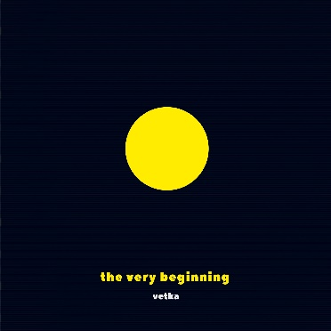
«the very beginning», EP 2017:

iTunes: https://goo.gl/6BFLBj
Google play: https://goo.gl/kbC1MN
Spotify: https://goo.gl/PZVxjc
Soundcloud: https://goo.gl/mcXw9V

Video playlist:
Acoustic: https://goo.gl/LkXDtn
Full sound: https://goo.gl/xpfPnJ
«VETKA» on-line:
Official site: vetkaband.com
Fb: www.facebook.com/vetkaband
Instagram: www.instagram.com/vetkaband
YouTube: www.youtube.com/VETKAband
Contact:
E-mail: denisvasiluk@gmail.com
Tel.: + 38 (095) 311 96 91- Denis Vasiluk
FB: www.facebook.com/denisvasiluk

